Contents

A. System Documentation

1. Certificate

1. Acknowledgement

2. Organizational Overview 6

3. Description of Present System 7

4. Limitations of Present System 8

5. Proposed System and Its Advantages 9

6. Timeline 10

7. Eshop List 14

8. Eshop Table 15

9. Entity Relationship Diagram (ER-Diagram) 18

10. Use Case Diagram 22

11. Activity Data Matrix (CRUD Table) 25

12. Activity Diagram 26

13. Class Diagram 28

14. Object Diagram 30

15. Sequence/Collaboration Diagram 32

16. State Diagram 34

17. Component Diagram 37

18. Structured English 39

19. Deployment Diagram 41

20. Package Diagram 43

21. Menu Tree 45

23. System Controls and Standards 46

24. Form Listing 47

25. Report Listing 49

26. Database and List of Tables 50

B. Project Documentation 55

1. Program Source Code 55

2. Data Entry Screens 205

C. Validations 215

1. Test Cases 215

2. Test Data 215

3. Test Results 217

D. Report Layout 219.

# System Documentation

## Certificate

## Acknowledgement

It gives me great pleasure in presenting this project report. Its justification will never sound good if I do not express my vote of thanks to our C.H.M. College and respective Principal. I would also like to thank our HOD Ritika Sachdev for her timely support in this completion of this project.

I thank our internal project guide Piyali Maghi*,* who has done a lot to keep this project systematically and on schedule. I am thankful for their valuable guidance to every stage of the project. Finally, I would thank to all others, who give there extended support to complete this project.

## Organizational Overview

The online electronic shopping application enables vendors to set up online shops, customers to browse through the shops and maintain list of shop categories by administrator. The product is web based system that allows the customer to shop virtually using the internet and allow customer to buy the items of their desire from the store.

In my system a user can shop a Electronic products in discount rates and offers, it helps to user attract to electronic products onwards and they purchase.

## Description of Present System

• General Description:- The online electronic shopping application enables vendors to set up online shops, customers to browse through the shops and maintain list of shop categories by administrator.

• Product Perspective:- The product is web based system that allows the customer to shop virtually using the internet and allow customer to buy the items of their desire from the store.

• System Interface:- Operating system window 11 which supports networking web browser: Google chrome(64 bit).

• User Interface:- Login page has login block which asks for the user id and password. Search page: lets the user search for the items. Browsing page: lets the user see the products.

• Communication Interface:- The system shall use the http protocol for communication over the internal.

## Limitations of Present System

• In this website security is not strong.

• No proper coordination between different application and user.

• Products and Images are limited.

• Forgot password not declared.

## Proposed System and Its Advantages

1. This system provides a graphical user interface to add or delete the information.
2. Faster Response to buyer/market demands.
3. Flexibility for the customer.
4. Online shop easy and comfortable.

**advantages**

1. This system is effective and save time and cost of the user.

* Faster Buying Process.
* Store and Product listing creation.
* Cost reduction during festive offers.
* Enable easy exports.

1. **Potential timeline of the Project’s Progress**

|  |  |  |  |  |  |  |  |
| --- | --- | --- | --- | --- | --- | --- | --- |
|  | Task Name | Planned  Start Date | Planned  Finish Date | Planned  Duration  (in days) | Actual  Start  Date | Actual  Finish  Date | Signature of  the Guide |
| 1 | Analysis | Tuesday  June 28, 2022 | Saturday  July 2, 2022 | 5 | 29-06-22 | 02-07-22 |  |
| 1.1 | Defining Problem  Statement of the Project and  gathering Information | Tuesday  June 28, 2022 | Wednesday  June 29, 2022 | 2 | 28-06-22 | 29-06-22 |  |
| 1.2 | Defining WBS  (Work Breakdown  Structure) of the Project | Thursday  June 30, 2022 | Friday  July 1, 2022 | 2 | 30-06-22 | 01-07-22 |  |
| 1.3 | Document Current System | Saturday  July 2, 2022 | Saturday  July 2, 2022 | 1 | 02-07-22 | 02-07-22 |  |
| 1.4 | Analysis Complete | Saturday  July 2, 2022 | Saturday  July 2, 2022 | 0 | 02-07-22 | 02-07-22 |  |
|  |  |  |  |  |  |  |  |
| 2 | Design | Monday  July 4, 2022 | Tuesday  July 19, 2022 | 14 | 03-07-22 | 19-07-22 |  |
|  |  |  |  |  |  |  |  |
| 2.1 | Design Database | Monday  July 4, 2022 | Wednesday  July 6, 2022 | 3 | 05-07-22 | 06-07-22 |  |
| 2.2 | Software Design | Thursday  July 7, 2022 | Tuesday  July 12, 2022 | 5 | 06-07-22 | 12-07-22 |  |
| 2.3 | Interface Design | Wednesday  July 13, 2022 | Wednesday  July 13, 2022 | 1 | 12-07-22 | 13-07-22 |  |

|  |  |  |  |  |  |  |  |
| --- | --- | --- | --- | --- | --- | --- | --- |
|  | Task Name | Planned  Start Date | Planned  Finish Date | Planned  Duration  (in days) | Actual  Start  Date | Actual  Finish  Date | Signature of  the Guide |
| 2.4 | Create Design Specification | Thursday  July 14, 2022 | Tuesday  July 19, 2022 | 5 | 14-07-22 | 19-07-22 |  |
| 2.5 | Design Complete | Tuesday  July 19, 2022 | Tuesday  July 19, 2022 | 0 | 19-07-22 | 19-07-22 |  |
|  |  |  |  |  |  |  |  |
| 3 | Development | Wednesday  July 20, 2022 | Saturday  August 13, 2022 | 20 | 22-07-22 | 13-08-22 |  |
|  |  |  |  |  |  |  |  |
| 3.1 | Develop System Module | Wednesday  July 20, 2022 | Saturday  July 30, 2022 | 10 | 20-07-22 | 30-07-22 |  |
| 3.2 | Integrate System Module | Monday  August 1, 2022 | Tuesday  August 9, 2022 | 7 | 01-08-22 | 09-08-22 |  |
| 3.3 | Perform Initial Testing | Wednesday  August 10, 2022 | Saturday  August 13, 2022 | 3 | 10-08-22 | 13-08-22 |  |
| 3.4 | Development Complete | Saturday  August 13, 2022 | Saturday  August 13, 2022 | 0 | 13-08-22 | 13-08-22 |  |
|  |  |  |  |  |  |  |  |
| 4 | Testing | Wednesday  August 17, 2022 | Friday  September 9, 2022 | 16 | 16-08-22 | 09-09-22 |  |
|  |  |  |  |  |  |  |  |
| 4.1 | Perform System Testing | Wednesday  August 17, 2022 | Thursday  August 25, 2022 | 7 | 17-08-22 | 25-08-22 |  |

|  |  |  |  |  |  |  |  |
| --- | --- | --- | --- | --- | --- | --- | --- |
|  | Task Name | Planned  Start Date | Planned  Finish Date | Planned  Duration  (in days) | Actual  Start  Date | Actual  Finish  Date | Signature of  the Guide |
| 4.2 | Documenting Issues Found | Friday  August 26, 2022 | Tuesday  September 6, 2022 | 6 | 24-08-22 | 06-09-22 |  |
| 4.3 | Correcting/Resolving Issues  Found | Wednesday  September 7, 2022 | Friday  September 9, 2022 | 3 | 07-09-22 | 09-09-22 |  |
| 4.4 | Testing Complete | Friday  September 9, 2022 | Friday  September 9, 2022 | 0 | 09-09-22 | 09-09-22 |  |
|  |  |  |  |  |  |  |  |
| 5 | Implementation | Saturday  September 10, 2022 | Wednesday  September 14, 2022 | 4 | 10-09-22 | 14-09-22 |  |
|  |  |  |  |  |  |  |  |
| 5.1 | On-Site/On-Campus  Installation | Saturday  September 10, 2022 | Tuesday  September 13, 2022 | 3 | 10-09-22 | 13-09-22 |  |
| 5.2 | Demonstration | Wednesday  September 14, 2022 | Wednesday  September 14, 2022 | 1 | 14-09-22 | Till date |  |

## Eshop List

* Admin log into the system.
* Admin add/update/delete details of User.
* Admin view the order status.
* Admin can edit the user.
* Admin can add the new products.
* Admin view reports of order.
* New customers register into the system.
* Register customer log into the system.
* Customer can see details of product.
* Customer can add a product in cart.
* Customer can increase the quantity of the product.
* Customers pay the payment.
* Customers give the feedback.

## EShop Table

A table that lists events in tabular format that is in rows and key pieces of information about each event in columns.

**Designing Of Eshop Table:-**

* While developing the list of Eshop the analyst should note additional information about each products for later use.
* This information is entered in an Eshop table.
* An Eshop table compares of rows and columns.
* Each row in the Eshop table records information about products.

**Eshop table should consist of the following:-**

* Event: Occurrence happening at a determinable time & place with/without human agents.
* Trigger: An occurrence that tells the system about the event.
* Source: An external agent or actor that supplies information.
* Activity: Behaviour that the system provides.
* Response: An output produced by the system that gives information.
* vi. Destination: An external agent or actor that receives data from the system.

**Types of Products:**

There are six category and 7 or more different brand are to identify products.

**1. Electronics:**

* There many different products like pendrives,

**2. Mobiles:**

* There are many brands of mobile are there like iphone 13 pro, Redmi Note 10 pro, Samsung Galaxy S22 Ultra and etc.

**3. Laptops:**

* In Laptop there are many variety of laptops are available like hp pavilion gaming, Dell Insipration, Asus Tuf Gaming and etc.

**4. Camera:**

* In camera, there are many dslr available for users like canon, sony alpha and etc.

1. **Accessories:**

* In accessories there are chargers, adapters, keyboard and mouse, etc are available.

1. **Home Appliances:**

* In home appliances there are tvs, fridge and etc are available in this section.

1. **Electronic Gadgets:**

* In electronic gadgets there are webcam, speaker, alexa and etc are available in this section.

|  |  |  |  |  |  |  |
| --- | --- | --- | --- | --- | --- | --- |
| **Sr.No** | **Event** | **Trigger** | **Source** | **Activity** | **Response** | **Destination** |
| 1. | Admin logs into the system | Admin logs into system | Admin | Admin is logged in | Logged in | System |
| 2. | Admin add new product and its details | Product and Details are added | Admin | Add new product and its details | Product and details are added | System |
| 3. | Admin update products details | Details are update | Admin | Update product details | product details are update | System |
| 2. | Admin deletes User details | Details are delete | Admin | Delete User details | User details are delete | System |
| 5. | Admin view Order details | View order details | Admin | View order details | order detail are view | System |
| 6. | Admin edit the user details | User details are edited | Admin | User details are edited | User details are updated | System |
| 7. | Customer logs into the system | Customer logs into system | Admin | Customer is logged in | Logged in | System |
| 8. | Customer order an product | Customer order product | Admin | Customer is order product | Order booked | System |
| 9. | Customer view own details | Customer view own details | Admin | Customer is view own details | View own details | System, Customer |
| 10. | Customer view all categories details | Customer view all categories details | Admin | Customer is view categories  details | View categories details | System, Customer |
| 11. | Customer pay the payment | Payment are pay | Admin | Customer is pay payment | Paying payment | System, Customer |
| 12. | Customer give feedback | Customer | Customer | Send Feedback | Feedback sent successfully | System |

## Entity Relationship Diagram (ER-Diagram)

1. Entity relationship diagram can express overall logical structure of database logically.

2. ER Diagrams are simple and clear.

3. ER Diagrams represents entities and tables and their relationship with one another.

**Components of ER diagram:**

|  |  |  |  |
| --- | --- | --- | --- |
| **Sr. No.** |  | **Shape** | **Description** |
| 1 | Rectangle |  | Represents entity set. |
| 2 | Ellipse |  | Represents attributes. |
| 3 | Diamond |  | Represents relationship. |
| 4 | Flow lines |  | Represents link between 2 entities set. |
| 5 | Double ellipse |  | Represents multivalve attributes. |
| 6 | Dashed ellipse |  | Denotes derived attributes. |
| 7 | Double Rectangle |  | Represents weak entity set. |
| 8 | Double Diamond |  | Represents relationship set for weak entity set. |

**Login:**

User Name

Login Id

Password

Login

**Categories:**

Mobiles

Electronics

Laptops

EShop

Electronic

Gadgets

Camera

Home Appliances

**Receipt:**

Items

Cost

Bill id

Customer id

Name

Receipt

Mode of Payment

Transaction id

Online

payment

**Customer:**

Name

Email id

Customer id

Customer

Mobile No

Address

As

Paeeysssssss

Customer

Login

Order

Manages

Bill

Alert By Email

Generateeeeeeeeeee

Categories

As

Add

Admin

Vieww

Reports

## Use Case Diagram

use case description

**Admin Subsystem:**

* Admin log into the system.
* Admin add/update/delete details of User.
* Admin view the order status.
* Admin can Manage the user.
* Admin can add the new products.
* Admin view reports of order.

**Customer Subsystem:**

* New customers register into the system.
* Register customer log into the system.
* Customer can see details of product.
* Customer can add a product in cart.
* Customer can increase the quantity of the product.
* Customers pay the payment.
* Customers give the feedback.

use case diagram

A use case diagram is a set of scenarios that describing an interaction between user and system. A use case diagram displays the relationship among actors & use cases. The 2 main components of use case diagram are use case and actor.

Actor Use Case

An actor represents a user or another system will interact with the system that you are modelling. A use case is an external view of the system that represents some action that might perform in order to complete a task.

**Admin**

**Customer**

## Activity Data Matrix (CRUD Table)

A table that describes data entities, the location from which they are accessed for the nature or access is called as CRUD.

C: Create new table

R: Read existing data

U: Update existing data

D: Delete existing file

|  |  |  |  |  |
| --- | --- | --- | --- | --- |
| **Sr.No** | **Activity** | **Entity** | | |
|  |  | 1 | 2 | 3 |
| 1. | New customers register into system. | C |  |  |
| 2. | Register Customers log into system. | R |  |  |
| 3. | Customers can add to cart. | R |  |  |
| 4. | Customers order their product. | U |  |  |
| 5. | Customers see the details of product. | U |  |  |
| 6. | Customers pay the payment. | U |  |  |
| 7. | Customers give the feedback. | U |  |  |
| 8. | Add new product. |  | CU |  |
| 9. | Generate Receipt |  |  | CU |

**Entities:**

1. Customer
2. product
3. Receipt

## Activity Diagram

1. Activity diagram describes the workflow behavior of the system.
2. 2. Activity diagram are similar to state diagram because activities are the state of doing something.
3. The diagram describes the state of activities by showing the sequence of activities performed.
4. Activity diagram can resolve activities that are conditional or parallel.
5. Activity diagram should be used in conjunction with other modeling techniques such as interaction diagram and state diagram.
6. Main reason to use the activity diagram is to model workflow behind the system being designed.

**Components of Activity Diagram:-**

|  |  |  |
| --- | --- | --- |
| 1 |  | Represents the activity. |
| **2** |  | Merge |
| **3** |  | Fork |

Customer

Admin

No

No

Login

Login****

Yes

Add New products

See product

New Register

Update Products

product Details

End

Delete products

Add to cart for buy

Payment Verification

Manage User

Order Status

Payment approval

Cancel order

Payment by online

Receipt

## Class Diagram

Class diagrams are widely used to describe the types of objects used in system and their relationship. Class diagram models class structure and contents using design elements such as classes and packages and objects.

Class diagram describes 3 different perspectives when designing a system. These perspectives become evident as the diagram is created and help solidify the design.

Classes are composed of 3 things:

1. Class name.

2. Attributes and

3. Operations.

**For Example Diagram:**



**Operations**

**Attribute**

**Class Name**







Admin





## Object Diagram

Object diagram are same as that of class diagram. Instead they contain the values in place of data types.

The object diagram describes 3 different perspectives when designing a system. This perspective becomes evident as the system is created & helps solidify the design.

They are composed of 2 things:

1. Class name.

2. Attributes.

For Example Diagram:



**Attribute**

**Class Name**

|  |
| --- |
| products |
| Id:14  Product id:3  Name: ”HP pavilion”  Description: HP Laptop  Price:62000 |

|  |
| --- |
| Receipt |
| Id:14  Name: shivam  Address: Vithalwadi  Brand: HP pavilion  Mobile: 999999999  Price:62000  Transaction id: M34DXCDG  Payment: success |

|  |
| --- |
| Admin |

|  |
| --- |
| customer |
| Id:14  Name: shivam.  Address: vitthalwadi.  City: Kalyan  State: Mahrashtra  Mobile:9999999999 |

|  |
| --- |
| Login |
| Email id: [shivam@gmail.com](mailto:shivam@gmail.com)  Password:”*******” |

## Sequence/Collaboration Diagram

Sequence diagram demonstrates the behavior of the objects in a use- case by describing the objects and the messages they pass. The diagrams are read left to right & descending.

**Components of Sequence Diagram:-**

|  |  |  |
| --- | --- | --- |
| 1 |  | Represent object activation. |
| 2 |  | Represents the objects of case study. |
| 3 |  | Represents life of objects. |
| 4 |  | Represents end of objects. |

receipt

product

customer

1: book ()

2: view ()

10: payTheBill ()

9: generate ()

8: delete ()

7: update ()

6: add ()

5: sendAlert ()

4: delete ()

3: product()pdate ()

## State Diagram

* State diagram are used to describe the behavior of the system.
* State diagram describe all of the possible state of an object as an event occurs.
* Each diagram usually represents objects of single class and track the different state of its object through the system.
* We use the state diagram to demonstrate the behavior of an object through many use cases of the system.
* We use the state diagram for classes where it is necessary to understand the behavior of the object through the entire system.

**Diagram:**

Activity

State Diagram

Transitions

Customer

No

Login****

Payment Verification

New Register

Only online payment

Cancel Order

Confirm the order

Add to cart

View product

Yes

No

End

Yes

Pay the Bill

**Admin:**

Yes

Login

No

End

receipt

Payment approval

Order status

Manage user

Delete product

Update product

Add New product

## Component Diagram

* The component diagram contains component & dependencies.
* Component represents the physical packaging of the module of the code.
* The dependencies between the components show how changes made to one component may affect each other components in the system.
* Dependencies in a component system are represented by dashed lines between 2 or more components.
* Component diagram can also show the interface used by the component to communicate with each other.

**Diagram:**

Object2

+method1 ()

+method2 ()

Object1

+method1 ()

+method2 ()

Object2

+method1 ()

+method2 ()

Object1

+method1 ()

+method2 ()

+add ()

+update ()

+delete ()

+add ()

+update ()

+delete ()

product

Customer

+generate ()

+add ()

+update ()

+delete ()

+sendAlert ()

Admin

Receipt

Login

+authenticate ()

## Structured English

1] Get new Customer entry data flow from Customer

If new Customer then

Generate new Customer ID

Add Customer details to Customer data store

Else

Validate the Customer using Customer name

End If

**Output: Customer details data flow.**

2] Update Customer entry data flow from Customer

If update Customer then

Update Customer Details to Customer data store

Else

Validate the Customer using Customer name

End If

**Output: Customer details data flow.**

3] Delete Customer entry data flow from Customer

If delete Customer then

Delete Customer Details from Customer data store

Else

Validate the Customer using Customer name

End If

**Output:** **Customer details data flow.**

4] Login

For each User login

If login detail=correct

Login successful

Else

Invalid details

## Deployment Diagram

* The deployment diagram contains nodes & connections.
* A node usually represents a piece of hardware in the system.
* A connection depicts the communication path used by the hardware to communicate & usually indicates a method such as TCP/IP.

**Diagram:**





Login

Admin

Receipt

Event

Customer

## Package Diagram

* In addition to standard UML dependency relationship there are two special types decencies defined between packages:

Package Import

Package Merge

* A package imports a relationship between an import namespace and a package indicating that importing namespace adds the names of members an unlabeled dependency between two packages an interpreted as a package import relationship. In this relationship elements within the target package will be imported in source package.
* A package merge is a directed relationship between two packages that indicates that the contents of two packages that are to be combined. It is very similar to generalization.

**Elements of package Diagram:-**

1. Package: It is a general purpose mechanism for organizing model contains elements is designed diagrams into groups. It provides an encapsulated namespace within which all names must be unique.
2. Class: It is representation of objects that reflects their structure and behavior of system.
3. Interface:It is specification of behavior. By implementing interface classes are required to support the behavior
4. Object: It is instance of class. It often used in analysis to represent numerous artifacts and item that exist.
5. Table: It is stereotyped class.

Electronic shop

product

Customer

Admin

Receipt

Login

Database

## Menu Tree

**Login:**

* Create new account
* Forgot Password
* Change password

**Main:**

* Customer
* Admin

**Activities:**

* Shop a product

**Administrative:**

* Register Customer
* Order Report
* Receipt Report

**User:**

* Change password
* Sign up
* Log in
* Add to cart
* View product description and order
* payment
* Exit

## System Controls and Standards

CREATE DEFINER=`root`@`localhost` PROCEDURE `getcat` (IN `cid` INT)  SELECT * FROM categories WHERE cat_id=cid$$

CREATE TABLE `admin_info`

INSERT INTO `admin_info`

CREATE TABLE `brands`

CREATE TABLE `cart`

INSERT INTO `cart`

CREATE TABLE `email_info

INSERT INTO `email_info`

CREATE TABLE `logs`

CREATE TABLE `orders`

INSERT INTO `orders`

CREATE TABLE `orders_info`

CREATE TABLE `order_products

INSERT INTO `order_products

CREATE TABLE `products`

INSERT INTO `products`

CREATE TABLE `user_info`

INSERT INTO `user_info`

## Form Listing

1. CSS

* Accountbtn.css
* Bootstrap.min.css
* Nouislider.min.css
* Slick-theme.css
* Slick.css
* Style.css
* Black-dashboard.css
* font-awesome.css
* font-awesome.min.css
* material-dashboard.min.css
* material+icons.css

1. Js

* Action.js
* Bootstrap.min.js
* Jquery.min.js
* Jquery.payform.min.js
* Jquery.zoom.min.js
* Main.js
* Nouislider.min.js
* Script.js
* Slick.min.js
* Sweetalert.min.js
* Bootstrap-material-design.min.js
* Popper.min.js
* Bootstrap-notify.js
* Chartist.min.js
* Perfect—scrollbar.jquery.min.js
* Material-dashboard.js.map

1. Html and php file

* Addproduct.php
* Adduser.php
* Edituser.php
* Electroniclist.php
* Footer.php
* Index.php
* Manageuser.php
* Orders.php
* Productlist.php
* Sidenav.php
* Sumbit_form.php
* Topheader.php
* Action.php
* Body.php
* Cart.php
* Checkout.php
* Config.php
* Db.php
* Error.php
* Homeaction.php
* Login.php
* Login_form.php
* Logout.php
* Newsletter.php
* Offersmail.php
* Payment_success.php
* Product.php
* Register.php
* Register_form.php
* Store.php

## Report Listing

1. Addproduct.php
2. Adduser.php
3. Orders.php
4. Cart.php
5. Payment_success.php

## Database and List of Tables

Database:

Name of the database:

1. admin_info

|  |  |  |  |  |  |  |
| --- | --- | --- | --- | --- | --- | --- |
| # | Name | Type | Collation | Null | Default | Extra |
| 1 | Admin_id | int(10) |  | no | none | Auto_Increment |
| 2 | Admin_name | varchar(100) | Latin1_swedish_ci | no | none | Auto_Increment |
| 3 | Admin_email | varchar(300) | Latin1_swedish_ci | no | none | Auto_Increment |
| 4 | Admin_password | varchar(300) | Latin1_swedish_ci | no | none | Auto_Increment |

1. brands

|  |  |  |  |  |  |  |
| --- | --- | --- | --- | --- | --- | --- |
| # | Name | Type | Collation | Null | Default | Extra |
| 1 | Brand_id | int(100) |  | no | none | Auto_Increment |
| 2 | Brand_title | text | Latin1_swedish_ci | no | none | Auto_Increment |

1. cart

|  |  |  |  |  |  |  |
| --- | --- | --- | --- | --- | --- | --- |
| # | Name | Type | Collation | Null | Default | Extra |
| 1 | id | int(10) |  | no | none | Auto_Increment |
| 2 | P_id | int(10) |  | no | none | Auto_Increment |
| 3 | ip_add | varchar(250) | Latin1_swedish_ci | no | none | Auto_Increment |
| 4 | User_id | int(10) |  | yes | null | Auto_Increment |
| 5 | qty | int(10) |  | no | none | Auto_Increment |

1. categories

|  |  |  |  |  |  |  |
| --- | --- | --- | --- | --- | --- | --- |
| # | Name | Type | Collation | Null | Default | Extra |
| 1 | cat_id | int(100) |  | no | none | Auto_Increment |
| 2 | cat_title | text | Latin1_swedish_ci | no | none | Auto_Increment |

1. email_info

|  |  |  |  |  |  |  |
| --- | --- | --- | --- | --- | --- | --- |
| # | Name | Type | Collation | Null | Default | Extra |
| 1 | Email_id | int(100) |  | no | none | Auto_Increment |
| 2 | email | text | Latin1_swedish_ci | no | none | Auto_Increment |

1. logs

|  |  |  |  |  |  |  |
| --- | --- | --- | --- | --- | --- | --- |
| # | Name | Type | Collation | Null | Default | Extra |
| 1 | id | int(11) |  | no | none | Auto_Increment |
| 2 | User_id | varchar(50) | Latin1_swedish_ci | no | none | Auto_Increment |
| 3 | action | varchar(50) | Latin1_swedish_ci | no | none | Auto_Increment |
| 4 | date | datetime |  | no | none | Auto_Increment |

1. orders

|  |  |  |  |  |  |  |
| --- | --- | --- | --- | --- | --- | --- |
| # | Name | Type | Collation | Null | Default | Extra |
| 1 | order_id | int(11) |  | no | none |  |
| 2 | user_id | int(11) |  | no | none |  |
| 3 | product_id | int(11) |  | no | none |  |
| 4 | qty | int(11) |  | no | none |  |
| 5 | trx_id | varchar(255) | Latin1_swedish_ci | no | none |  |
| 6 | p_status | varchar(20) | Latin1_swedish_ci | no | none | Auto_Increment |

1. orders_info

|  |  |  |  |  |  |  |
| --- | --- | --- | --- | --- | --- | --- |
| # | Name | Type | Collation | Null | Default | Extra |
| 1 | order_id | int(10) |  | no | none | Auto_Increment |
| 2 | user_id | int(11) |  | no | none |  |
| 3 | f_name | varchar(255) | Latin1_swedish_ci | no | none |  |
| 4 | email | varchar(255) | Latin1_swedish_ci | no | none |  |
| 5 | address | varchar(255) | Latin1_swedish_ci | no | none |  |
| 6 | city | varchar(255) | Latin1_swedish_ci | no | none |  |
| 7 | state | varchar(255) | Latin1_swedish_ci | no | none |  |
| 8 | zip | int(10) |  | no | none |  |
| 9 | cardname | varchar(255) | Latin1_swedish_ci | no | none |  |
| 10 | cardnumber | varchar(20) | Latin1_swedish_ci | no | none |  |
| 11 | expdate | varchar(255) | Latin1_swedish_ci | no | none |  |
| 12 | prod_count | int(15) |  | yes | nulll |  |
| 13 | total_amt | int(15) |  | yes | null |  |
| 14 | cvv | int(15) |  | no | none |  |

1. order_products

|  |  |  |  |  |  |  |
| --- | --- | --- | --- | --- | --- | --- |
| # | Name | Type | Collation | Null | Default | Extra |
| 1 | order_pro_id | int(10) |  | no | none | Auto_Increment |
| 2 | order_id | int(11) |  | no | none |  |
| 3 | product_id | int(11) |  | no | none |  |
| 4 | qty | int(15) |  | yes | null |  |
| 5 | amt | int(15) |  | yes | null |  |

1. products

|  |  |  |  |  |  |  |
| --- | --- | --- | --- | --- | --- | --- |
| # | Name | Type | Collation | Null | Default | Extra |
| 1 | product_id | int(100) |  | no | none | Auto_Increment |
| 2 | product_cat | int(100) |  | no | none |  |
| 3 | product_brand | int(100) |  | no | none |  |
| 4 | product_title | varchar(255) |  | no | none |  |
| 5 | Product_price | int(100) |  | no | none |  |
| 6 | product_desc | text | Latin1_swedish_ci | no | none |  |
| 7 | product_image | text | Latin1_swedish_ci | no | none |  |
| 8 | Product_keywords | text | Latin1_swedish_ci | no | none |  |

1. user_info

|  |  |  |  |  |  |  |
| --- | --- | --- | --- | --- | --- | --- |
| # | Name | Type | Collation | Null | Default | Extra |
| 1 | user_id | int(10) |  | no | none | Auto_Increment |
| 2 | first_name | varchar(100) | Latin1_swedish_ci | no | none |  |
| 3 | last_name | varchar(100) | Latin1_swedish_ci | no | none |  |
| 4 | email | varchar(300) | Latin1_swedish_ci | no | none |  |
| 5 | password | varchar(300) | Latin1_swedish_ci | no | none |  |
| 6 | mobile | varchar(10) | Latin1_swedish_ci | no | none |  |
| 7 | Address1 | varchar(300) | Latin1_swedish_ci | no | none |  |
| 8 | Address2 | varchar(11) | Latin1_swedish_ci | no | none |  |

1. user_info_backup

|  |  |  |  |  |  |  |
| --- | --- | --- | --- | --- | --- | --- |
| # | Name | Type | Collation | Null | Default | Extra |
| 1 | user_id | int(10) |  | no | none | Auto_Increment |
| 2 | first_name | varchar(100) | Latin1_swedish_ci | no | none |  |
| 3 | last_name | varchar(100) | Latin1_swedish_ci | no | none |  |
| 4 | email | varchar(300) | Latin1_swedish_ci | no | none |  |
| 5 | password | varchar(300) | Latin1_swedish_ci | no | none |  |
| 6 | mobile | varchar(10) | Latin1_swedish_ci | no | none |  |
| 7 | Address1 | varchar(300) | Latin1_swedish_ci | no | none |  |
| 8 | Address2 | varchar(11) | Latin1_swedish_ci | no | none |  |

1. Project Documentation

## Program Source Code

**Admin source code -**

**Source Code:**

**File Name:** addproduct.php

<?php

session_start();

include("../db.php");

if(isset($_POST['btn_save']))

{

$product_name=$_POST['product_name'];

$details=$_POST['details'];

$price=$_POST['price'];

$c_price=$_POST['c_price'];

$product_type=$_POST['product_type'];

$brand=$_POST['brand'];

$tags=$_POST['tags'];

$picture_name=$_FILES['picture']['name'];

$picture_type=$_FILES['picture']['type'];

$picture_tmp_name=$_FILES['picture']['tmp_name'];

$picture_size=$_FILES['picture']['size'];

if($picture_type=="image/jpeg" || $picture_type=="image/jpg" || $picture_type=="image/png" || $picture_type=="image/gif")

{

if($picture_size<=50000000)

$pic_name=time()."_".$picture_name;

move_uploaded_file($picture_tmp_name,"../product_images/".$pic_name);

mysqli_query($con,"insert into products (product_cat, product_brand,product_title,product_price, product_desc, product_image,product_keywords) values ('$product_type','$brand','$product_name','$price','$details','$pic_name','$tags')") or die ("query incorrect");

header("location: sumit_form.php?success=1");

}

mysqli_close($con);

}

include "sidenav.php";

include "topheader.php";

?>

<!-- End Navbar -->

<div class="content">

<div class="container-fluid">

<form action="" method="post" type="form" name="form" enctype="multipart/form-data">

<div class="row">

<div class="col-md-7">

<div class="card">

<div class="card-header card-header-primary">

<h5 class="title">Add Product</h5>

</div>

<div class="card-body">

<div class="row">

<div class="col-md-12">

<div class="form-group">

<label>Product Title</label>

<input type="text" id="product_name" required name="product_name" class="form-control">

</div>

</div>

<div class="col-md-4">

<div class="">

<label for="">Add Image</label>

<input type="file" name="picture" required class="btn btn-fill btn-success" id="picture" >

</div>

</div>

<div class="col-md-12">

<div class="form-group">

<label>Description</label>

<textarea rows="4" cols="80" id="details" required name="details" class="form-control"></textarea>

</div>

</div>

<div class="col-md-12">

<div class="form-group">

<label>Pricing</label>

<input type="text" id="price" name="price" required class="form-control" >

</div>

</div>

</div>

</div>

</div>

</div>

<div class="col-md-5">

<div class="card">

<div class="card-header card-header-primary">

<h5 class="title">Categories</h5>

</div>

<div class="card-body">

<div class="row">

<div class="col-md-12">

<div class="form-group">

<label>Product Category</label>

<input type="number" id="product_type" name="product_type" required="[1-6]" class="form-control">

</div>

</div>

<div class="col-md-12">

<div class="form-group">

<label for="">Product Brand</label>

<input type="number" id="brand" name="brand" required class="form-control">

</div>

</div>

<div class="col-md-12">

<div class="form-group">

<label>Product Keywords</label>

<input type="text" id="tags" name="tags" required class="form-control" >

</div>

</div>

</div>

</div>

<div class="card-footer">

<button type="submit" id="btn_save" name="btn_save" required class="btn btn-fill btn-primary">Update Product</button>

</div>

</div>

</div>

</div>

</form>

**Source Code:**

**File Name:** adduser.php

<?php

session_start();

include("../db.php");

include "sidenav.php";

include "topheader.php";

if(isset($_POST['btn_save']))

{

$first_name=$_POST['first_name'];

$last_name=$_POST['last_name'];

$email=$_POST['email'];

$user_password=$_POST['password'];

$mobile=$_POST['phone'];

$address1=$_POST['city'];

$address2=$_POST['country'];

mysqli_query($con,"insert into user_info(first_name, last_name,email,password,mobile,address1,address2) values ('$first_name','$last_name','$email','$user_password','$mobile','$address1','$address2')")

or die ("Query 1 is inncorrect........");

header("location: manage_users.php");

mysqli_close($con);

}

?>

<!-- End Navbar -->

<div class="content">

<div class="container-fluid">

<!-- your content here -->

<div class="col-md-12">

<div class="card">

<div class="card-header card-header-primary">

<h4 class="card-title">Add Users</h4>

<p class="card-category">Complete User profile</p>

</div>

<div class="card-body">

<form action="" method="post" name="form" enctype="multipart/form-data">

<div class="row">

<div class="col-md-3">

<div class="form-group bmd-form-group">

<label class="bmd-label-floating">First Name</label>

<input type="text" id="first_name" name="first_name" class="form-control" required>

</div>

</div>

<div class="col-md-4">

<div class="form-group bmd-form-group">

<label class="bmd-label-floating">Last Name</label>

<input type="text" name="last_name" id="last_name" class="form-control" required>

</div>

</div>

</div>

<div class="row">

<div class="col-md-6">

<div class="form-group bmd-form-group">

<label class="bmd-label-floating">Email</label>

<input type="email" name="email" id="email" class="form-control" required>

</div>

</div>

<div class="col-md-6">

<div class="form-group bmd-form-group">

<label class="bmd-label-floating">Password</label>

<input type="password" id="password" name="password" class="form-control" required>

</div>

</div>

</div>

<div class="row">

<div class="col-md-12">

<div class="form-group bmd-form-group">

<label class="bmd-label-floating">phone number</label>

<input type="text" id="phone" name="phone" class="form-control" required>

</div>

</div>

</div>

<div class="row">

<div class="col-md-4">

<div class="form-group bmd-form-group">

<label class="bmd-label-floating">City</label>

<input type="text" name="city" id="city" class="form-control" required>

</div>

</div>

<div class="col-md-4">

<div class="form-group bmd-form-group">

<label class="bmd-label-floating">Address</label>

<input type="text" name="country" id="country" class="form-control" required>

</div>

</div>

</div>

<button type="submit" name="btn_save" id="btn_save" class="btn btn-primary pull-right">Update User</button>

<div class="clearfix"></div>

</form>

</div>

</div>

</div>

**Source Code:**

**File Name:** edituser.php

<?php

session_start();

include("../db.php");

$user_id=$_REQUEST['user_id'];

$result=mysqli_query($con,"select user_id,first_name,last_name, email, password from user_info where user_id='$user_id'")or die ("query 1 incorrect.......");

list($user_id,$first_name,$last_name,$email,$user_password)=mysqli_fetch_array($result);

if(isset($_POST['btn_save']))

{

$first_name=$_POST['first_name'];

$last_name=$_POST['last_name'];

$email=$_POST['email'];

$user_password=$_POST['password'];

mysqli_query($con,"update user_info set first_name='$first_name', last_name='$last_name', email='$email', password='$user_password' where user_id='$user_id'")or die("Query 2 is inncorrect..........");

header("location: manageuser.php");

mysqli_close($con);

}

include "sidenav.php";

include "topheader.php";

?>

<!-- End Navbar -->

<div class="content">

<div class="container-fluid">

<div class="col-md-5 mx-auto">

<div class="card">

<div class="card-header card-header-primary">

<h5 class="title">Edit User</h5>

</div>

<form action="edituser.php" name="form" method="post" enctype="multipart/form-data">

<div class="card-body">

<input type="hidden" name="user_id" id="user_id" value="<?php echo $user_id;?>" />

<div class="col-md-12 ">

<div class="form-group">

<label>First name</label>

<input type="text" id="first_name" name="first_name" class="form-control" value="<?php echo $first_name; ?>" >

</div>

</div>

<div class="col-md-12 ">

<div class="form-group">

<label>Last name</label>

<input type="text" id="last_name" name="last_name" class="form-control" value="<?php echo $last_name; ?>" >

</div>

</div>

<div class="col-md-12 ">

<div class="form-group">

<label for="exampleInputEmail1">Email address</label>

<input type="email" id="email" name="email" class="form-control" value="<?php echo $email; ?>">

</div>

</div>

<div class="col-md-12 ">

<div class="form-group">

<label >Password</label>

<input type="text" name="password" id="password" class="form-control" value="<?php echo $user_password; ?>">

</div>

</div>

</div>

<div class="card-footer">

<button type="submit" id="btn_save" name="btn_save" class="btn btn-fill btn-primary">Update</button>

</div>

</form>

</div>

</div>

**Source Code:**

**File Name:** electroniclist.php

<?php

session_start();

include("../db.php");

error_reporting(0);

if(isset($_GET['action']) && $_GET['action']!="" && $_GET['action']=='delete')

{

$product_id=$_GET['product_id'];

///////picture delete/////////

$result=mysqli_query($con,"select product_image from products where product_id='$product_id'")

or die("query is incorrect...");

list($picture)=mysqli_fetch_array($result);

$path="../product_images/$picture";

if(file_exists($path)==true)

{

unlink($path);

}

else

{}

/*this is delet query*/

mysqli_query($con,"delete from products where product_id='$product_id'")or die("query is incorrect...");

}

///pagination

$page=$_GET['page'];

if($page=="" || $page=="1")

{

$page1=0;

}

else

{

$page1=($page*10)-10;

}

include "sidenav.php";

include "topheader.php";

?>

<!-- End Navbar -->

<div class="content">

<div class="container-fluid">

<div class="col-md-14">

<div class="card ">

<div class="card-header card-header-primary">

<h4 class="card-title"> Products List</h4>

<div class="btn-group btn-group-toggle float-right" data-toggle="buttons">

<label class="btn btn-sm btn-primary btn-simple active" id="0">

<input type="radio" name="options" autocomplete="off" checked=""> Electronics

</label>

<label class="btn btn-sm btn-primary btn-simple" id="1">

<input type="radio" name="options" autocomplete="off"> Mobiles

</label>

<label class="btn btn-sm btn-primary btn-simple" id="2">

<input type="radio" name="options" autocomplete="off"> Home Appliances

</label>

</div>

</div>

<div class="card-body">

<div class="table-responsive ps">

<table class="table table-hover tablesorter " id="page1">

<thead class=" text-primary">

<tr><th>Image</th><th>Name</th><th>Price</th><th>

<a class=" btn btn-primary" href="addproduct.php">Add New</a></th></tr></thead>

<tbody>

<?php

$result=mysqli_query($con,"select product_id,product_image, product_title,product_price from products where product_cat=1 Limit $page1,12")or die ("query 1 incorrect.....");

while(list($product_id,$image,$product_name,$price)=mysqli_fetch_array($result))

{

echo "<tr><td><img src='../product_images/$image' style='width:50px; height:50px; border:groove #000'></td><td>$product_name</td>

<td>$price</td>

<td>

<a class=' btn btn-success' href='clothes_list.php?product_id=$product_id&action=delete'>Delete</a>

</td></tr>";

}

?>

</tbody>

</table>

<div class="ps__rail-x" style="left: 0px; bottom: 0px;"><div class="ps__thumb-x" tabindex="0" style="left: 0px; width: 0px;"></div></div><div class="ps__rail-y" style="top: 0px; right: 0px;"><div class="ps__thumb-y" tabindex="0" style="top: 0px; height: 0px;"></div></div></div>

</div>

</div>

<nav aria-label="Page navigation example">

<ul class="pagination">

<li class="page-item">

<a class="page-link" href="#" aria-label="Previous">

<span aria-hidden="true">&laquo;</span>

<span class="sr-only">Previous</span>

</a>

</li>

<?php

//counting paging

$paging=mysqli_query($con,"select product_id,product_image, product_title,product_price from products");

$count=mysqli_num_rows($paging);

$a=$count/10;

$a=ceil($a);

for($b=1; $b<=$a;$b++)

{

?>

<li class="page-item"><a class="page-link" href="productlist.php?page=<?php echo $b;?>"><?php echo $b." ";?></a></li>

<?php

}

?>

<li class="page-item">

<a class="page-link" href="#" aria-label="Next">

<span aria-hidden="true">&raquo;</span>

<span class="sr-only">Next</span>

</a>

</li>

</ul>

</nav>

</div>

</div>

</div>

</div>

<?php

include "footer.php";

?>

**Source Code:**

**File Name:** footer.php

<footer class="footer">

<div class="container-fluid">

<nav class="float-left">

<ul>

<li>

<a href="">

Shivam Yadav

</a>

</li>

</ul>

</nav>

<div class="copyright float-right">

&copy;

<script>

document.write(new Date().getFullYear())

</script>, made with <i class="material-icons">favorite</i> by

<a href="" target="_blank">Shivam Yadav</a> for a better web.

</div>

<!-- your footer here -->

</div>

</footer>

</div>

</div>

<!-- Core JS Files -->

<script src="./assets/js/core/jquery.min.js"></script>

<script src="./assets/js/core/popper.min.js"></script>

<script src="./assets/js/core/bootstrap-material-design.min.js"></script>

<script src=""></script>

<script src="./assets/js/plugins/perfect-scrollbar.jquery.min.js"></script>

<!-- Place this tag in your head or just before your close body tag. -->

<script async defer src=""></script>

<!-- Google Maps Plugin -->

<script src=""></script>

<!-- Chartist JS -->

<script src="./assets/js/plugins/chartist.min.js"></script>

<!-- Notifications Plugin -->

<script src="./assets/js/plugins/bootstrap-notify.js"></script>

<!-- Control Center for Material Dashboard: parallax effects, scripts for the example pages etc -->

<script src="./assets/js/material-dashboard.js?v=2.1.0"></script>

<!-- Material Dashboard DEMO methods, don't include it in your project! -->

<script src="./assets/demo/demo.js"></script>

<script>

$(document).ready(function() {

$().ready(function() {

$sidebar = $('.sidebar');

$sidebar_img_container = $sidebar.find('.sidebar-background');

$full_page = $('.full-page');

$sidebar_responsive = $('body > .navbar-collapse');

window_width = $(window).width();

$('.fixed-plugin a').click(function(event) {

// Alex if we click on switch, stop propagation of the event, so the dropdown will not be hide, otherwise we set the section active

if ($(this).hasClass('switch-trigger')) {

if (event.stopPropagation) {

event.stopPropagation();

} else if (window.event) {

window.event.cancelBubble = true;

}

}

});

$('.fixed-plugin .active-color span').click(function() {

$full_page_background = $('.full-page-background');

$(this).siblings().removeClass('active');

$(this).addClass('active');

var new_color = $(this).data('color');

if ($sidebar.length != 0) {

$sidebar.attr('data-color', new_color);

}

if ($full_page.length != 0) {

$full_page.attr('filter-color', new_color);

}

if ($sidebar_responsive.length != 0) {

$sidebar_responsive.attr('data-color', new_color);

}

});

$('.fixed-plugin .background-color .badge').click(function() {

$(this).siblings().removeClass('active');

$(this).addClass('active');

var new_color = $(this).data('background-color');

if ($sidebar.length != 0) {

$sidebar.attr('data-background-color', new_color);

}

});

$('.fixed-plugin .img-holder').click(function() {

$full_page_background = $('.full-page-background');

$(this).parent('li').siblings().removeClass('active');

$(this).parent('li').addClass('active');

var new_image = $(this).find("img").attr('src');

if ($sidebar_img_container.length != 0 && $('.switch-sidebar-image input:checked').length != 0) {

$sidebar_img_container.fadeOut('fast', function() {

$sidebar_img_container.css('background-image', 'url("' + new_image + '")');

$sidebar_img_container.fadeIn('fast');

});

}

if ($full_page_background.length != 0 && $('.switch-sidebar-image input:checked').length != 0) {

var new_image_full_page = $('.fixed-plugin li.active .img-holder').find('img').data('src');

$full_page_background.fadeOut('fast', function() {

$full_page_background.css('background-image', 'url("' + new_image_full_page + '")');

$full_page_background.fadeIn('fast');

});

}

if ($('.switch-sidebar-image input:checked').length == 0) {

var new_image = $('.fixed-plugin li.active .img-holder').find("img").attr('src');

var new_image_full_page = $('.fixed-plugin li.active .img-holder').find('img').data('src');

$sidebar_img_container.css('background-image', 'url("' + new_image + '")');

$full_page_background.css('background-image', 'url("' + new_image_full_page + '")');

}

if ($sidebar_responsive.length != 0) {

$sidebar_responsive.css('background-image', 'url("' + new_image + '")');

}

});

$('.switch-sidebar-image input').change(function() {

$full_page_background = $('.full-page-background');

$input = $(this);

if ($input.is(':checked')) {

if ($sidebar_img_container.length != 0) {

$sidebar_img_container.fadeIn('fast');

$sidebar.attr('data-image', '#');

}

if ($full_page_background.length != 0) {

$full_page_background.fadeIn('fast');

$full_page.attr('data-image', '#');

}

background_image = true;

} else {

if ($sidebar_img_container.length != 0) {

$sidebar.removeAttr('data-image');

$sidebar_img_container.fadeOut('fast');

}

if ($full_page_background.length != 0) {

$full_page.removeAttr('data-image', '#');

$full_page_background.fadeOut('fast');

}

background_image = false;

}

});

$('.switch-sidebar-mini input').change(function() {

$body = $('body');

$input = $(this);

if (md.misc.sidebar_mini_active == true) {

$('body').removeClass('sidebar-mini');

md.misc.sidebar_mini_active = false;

$('.sidebar .sidebar-wrapper, .main-panel').perfectScrollbar();

} else {

$('.sidebar .sidebar-wrapper, .main-panel').perfectScrollbar('destroy');

setTimeout(function() {

$('body').addClass('sidebar-mini');

md.misc.sidebar_mini_active = true;

}, 300);

}

// we simulate the window Resize so the charts will get updated in realtime.

var simulateWindowResize = setInterval(function() {

window.dispatchEvent(new Event('resize'));

}, 180);

// we stop the simulation of Window Resize after the animations are completed

setTimeout(function() {

clearInterval(simulateWindowResize);

}, 1000);

});

});

});

</script>

</body>

</html>

**Source Code:**

**File Name:** index.php

<?php

session_start();

include("../db.php");

include "sidenav.php";

include "topheader.php";

?>

<!-- End Navbar -->

<div class="content">

<div class="container-fluid">

<div class="panel-body">

<a>

<?php //success message

if(isset($_POST['success'])) {

$success = $_POST["success"];

echo "<h1 style='color:#0C0'>Your Product was added successfully &nbsp;&nbsp; <span class='glyphicon glyphicon-ok'></h1></span>";

}

?></a>

</div>

<div class="col-md-14">

<div class="card ">

<div class="card-header card-header-primary">

<h4 class="card-title"> Users List</h4>

</div>

<div class="card-body">

<div class="table-responsive ps">

<table class="table table-hover tablesorter " id="">

<thead class=" text-primary">

<tr><th>ID</th><th>FirstName</th><th>LastName</th><th>Email</th><th>Password</th><th>Contact</th><th>Address</th><th>City</th>

</tr></thead>

<tbody>

<?php

$result=mysqli_query($con,"select * from user_info")or die ("query 1 incorrect.....");

while(list($user_id,$first_name,$last_name,$email,$password,$phone,$address1,$address2)=mysqli_fetch_array($result))

{

echo "<tr><td>$user_id</td><td>$first_name</td><td>$last_name</td><td>$email</td><td>$password</td><td>$phone</td><td>$address1</td><td>$address2</td>

</tr>";

}

?>

</tbody>

</table>

<div class="ps__rail-x" style="left: 0px; bottom: 0px;"><div class="ps__thumb-x" tabindex="0" style="left: 0px; width: 0px;"></div></div><div class="ps__rail-y" style="top: 0px; right: 0px;"><div class="ps__thumb-y" tabindex="0" style="top: 0px; height: 0px;"></div></div></div>

</div>

</div>

</div>

<div class="row">

<div class="col-md-6">

<div class="card ">

<div class="card-header card-header-primary">

<h4 class="card-title"> Categories List</h4>

</div>

<div class="card-body">

<div class="table-responsive ps">

<table class="table table-hover tablesorter " id="">

<thead class=" text-primary">

<tr><th>ID</th><th>Categories</th><th>Count</th>

</tr></thead>

<tbody>

<?php

$result=mysqli_query($con,"select * from categories")or die ("query 1 incorrect.....");

$i=1;

while(list($cat_id,$cat_title)=mysqli_fetch_array($result))

{

$sql = "SELECT COUNT(*) AS count_items FROM products WHERE product_cat=$i";

$query = mysqli_query($con,$sql);

$row = mysqli_fetch_array($query);

$count=$row["count_items"];

$i++;

echo "<tr><td>$cat_id</td><td>$cat_title</td><td>$count</td>

</tr>";

}

?>

</tbody>

</table>

<div class="ps__rail-x" style="left: 0px; bottom: 0px;"><div class="ps__thumb-x" tabindex="0" style="left: 0px; width: 0px;"></div></div><div class="ps__rail-y" style="top: 0px; right: 0px;"><div class="ps__thumb-y" tabindex="0" style="top: 0px; height: 0px;"></div></div></div>

</div>

</div>

</div>

<div class="col-md-6">

<div class="card ">

<div class="card-header card-header-primary">

<h4 class="card-title">Brands List</h4>

</div>

<div class="card-body">

<div class="table-responsive ps">

<table class="table table-hover tablesorter " id="">

<thead class=" text-primary">

<tr><th>ID</th><th>Brands</th><th>Count</th>

</tr></thead>

<tbody>

<?php

$result=mysqli_query($con,"select * from brands")or die ("query 1 incorrect.....");

$i=1;

while(list($brand_id,$brand_title)=mysqli_fetch_array($result))

{

$sql = "SELECT COUNT(*) AS count_items FROM products WHERE product_brand=$i";

$query = mysqli_query($con,$sql);

$row = mysqli_fetch_array($query);

$count=$row["count_items"];

$i++;

echo "<tr><td>$brand_id</td><td>$brand_title</td><td>$count</td>

</tr>";

}

?>

</tbody>

</table>

<div class="ps__rail-x" style="left: 0px; bottom: 0px;"><div class="ps__thumb-x" tabindex="0" style="left: 0px; width: 0px;"></div></div><div class="ps__rail-y" style="top: 0px; right: 0px;"><div class="ps__thumb-y" tabindex="0" style="top: 0px; height: 0px;"></div></div></div>

</div>

</div>

</div>

</div>

<div class="col-md-5">

<div class="card ">

<div class="card-header card-header-primary">

<h4 class="card-title">Subscribers</h4>

</div>

<div class="card-body">

<div class="table-responsive ps">

<table class="table table-hover tablesorter " id="">

<thead class=" text-primary">

<tr><th>ID</th><th>email</th>

</tr></thead>

<tbody>

<?php

$result=mysqli_query($con,"select * from email_info")or die ("query 1 incorrect.....");

while(list($brand_id,$brand_title)=mysqli_fetch_array($result))

{

echo "<tr><td>$brand_id</td><td>$brand_title</td>

</tr>";

}

?>

</tbody>

</table>

<div class="ps__rail-x" style="left: 0px; bottom: 0px;"><div class="ps__thumb-x" tabindex="0" style="left: 0px; width: 0px;"></div></div><div class="ps__rail-y" style="top: 0px; right: 0px;"><div class="ps__thumb-y" tabindex="0" style="top: 0px; height: 0px;"></div></div></div>

</div>

</div>

</div>

</div>

</div>

<?php

include "footer.php";

?>

**Source Code:**

**File Name:** manageuser.php

<?php

session_start();

include("../db.php");

if(isset($_GET['action']) && $_GET['action']!="" && $_GET['action']=='delete')

{

$user_id=$_GET['user_id'];

/*this is delet quer*/

mysqli_query($con,"delete from user_info where user_id='$user_id'")or die("query is incorrect...");

}

include "sidenav.php";

include "topheader.php";

?>

<!-- End Navbar -->

<div class="content">

<div class="container-fluid">

<div class="col-md-14">

<div class="card ">

<div class="card-header card-header-primary">

<h4 class="card-title">Manage User</h4>

</div>

<div class="card-body">

<div class="table-responsive ps">

<table class="table tablesorter table-hover" id="">

<thead class=" text-primary">

<tr><th>User Name</th>

<th>User Password</th>

<th><a href="adduser.php" class="btn btn-success">Add New</a></th>

</tr></thead>

<tbody>

<?php

$result=mysqli_query($con,"select user_id, email, password from user_info")or die ("query 2 incorrect.......");

while(list($user_id,$user_name,$user_password)=

mysqli_fetch_array($result))

{

echo "<tr><td>$user_name</td><td>$user_password</td>";

echo"<td>

<a href='edituser.php?user_id=$user_id' type='button' rel='tooltip' title='' class='btn btn-info btn-link btn-sm' data-original-title='Edit User'>

<i class='material-icons'>edit</i>

<div class='ripple-container'></div></a>

<a href='manageuser.php?user_id=$user_id&action=delete' type='button' rel='tooltip' title='' class='btn btn-danger btn-link btn-sm' data-original-title='Delete User'>

<i class='material-icons'>close</i>

<div class='ripple-container'></div></a>

</td></tr>";

}

mysqli_close($con);

?>

</tbody>

</table>

<div class="ps__rail-x" style="left: 0px; bottom: 0px;"><div class="ps__thumb-x" tabindex="0" style="left: 0px; width: 0px;"></div></div><div class="ps__rail-y" style="top: 0px; right: 0px;"><div class="ps__thumb-y" tabindex="0" style="top: 0px; height: 0px;"></div></div></div>

</div>

</div>

</div>

</div>

</div>

<?php

include "footer.php";

?>

**Source Code:**

**File Name:** orders.php

<?php

session_start();

include("../db.php");

error_reporting(0);

if(isset($_GET['action']) && $_GET['action']!="" && $_GET['action']=='delete')

{

$order_id=$_GET['order_id'];

/*this is delet query*/

mysqli_query($con,"delete from orders where order_id='$order_id'")or die("delete query is incorrect...");

}

$page=$_GET['page'];

if($page=="" || $page=="1")

{

$page1=0;

}

else

{

$page1=($page*10)-10;

}

include "sidenav.php";

include "topheader.php";

?>

<!-- End Navbar -->

<div class="content">

<div class="container-fluid">

<!-- your content here -->

<div class="col-md-14">

<div class="card ">

<div class="card-header card-header-primary">

<h4 class="card-title">Orders / Page <?php echo $page;?> </h4>

</div>

<div class="card-body">

<div class="table-responsive ps">

<table class="table table-hover tablesorter " id="">

<thead class=" text-primary">

<tr><th>Customer Name</th><th>Products</th><th>Contact | Email</th><th>Address</th><th>Details</th><th>Shipping</th><th>Time</th>

</tr></thead>

<tbody>

<?php

$result=mysqli_query($con,"select order_id, product_title, first_name, mobile, email, address1, address2, product_price,address2, qty from orders,products,user_info where orders.product_id=products.product_id and user_info.user_id=orders.user_id Limit $page1,10")or die ("query 1 incorrect.....");

while(list($order_id,$p_names,$cus_name,$contact_no,$email,$address,$country,$details,$zip_code,$time,$quantity)=mysqli_fetch_array($result))

{

echo "<tr><td>$cus_name</td><td>$p_names</td><td>$email<br>$contact_no</td><td>$address<br>ZIP: $zip_code<br>$country</td><td>$details</td><td>$quantity</td><td>$time</td>

<td>

<a class=' btn btn-danger' href='orders.php?order_id=$order_id&action=delete'>Delete</a>

</td></tr>";

}

?>

</tbody>

</table>

<div class="ps__rail-x" style="left: 0px; bottom: 0px;"><div class="ps__thumb-x" tabindex="0" style="left: 0px; width: 0px;"></div></div><div class="ps__rail-y" style="top: 0px; right: 0px;"><div class="ps__thumb-y" tabindex="0" style="top: 0px; height: 0px;"></div></div></div>

</div>

</div>

</div>

</div>

</div>

<?php

include "footer.php";

?>

**Source Code:**

**File Name:** productlist.php

<?php

session_start();

include("../db.php");

error_reporting(0);

if(isset($_GET['action']) && $_GET['action']!="" && $_GET['action']=='delete')

{

$product_id=$_GET['product_id'];

$result=mysqli_query($con,"select product_image from products where product_id='$product_id'")

or die("query is incorrect...");

list($picture)=mysqli_fetch_array($result);

$path="../product_images/$picture";

if(file_exists($path)==true)

{

unlink($path);

}

else

{}

/*this is delet query*/

mysqli_query($con,"delete from products where product_id='$product_id'")or die("query is incorrect...");

}

$page=$_GET['page'];

if($page=="" || $page=="1")

{

$page1=0;

}

else

{

$page1=($page*10)-10;

}

include "sidenav.php";

include "topheader.php";

?>

<div class="content">

<div class="container-fluid">

<div class="col-md-14">

<div class="card ">

<div class="card-header card-header-primary">

<h4 class="card-title"> Products List</h4>

</div>

<div class="card-body">

<div class="table-responsive ps">

<table class="table tablesorter " id="page1">

<thead class=" text-primary">

<tr><th>Image</th><th>Name</th><th>Price</th><th>

<a class=" btn btn-primary" href="addproduct.php">Add New</a></th></tr></thead>

<tbody>

<?php

$result=mysqli_query($con,"select product_id,product_image, product_title,product_price from products where product_cat=2 or product_cat=3 or product_cat=4 Limit $page1,12")or die ("query 1 incorrect.....");

while(list($product_id,$image,$product_name,$price)=mysqli_fetch_array($result))

{

echo "<tr><td><img src='../product_images/$image' style='width:50px; height:50px; border:groove #000'></td><td>$product_name</td>

<td>$price</td>

<td>

<a class=' btn btn-success' href='clothes_list.php?product_id=$product_id&action=delete'>Delete</a>

</td></tr>";

}

?>

</tbody>

</table>

<div class="ps__rail-x" style="left: 0px; bottom: 0px;"><div class="ps__thumb-x" tabindex="0" style="left: 0px; width: 0px;"></div></div><div class="ps__rail-y" style="top: 0px; right: 0px;"><div class="ps__thumb-y" tabindex="0" style="top: 0px; height: 0px;"></div></div></div>

</div>

</div>

<nav aria-label="Page navigation example">

<ul class="pagination">

<li class="page-item">

<a class="page-link" href="#" aria-label="Previous">

<span aria-hidden="true">&laquo;</span>

<span class="sr-only">Previous</span>

</a>

</li>

<?php

$paging=mysqli_query($con,"select product_id,product_image, product_title,product_price from products");

$count=mysqli_num_rows($paging);

$a=$count/10;

$a=ceil($a);

for($b=1; $b<=$a;$b++)

{

?>

<li class="page-item"><a class="page-link" href="productlist.php?page=<?php echo $b;?>"><?php echo $b." ";?></a></li>

<?php

}

?>

<li class="page-item">

<a class="page-link" href="#" aria-label="Next">

<span aria-hidden="true">&raquo;</span>

<span class="sr-only">Next</span>

</a>

</li>

</ul>

</nav>

</div>

</div>

</div>

<?php

include "footer.php";

?>

**Source Code:**

**File Name:** sidenav.php

<!doctype html>

<html lang="en">

<head>

<title>Hello, world!</title>

<!-- Required meta tags -->

<meta charset="utf-8">

<meta content="width=device-width, initial-scale=1.0, maximum-scale=1.0, user-scalable=0" name="viewport" />

<meta http-equiv="X-UA-Compatible" content="IE=edge,chrome=1" />

<!-- Fonts and icons -->

<link rel="stylesheet" type="text/css" href="assets/css/Material+Icons.css" />

<link rel="stylesheet" href="assets/css/font-awesome.min.css">

<!-- Material Kit CSS -->

<link href="assets/css/material-dashboard.css?v=2.1.0" rel="stylesheet" />

<link href="assets/css/black-dashboard.css" rel="stylesheet" />

</head>

<body class="dark-edition">

<div class="wrapper ">

<div class="sidebar" data-color="purple" data-background-color="black" data-image="./assets/img/sidebar-2.jpg">

<!--

Tip 1: You can change the color of the sidebar using: data-color="purple | azure | green | orange | danger"

Tip 2: you can also add an image using data-image tag

-->

<div class="logo">

<a href="" class="simple-text logo-normal">

Shivam Yadav

</a>

</div>

<div class="sidebar-wrapper ps-container ps-theme-default" data-ps-id="3a8db1f4-24d8-4dbf-85c9-4f5215c1b29a">

<ul class="nav">

<li class="nav-item active">

<a class="nav-link" href="index.php">

<i class="material-icons">dashboard</i>

<p>Dashboard</p>

</a>

</li>

<li class="nav-item ">

<a class="nav-link" href="adduser.php">

<i class="material-icons">person</i>

<p>Add User</p>

</a>

</li>

<li class="nav-item">

<a class="nav-link" href="productlist.php">

<i class="material-icons">list</i>

<p>Product List</p>

</a>

</li>

<li class="nav-item ">

<a class="nav-link" href="orders.php">

<i class="material-icons">library_books</i>

<p>Orders</p>

</a>

</li>

<li class="nav-item ">

<a class="nav-link" href="addproduct.php">

<i class="material-icons">add</i>

<p>Add Products</p>

</a>

</li>

<li class="nav-item ">

<a class="nav-link" href="manageuser.php">

<i class="material-icons">edit_user</i>

<p>Manage User</p>

</a>

</li>

<li class="nav-item ">

<a class="nav-link" href="index.php">

<i class="material-icons">logout</i>

<p>Logout</p>

</a>

</li>

<!-- <li class="nav-item active-pro ">

<a class="nav-link" href="./upgrade.html">

<i class="material-icons">unarchive</i>

<p>Upgrade to PRO</p>

</a>

</li> -->

</ul>

</div>

</div>

**Source Code:**

**File Name:** sumit_form.php

<?php

$link=$_REQUEST['success'];

?>

<html>

<head>

<script>

function myfunction()

{

document.getElementById("success").click();

}

</script>

</head>

<body onLoad="myfunction()">

<form action="index.php" method="post" id="myform">

<input hidden="" type="text" name="success" value="<?php echo"$link";?>">

<button hidden="" type="submit" id="success" data-modal="success" name="success" value="success"></button>

</form>

<h1 style="padding-left:400px; padding-top:200px;"><img src="../images/loading-x.gif" /></h1>

</body>

</html>

**Source Code:**

**File Name:** topheader.php

<div class="main-panel">

<!-- Navbar -->

<nav class="navbar navbar-expand-lg navbar-transparent navbar-absolute fixed-top ">

<div class="container-fluid">

<div class="navbar-wrapper">

<a class="navbar-brand" href="javascript:void(0)">Admin</a>

</div>

<button class="navbar-toggler" type="button" data-toggle="collapse" aria-controls="navigation-index" aria-expanded="false" aria-label="Toggle navigation">

<span class="sr-only">Toggle navigation</span>

<span class="navbar-toggler-icon icon-bar"></span>

<span class="navbar-toggler-icon icon-bar"></span>

<span class="navbar-toggler-icon icon-bar"></span>

</button>

<div class="collapse navbar-collapse justify-content-end">

<ul class="navbar-nav">

<li class="nav-item dropdown">

<a class="nav-link" href="javscript:void(0)" id="navbarDropdownMenuLink" data-toggle="dropdown" aria-haspopup="true" aria-expanded="false">

<i class="material-icons">person</i>

<p class="d-lg-none d-md-block">

Some Actions

</p>

</a>

</li>

</ul>

</div>

</div>

</nav>

**Source Code:**

**File Name:** demo.css

.tim-typo {

padding-left: 25%;

margin-bottom: 40px;

position: relative;

width: 100%;

}

.tim-typo .tim-note {

bottom: 5px;

color: #c0c1c2;

display: block;

font-weight: 400;

font-size: 13px;

line-height: 15px;

left: 0;

margin-left: 20px;

position: absolute;

width: 260px;

}

.offline-doc .navbar.navbar-transparent {

padding-top: 25px;

border-bottom: none;

}

.offline-doc .navbar.navbar-transparent .navbar-minimize {

display: none;

}

.offline-doc .navbar.navbar-transparent .navbar-brand,

.offline-doc .navbar.navbar-transparent .collapse .navbar-nav .nav-link {

color: #FFF;

}

.offline-doc .footer {

z-index: 3 !important;

position: absolute;

width: 100%;

background: transparent;

bottom: 0;

color: #fff;

}

.offline-doc .page-header .content-center {

z-index: 3;

}

.offline-doc .brand .title {

color: #fff;

}

.offline-doc .footer {

z-index: 3 !important;

}

.offline-doc .page-header .container {

z-index: 3;

}

.offline-doc .page-header:after {

background-color: rgba(0, 0, 0, 0.5);

content: "";

display: block;

height: 100%;

left: 0;

position: absolute;

top: 0;

width: 100%;

z-index: 2;

}

@media all and (max-width: 991px) {

.offline-doc .navbar .navbar-collapse.collapse,

.offline-doc .navbar .navbar-collapse.collapse.in,

.offline-doc .navbar .navbar-collapse.collapsing {

display: block !important;

}

.nav-open .offline-doc .navbar-wrapper,

.nav-open .offline-doc .navbar-toggler {

-webkit-transform: translate3d(-260px, 0, 0);

-moz-transform: translate3d(-260px, 0, 0);

-o-transform: translate3d(-260px, 0, 0);

-ms-transform: translate3d(-260px, 0, 0);

transform: translate3d(-260px, 0, 0);

}

.offline-doc .navbar-wrapper,

.offline-doc .navbar-toggler {

-webkit-transition: all 0.33s cubic-bezier(0.685, 0.0473, 0.346, 1);

-moz-transition: all 0.33s cubic-bezier(0.685, 0.0473, 0.346, 1);

-o-transition: all 0.33s cubic-bezier(0.685, 0.0473, 0.346, 1);

-ms-transition: all 0.33s cubic-bezier(0.685, 0.0473, 0.346, 1);

transition: all 0.33s cubic-bezier(0.685, 0.0473, 0.346, 1);

}

.offline-doc .navbar .collapse .navbar-nav .nav-item .nav-link {

margin-left: 15px;

color: #8b92a9 !important;

}

}

#map {

z-index: 2;

height: calc(100vh - 70px);

margin-top: 70px;

}

.bd-docs.dark-edition .bd-example {

background-color: #1a2035;

border: 0;

border-radius: 10px;

border-bottom-left-radius: 0;

border-bottom-right-radius: 0;

}

.bd-docs.dark-edition {

background-color: #fff;

}

**Source Code:**

**File Name:** demo.js

demo = {

initDocumentationCharts: function() {

if ($('#dailySalesChart').length != 0 && $('#websiteViewsChart').length != 0) {

dataDailySalesChart = {

labels: ['M', 'T', 'W', 'T', 'F', 'S', 'S'],

series: [

[12, 17, 7, 17, 23, 18, 38]

]

};

optionsDailySalesChart = {

lineSmooth: Chartist.Interpolation.cardinal({

tension: 0

}),

low: 0,

high: 50,

chartPadding: {

top: 0,

right: 0,

bottom: 0,

left: 0

},

}

var dailySalesChart = new Chartist.Line('#dailySalesChart', dataDailySalesChart, optionsDailySalesChart);

var animationHeaderChart = new Chartist.Line('#websiteViewsChart', dataDailySalesChart, optionsDailySalesChart);

}

},

initGoogleMaps: function() {

var myLatlng = new google.maps.LatLng(40.748817, -73.985428);

var mapOptions = {

zoom: 13,

center: myLatlng,

scrollwheel: false,

styles: [{

"elementType": "geometry",

"stylers": [{

"color": "#f5f5f5"

}]

},

{

"elementType": "labels.icon",

"stylers": [{

"visibility": "off"

}]

},

{

"elementType": "labels.text.fill",

"stylers": [{

"color": "#616161"

}]

},

{

"elementType": "labels.text.stroke",

"stylers": [{

"color": "#f5f5f5"

}]

},

{

"featureType": "administrative.land_parcel",

"elementType": "labels.text.fill",

"stylers": [{

"color": "#bdbdbd"

}]

},

{

"featureType": "poi",

"elementType": "geometry",

"stylers": [{

"color": "#eeeeee"

}]

},

{

"featureType": "poi",

"elementType": "labels.text.fill",

"stylers": [{

"color": "#757575"

}]

},

{

"featureType": "poi.park",

"elementType": "geometry",

"stylers": [{

"color": "#e5e5e5"

}]

},

{

"featureType": "poi.park",

"elementType": "labels.text.fill",

"stylers": [{

"color": "#9e9e9e"

}]

},

{

"featureType": "road",

"elementType": "geometry",

"stylers": [{

"color": "#ffffff"

}]

},

{

"featureType": "road.arterial",

"elementType": "labels.text.fill",

"stylers": [{

"color": "#757575"

}]

},

{

"featureType": "road.highway",

"elementType": "geometry",

"stylers": [{

"color": "#dadada"

}]

},

{

"featureType": "road.highway",

"elementType": "labels.text.fill",

"stylers": [{

"color": "#616161"

}]

},

{

"featureType": "road.local",

"elementType": "labels.text.fill",

"stylers": [{

"color": "#9e9e9e"

}]

},

{

"featureType": "transit.line",

"elementType": "geometry",

"stylers": [{

"color": "#e5e5e5"

}]

},

{

"featureType": "transit.station",

"elementType": "geometry",

"stylers": [{

"color": "#eeeeee"

}]

},

{

"featureType": "water",

"elementType": "geometry",

"stylers": [{

"color": "#c9c9c9"

}]

},

{

"featureType": "water",

"elementType": "labels.text.fill",

"stylers": [{

"color": "#9e9e9e"

}]

}

]

};

var map = new google.maps.Map(document.getElementById("map"), mapOptions);

var marker = new google.maps.Marker({

position: myLatlng,

title: "Hello World!"

});

marker.setMap(map);

}

}

**Client source code -**

**Source Code:**

**File Name:** action.php

<?php

session_start();

$ip_add = getenv("REMOTE_ADDR");

include "db.php";

if(isset($_POST["category"])){

$category_query = "SELECT * FROM categories";

$run_query = mysqli_query($con,$category_query) or die(mysqli_error($con));

echo "

<div class='aside'>

<h3 class='aside-title'>Categories</h3>

<div class='btn-group-vertical'>

";

if(mysqli_num_rows($run_query) > 0){

$i=1;

while($row = mysqli_fetch_array($run_query)){

$cid = $row["cat_id"];

$cat_name = $row["cat_title"];

$sql = "SELECT COUNT(*) AS count_items FROM products WHERE product_cat=$i";

$query = mysqli_query($con,$sql);

$row = mysqli_fetch_array($query);

$count=$row["count_items"];

$i++;

echo "

<div type='button' class='btn navbar-btn category' cid='$cid'>

<a href='#'>

<span ></span>

$cat_name

<small class='qty'>($count)</small>

</a>

</div>

";

}

echo "</div>";

}

}

if(isset($_POST["brand"])){

$brand_query = "SELECT * FROM brands";

$run_query = mysqli_query($con,$brand_query);

echo "

<div class='aside'>

<h3 class='aside-title'>Brand</h3>

<div class='btn-group-vertical'>

";

if(mysqli_num_rows($run_query) > 0){

$i=1;

while($row = mysqli_fetch_array($run_query)){

$bid = $row["brand_id"];

$brand_name = $row["brand_title"];

$sql = "SELECT COUNT(*) AS count_items FROM products WHERE product_brand=$i";

$query = mysqli_query($con,$sql);

$row = mysqli_fetch_array($query);

$count=$row["count_items"];

$i++;

echo "

<div type='button' class='btn navbar-btn selectBrand' bid='$bid'>

<a href='#'>

<span ></span>

$brand_name

<small >($count)</small>

</a>

</div>

";

}

echo "</div>";

}

}

if(isset($_POST["page"])){

$sql = "SELECT * FROM products";

$run_query = mysqli_query($con,$sql);

$count = mysqli_num_rows($run_query);

$pageno = ceil($count/9);

for($i=1;$i<=$pageno;$i++){

echo "

<li><a href='#product-row' page='$i' id='page' class='active'>$i</a></li>

";

}

}

if(isset($_POST["getProduct"])){

$limit = 9;

if(isset($_POST["setPage"])){

$pageno = $_POST["pageNumber"];

$start = ($pageno * $limit) - $limit;

}else{

$start = 0;

}

$product_query = "SELECT * FROM products,categories WHERE product_cat=cat_id LIMIT $start,$limit";

$run_query = mysqli_query($con,$product_query);

if(mysqli_num_rows($run_query) > 0){

while($row = mysqli_fetch_array($run_query)){

$pro_id = $row['product_id'];

$pro_cat = $row['product_cat'];

$pro_brand = $row['product_brand'];

$pro_title = $row['product_title'];

$pro_price = $row['product_price'];

$pro_image = $row['product_image'];

$cat_name = $row["cat_title"];

echo "

<div class='col-md-4 col-xs-6' >

<a href='product.php?p=$pro_id'><div class='product'>

<div class='product-img'>

<img src='product_images/$pro_image' style='max-height: 170px;' alt=''>

<div class='product-label'>

<span class='sale'>-20%</span>

<span class='new'>NEW</span>

</div>

</div></a>

<div class='product-body'><p class='product-category'>$cat_name</p><h3 class='product-name header-cart-item-name'><a href='product.php?p=$pro_id'>$pro_title</a></h3>

<h4 class='product-price header-cart-item-info'>$pro_price</h4>

<div class='product-rating'>

<i class='fa fa-star'></i>

<i class='fa fa-star'></i>

<i class='fa fa-star'></i>

<i class='fa fa-star'></i>

<i class='fa fa-star'></i>

</div>

</div>

<div class='add-to-cart'>

<button pid='$pro_id' id='product' class='add-to-cart-btn block2-btn-towishlist' href='#'><i class='fa fa-shopping-cart'></i> add to cart</button>

</div>

</div>

</div>

";

}

}

}

if(isset($_POST["get_seleted_Category"]) || isset($_POST["selectBrand"]) || isset($_POST["search"])){

if(isset($_POST["get_seleted_Category"])){

$id = $_POST["cat_id"];

$sql = "SELECT * FROM products,categories WHERE product_cat = '$id' AND product_cat=cat_id";

}else if(isset($_POST["selectBrand"])){

$id = $_POST["brand_id"];

$sql = "SELECT * FROM products,categories WHERE product_brand = '$id' AND product_cat=cat_id";

}else {

$keyword = $_POST["keyword"];

header('Location:store.php');

$sql = "SELECT * FROM products,categories WHERE product_cat=cat_id AND product_keywords LIKE '%$keyword%'";

}

$run_query = mysqli_query($con,$sql);

while($row=mysqli_fetch_array($run_query)){

$pro_id = $row['product_id'];

$pro_cat = $row['product_cat'];

$pro_brand = $row['product_brand'];

$pro_title = $row['product_title'];

$pro_price = $row['product_price'];

$pro_image = $row['product_image'];

$cat_name = $row["cat_title"];

echo "

<div class='col-md-4 col-xs-6'>

<a href='product.php?p=$pro_id'><div class='product'>

<div class='product-img'>

<img src='product_images/$pro_image' style='max-height: 170px;' alt=''>

<div class='product-label'>

<span class='sale'>-20%</span>

<span class='new'>NEW</span>

</div>

</div></a>

<div class='product-body'>

<p class='product-category'>$cat_name</p><h3 class='product-name header-cart-item-name'><a href='product.php?p=$pro_id'>$pro_title</a></h3>

<h4 class='product-price header-cart-item-info'>$pro_price</h4>

<div class='product-rating'>

<i class='fa fa-star'></i>

<i class='fa fa-star'></i>

<i class='fa fa-star'></i>

<i class='fa fa-star'></i>

<i class='fa fa-star'></i>

</div>

</div>

<div class='add-to-cart'>

<button pid='$pro_id' id='product' href='#' tabindex='0' class='add-to-cart-btn'><i class='fa fa-shopping-cart'></i> add to cart</button>

</div>

</div>

</div>

";

}

}

if(isset($_POST["addToCart"])){

$p_id = $_POST["proId"];

if(isset($_SESSION["uid"])){

$user_id = $_SESSION["uid"];

$sql = "SELECT * FROM cart WHERE p_id = '$p_id' AND user_id = '$user_id'";

$run_query = mysqli_query($con,$sql);

$count = mysqli_num_rows($run_query);

if($count > 0){

echo "

<div class='alert alert-warning'>

<a href='#' class='close' data-dismiss='alert' aria-label='close'>&times;</a>

<b>Product is already added into the cart Continue Shopping..!</b>

</div>

";//not in video

} else {

$sql = "INSERT INTO `cart`

(`p_id`, `ip_add`, `user_id`, `qty`)

VALUES ('$p_id','$ip_add','$user_id','1')";

if(mysqli_query($con,$sql)){

echo "

<div class='alert alert-success'>

<a href='#' class='close' data-dismiss='alert' aria-label='close'>&times;</a>

<b>Product is Added..!</b>

</div>

";

}

}

}else{

$sql = "SELECT id FROM cart WHERE ip_add = '$ip_add' AND p_id = '$p_id' AND user_id = -1";

$query = mysqli_query($con,$sql);

if (mysqli_num_rows($query) > 0) {

echo "

<div class='alert alert-warning'>

<a href='#' class='close' data-dismiss='alert' aria-label='close'>&times;</a>

<b>Product is already added into the cart Continue Shopping..!</b>

</div>";

exit();

}

$sql = "INSERT INTO `cart`

(`p_id`, `ip_add`, `user_id`, `qty`)

VALUES ('$p_id','$ip_add','-1','1')";

if (mysqli_query($con,$sql)) {

echo "

<div class='alert alert-success'> <a href='#' class='close' data-dismiss='alert' aria-label='close'>&times;</a>

<b>Your product is Added Successfully..!</b>

</div>

";

exit();

}

}

}

//Count User cart item

if (isset($_POST["count_item"])) {

//When user is logged in then we will count number of item in cart by using user session id

if (isset($_SESSION["uid"])) {

$sql = "SELECT COUNT(*) AS count_item FROM cart WHERE user_id = $_SESSION[uid]";

}else{

//When user is not logged in then we will count number of item in cart by using users unique ip address

$sql = "SELECT COUNT(*) AS count_item FROM cart WHERE ip_add = '$ip_add' AND user_id < 0";

}

$query = mysqli_query($con,$sql);

$row = mysqli_fetch_array($query);

echo $row["count_item"];

exit();

}

if (isset($_POST["Common"])) {

if (isset($_SESSION["uid"])) {

//When user is logged in this query will execute

$sql = "SELECT a.product_id,a.product_title,a.product_price,a.product_image,b.id,b.qty FROM products a,cart b WHERE a.product_id=b.p_id AND b.user_id='$_SESSION[uid]'";

}else{

//When user is not logged in this query will execute

$sql = "SELECT a.product_id,a.product_title,a.product_price,a.product_image,b.id,b.qty FROM products a,cart b WHERE a.product_id=b.p_id AND b.ip_add='$ip_add' AND b.user_id < 0";

}

$query = mysqli_query($con,$sql);

if (isset($_POST["getCartItem"])) {

//display cart item in dropdown menu

if (mysqli_num_rows($query) > 0) {

$n=0;

$total_price=0;

while ($row=mysqli_fetch_array($query)) {

$n++;

$product_id = $row["product_id"];

$product_title = $row["product_title"];

$product_price = $row["product_price"];

$product_image = $row["product_image"];

$cart_item_id = $row["id"];

$qty = $row["qty"];

$total_price=$total_price+$product_price;

echo '

<div class="product-widget">

<div class="product-img"> <img src="product_images/'.$product_image.'" alt="">

</div>

<div class="product-body">

<h3 class="product-name"><a href="#">'.$product_title.'</a></h3> <class="product-price"><span class="qty">'.$n.'</span>₹'.$product_price.'</h4>

</div>

</div>'

}

echo '<div class="cart-summary">

<small class="qty">'.$n.' Item(s) selected</small>

<h5>₹'.$total_price.'</h5>

</div>'

?>

<?php

exit();

}

}

if (isset($_POST["checkOutDetails"])) {

if (mysqli_num_rows($query) > 0) {

//display user cart item with "Ready to checkout" button if user is not login

echo '<div class="main ">

<div class="table-responsive">

<form method="post" action="login_form.php">

<table id="cart" class="table table-hover table-condensed" id="">

<thead>

<tr>

<th style="width:50%">Product</th>

<th style="width:10%">Price</th>

<th style="width:8%">Quantity</th>

<th style="width:7%" class="text-center">Subtotal</th>

<th style="width:10%"></th>

</tr>

</thead>

<tbody>

';

$n=0;

while ($row=mysqli_fetch_array($query)) {

$n++;

$product_id = $row["product_id"];

$product_title = $row["product_title"];

$product_price = $row["product_price"];

$product_image = $row["product_image"];

$cart_item_id = $row["id"];

$qty = $row["qty"];

echo

'

<tr>

<td data-th="Product" > <div class="row">

<div class="col-sm-4 "><img src="product_images/'.$product_image.'" style="height: 70px;width:75px;"/> <h4 class="nomargin product-name header-cart-item-name"><a href="product.php?p='.$product_id.'">'.$product_title.'</a></h4>

</div>

<div class="col-sm-6">

<div style="max-width=50px;">

<p>To See Full Specs Go On Homepage!</p>

</div>

</div

</div>

</td>

<input type="hidden" name="product_id[]" value="'.$product_id.'"/>

<input type="hidden" name="" value="'.$cart_item_id.'"/>

<td data-th="Price"><input type="text" class="form-control price" value="'.$product_price.'" readonly="readonly"></td>

<td data-th="Quantity">

<input type="text" class="form-control qty" value="'.$qty.'" >

</td>

<td data-th="Subtotal" class="text-center"><input type="text" class="form-control total" value="'.$product_price.'" readonly="readonly"></td>

<td class="actions" data-th="">

<div class="btn-group">

<a href="#" class="btn btn-info btn-sm update" update_id="'.$product_id.'"><i class="fa fa-refresh"></i></a>

<a href="#" class="btn btn-danger btn-sm remove" remove_id="'.$product_id.'"><i class="fa fa-trash-o"></i></a>

</div>

</td>

</tr>

';

}

echo '</tbody>

<tfoot>

<tr>

<td><a href="store.php" class="btn btn-warning"><i class="fa fa-angle-left"></i> Continue Shopping</a></td>

<td colspan="2" class="hidden-xs"></td>

<td class="hidden-xs text-center"><b class="net_total" ></b></td>

<div id="issessionset"></div>

<td>

';

if (!isset($_SESSION["uid"])) {

echo '

<a href="" data-toggle="modal" data-target="#Modal_register" class="btn btn-success">Ready to Checkout</a></td>

</tr>

</tfoot>

</table></div></div>';

}else if(isset($_SESSION["uid"])){

//Paypal checkout form

echo '

</form>

<form action="checkout.php" method="post">

<input type="hidden" name="cmd" value="_cart">

<input type="hidden" name="business" value="shoppingcart@shivam.com">

<input type="hidden" name="upload" value="1">';

$x=0;

$sql = "SELECT a.product_id,a.product_title,a.product_price,a.product_image,b.id,b.qty FROM products a,cart b WHERE a.product_id=b.p_id AND b.user_id='$_SESSION[uid]'";

$query = mysqli_query($con,$sql); while($row=mysqli_fetch_array($query)){

$x++;

echo

'<input type="hidden" name="total_count" value="'.$x.'">

<input type="hidden" name="item_name_'.$x.'" value="'.$row["product_title"].'">

<input type="hidden" name="item_number_'.$x.'" value="'.$x.'"

<input type="hidden" name="amount_'.$x.'" value="'.$row["product_price"].'">

<input type="hidden" name="quantity_'.$x.'" value="'.$row["qty"].'">';

}

echo

'<input type="hidden" name="return" value="http://localhost/myfiles/public_html/payment_success.php"/>

<input type="hidden" name="notify_url" value="http://localhost/myfiles/public_html/payment_success.php"><input type="hidden" name="cancel_return" value="http://localhost/myfiles/public_html/cancel.php"/><input type="hidden" name="currency_code" value="INR"/><input type="hidden" name="custom" value="'.$_SESSION["uid"].'"/><input type="submit" id="submit" name="login_user_with_product" name="submit" class="btn btn-success" value="Ready to Checkout">

</form></td>

</tr>

</tfoot>

</table></div></div>

';

}

}

}

}

if (isset($_POST["removeItemFromCart"])) {

$remove_id = $_POST["rid"];

if (isset($_SESSION["uid"])) {

$sql = "DELETE FROM cart WHERE p_id = '$remove_id' AND user_id = '$_SESSION[uid]'";

}else{

$sql = "DELETE FROM cart WHERE p_id = '$remove_id' AND ip_add = '$ip_add'";

}

if(mysqli_query($con,$sql)){

echo "<div class='alert alert-danger'>

<a href='#' class='close' data-dismiss='alert' aria-label='close'>&times;</a>

<b>Product is removed from cart</b>

</div>";

exit();

}

}

if (isset($_POST["updateCartItem"])) {

$update_id = $_POST["update_id"];

$qty = $_POST["qty"];

if (isset($_SESSION["uid"])) {

$sql = "UPDATE cart SET qty='$qty' WHERE p_id = '$update_id' AND user_id = '$_SESSION[uid]'";

}else{

$sql = "UPDATE cart SET qty='$qty' WHERE p_id = '$update_id' AND ip_add = '$ip_add'";

}

if(mysqli_query($con,$sql)){

echo "<div class='alert alert-info'>

<a href='#' class='close' data-dismiss='alert' aria-label='close'>&times;</a>

<b>Product is updated</b>

</div>";

exit();

}

}

?>

**Source Code:**

**File Name:** body.php

<div class="main main-raised">

<div class="container mainn-raised" style="width:100%;">

<div id="myCarousel" class="carousel slide" data-ride="carousel">

<div class="carousel-inner">

<div class="item active">

<img src="img/banner3.jpg" alt="Los Angeles" style="width:100%;">

</div>

<div class="item">

<img src="img/banner1.jpg" style="width:100%;">

</div>

<div class="item">

<img src="img/banner4.jpg" alt="New York" style="width:100%;">

</div>

<div class="item">

<img src="img/banner1.jpg" alt="New York" style="width:100%;">

</div>

<div class="item">

<img src="img/banner3.jpg" alt="New York" style="width:100%;">

</div>

</div>

<a class="left carousel-control _26sdfg" href="#myCarousel" data-slide="prev">

<span class="glyphicon glyphicon-chevron-left"></span>

<span class="sr-only" >Previous</span>

</a>

<a class="right carousel-control _26sdfg" href="#myCarousel" data-slide="next">

<span class="glyphicon glyphicon-chevron-right"></span>

<span class="sr-only">Next</span>

</a>

</div>

</div>

<div class="section mainn mainn-raised">

<div class="container">

<div class="row">

<!-- shop -->

<div class="col-md-4 col-xs-6">

<a href="product.php?p=78"><div class="shop">

<div class="shop-img">

<img src="./img/shop01.png" alt="">

</div>

<div class="shop-body">

<h3>Laptop<br>Collection</h3>

<a href="product.php?p=78" class="cta-btn">Shop now <i class="fa fa-arrow-circle-right"></i></a>

</div>

</div></a>

</div>

<div class="col-md-4 col-xs-6">

<a href="product.php?p=72"><div class="shop">

<div class="shop-img">

<img src="./img/shop03.png" alt="">

</div>

<div class="shop-body">

<h3>Accessories<br>Collection</h3> <a href="product.php?p=72" class="cta-btn">Shop now <i class="fa fa-arrow-circle-right"></i></a>

</div>

</div></a>

</div>

<div class="col-md-4 col-xs-6">

<a href="product.php?p=79"><div class="shop">

<div class="shop-img">

<img src="./img/shop02.png" alt="">

</div>

<div class="shop-body">

<h3>Cameras<br>Collection</h3>

<a href="product.php?p=79" class="cta-btn">Shop now <i class="fa fa-arrow-circle-right"></i></a>

</div>

</div></a>

</div>

</div>

</div>

</div>

<div class="section">

<div class="container">

<div class="row">

<div class="col-md-12">

<div class="section-title">

<h3 class="title">New Products</h3>

<div class="section-nav">

<ul class="section-tab-nav tab-nav">

<li class="active"><a data-toggle="tab" href="#tab1">Headphones</a></li>

<li><a data-toggle="tab" href="#tab1">Smart Watch</a></li>

<li><a data-toggle="tab" href="#tab1">Home Appliances</a></li>

</ul>

</div>

</div>

</div>

<div class="col-md-12 mainn mainn-raised">

<div class="row">

<div class="products-tabs">

<div id="tab1" class="tab-pane active">

<div class="products-slick" data-nav="#slick-nav-1" >

<?php

include 'db.php';

$product_query = "SELECT * FROM products,categories WHERE product_cat=cat_id AND product_id BETWEEN 70 AND 75";

$run_query = mysqli_query($con,$product_query);

if(mysqli_num_rows($run_query) > 0){

while($row = mysqli_fetch_array($run_query)){

$pro_id = $row['product_id'];

$pro_cat = $row['product_cat'];

$pro_brand = $row['product_brand'];

$pro_title = $row['product_title'];

$pro_price = $row['product_price'];

$pro_image = $row['product_image'];

$cat_name = $row["cat_title"];

echo "

<div class='product'>

<a href='product.php?p=$pro_id'><div class='product-img'>

<img src='product_images/$pro_image' style='max-height: 170px;' alt=''>

<div class='product-label'>

<span class='sale'>-20%</span>

<span class='new'>NEW</span>

</div>

</div></a>

<div class='product-body'>

<p class='product-category'>$cat_name</p>

<h3 class='product-name header-cart-item-name'><a href='product.php?p=$pro_id'>$pro_title</a></h3>

<h4 class='product-price header-cart-item-info'>$pro_price</h4>

<div class='product-rating'>

<i class='fa fa-star'></i>

<i class='fa fa-star'></i>

<i class='fa fa-star'></i>

<i class='fa fa-star'></i>

<i class='fa fa-star'></i>

</div>

</div>

<div class='add-to-cart'>

<button pid='$pro_id' id='product' class='add-to-cart-btn block2-btn-towishlist' href='#'><i class='fa fa-shopping-cart'></i> add to cart</button>

</div>

</div>

";

}

;

}

?> </div>

<div id="slick-nav-1" class="products-slick-nav"></div>

</div>

</div>

</div>

</div>

</div>

</div>

</div>

<div id="hot-deal" class="section mainn mainn-raised">

<!-- container -->

<div class="container">

<div class="row">

<div class="col-md-12">

<div class="hot-deal">

<ul class="hot-deal-countdown">

<li>

<div>

<h3>03</h3>

<span>Days</span>

</div>

</li>

<li>

<div>

<h3>05</h3>

<span>Hours</span>

</div>

</li>

<li>

<div>

<h3>52</h3>

<span>Mins</span>

</div>

</li>

<li>

<div>

<h3>33</h3>

<span>Secs</span>

</div>

</li>

</ul>

<h2 class="text-uppercase">hot deal this week</h2>

<p>New Collection Up to 30% OFF</p>

<a class="primary-btn cta-btn" href="store.php">Shop now</a>

</div>

</div>

</div>

</div>

</div>

<div class="section">

<div class="container">

<div class="row">

<div class="col-md-12">

<div class="section-title">

<h3 class="title">Top selling</h3>

<div class="section-nav">

<ul class="section-tab-nav tab-nav">

<li class="active"><a data-toggle="tab" href="#tab2">Accessories</a></li>

<li><a data-toggle="tab" href="#tab2">Speakers</a></li>

<li><a data-toggle="tab" href="#tab2">Keyboard and Mouse</a></li>

<li><a data-toggle="tab" href="#tab2">Chargers</a></li>

</ul>

</div>

</div>

</div>

<div class="col-md-12 mainn mainn-raised">

<div class="row">

<div class="products-tabs">

<!-- tab -->

<div id="tab2" class="tab-pane fade in active">

<div class="products-slick" data-nav="#slick-nav-2">

<?php

include 'db.php';

$product_query = "SELECT * FROM products,categories WHERE product_cat=cat_id AND product_id BETWEEN 59 AND 65";

$run_query = mysqli_query($con,$product_query);

if(mysqli_num_rows($run_query) > 0){

while($row = mysqli_fetch_array($run_query)){

$pro_id = $row['product_id'];

$pro_cat = $row['product_cat'];

$pro_brand = $row['product_brand'];

$pro_title = $row['product_title'];

$pro_price = $row['product_price'];

$pro_image = $row['product_image'];

$cat_name = $row["cat_title"];

echo "

<div class='product'>

<a href='product.php?p=$pro_id'><div class='product-img'>

<img src='product_images/$pro_image' style='max-height: 170px;' alt=''>

<div class='product-label'>

<span class='sale'>-20%</span>

<span class='new'>NEW</span>

</div>

</div></a>

<div class='product-body'>

<p class='product-category'>$cat_name</p>

<h3 class='product-name header-cart-item-name'><a href='product.php?p=$pro_id'>$pro_title</a></h3>

<h4 class='product-price header-cart-item-info'>$pro_price</h4>

<div class='product-rating'>

<i class='fa fa-star'></i>

<i class='fa fa-star'></i>

<i class='fa fa-star'></i>

<i class='fa fa-star'></i>

<i class='fa fa-star'></i>

</div>

</div>

<div class='add-to-cart'>

<button pid='$pro_id' id='product' class='add-to-cart-btn block2-btn-towishlist' href='#'><i class='fa fa-shopping-cart'></i> add to cart</button>

</div>

</div>

";

}

;

}

? </div>

<div id="slick-nav-2" class="products-slick-nav"></div>

</div> </div>

</div>

</div>

</div>

</div>

</div>

<div class="section">

<div class="container">

<div class="row">

<div class="col-md-4 col-xs-6">

<div class="section-title">

<h4 class="title">Top selling</h4>

<div class="section-nav">

<div id="slick-nav-3" class="products-slick-nav"></div>

</div>

</div>

<div class="products-widget-slick" data-nav="#slick-nav-3">

<div id="get_product_home">

</div>

<div id="get_product_home2">

<div class="product-widget">

<div class="product-img">

<img src="./img/product01.png" alt="">

</div>

<div class="product-body">

<p class="product-category">Laptops</p>

<h3 class="product-name"><a href="#">HP Laptop</a></h3>

<h4 class="product-price">₹48000 <del class="product-old-price">₹60000</del></h4>

</div>

</div>

<div class="product-widget">

<div class="product-img">

<img src="./img/product02.png" alt="">

</div>

<div class="product-body">

<p class="product-category">Headphones</p>

<h3 class="product-name"><a href="#">Sony Headphone</a></h3>

<h4 class="product-price">₹12000<del class="product-old-price">₹17000</del></h4>

</div>

</div>

<div class="product-widget">

<div class="product-img">

<img src="./img/product03.png" alt="">

</div>

<div class="product-body">

<p class="product-category">Laptops</p>

<h3 class="product-name"><a href="#">Asus Laptop</a></h3>

<h4 class="product-price">₹45000 <del class="product-old-price">₹52000</del></h4>

</div>

</div>

</div>

</div>

</div>

<div class="col-md-4 col-xs-6">

<div class="section-title">

<h4 class="title">Top selling</h4>

<div class="section-nav">

<div id="slick-nav-4" class="products-slick-nav"></div>

</div>

</div>

<div class="products-widget-slick" data-nav="#slick-nav-4">

<div>

<div class="product-widget">

<div class="product-img">

<img src="./img/product04.png" alt="">

</div>

<div class="product-body">

<p class="product-category">Mobiles</p>

<h3 class="product-name"><a href="#">iphone 13 pro</a></h3>

<h4 class="product-price">₹115000<del class="product-old-price">₹145000</del></h4>

</div>

</div> <div class="product-widget">

<div class="product-img">

<img src="./img/product05.png" alt="">

</div>

<div class="product-body">

<p class="product-category">Headphones</p>

<h3 class="product-name"><a href="#">sony elite lite</a></h3>

<h4 class="product-price">₹14000<del class="product-old-price">₹19000</del></h4>

</div>

</div>

<div class="product-widget">

<div class="product-img">

<img src="./img/product06.jpg" alt="">

</div>

<div class="product-body">

<p class="product-category">Laptops</p>

<h3 class="product-name"><a href="#">Macbook Pro</a></h3>

<h4 class="product-price">₹155000<del class="product-old-price">₹215000</del></h4>

</div>

</div>

</div>

<div>

<div class="product-widget">

<div class="product-img">

<img src="./img/product07.jpg" alt="">

</div>

<div class="product-body">

<p class="product-category">Mobiles</p>

<h3 class="product-name"><a href="#">Samsung Galaxy S22 Ultra</a></h3>

<h4 class="product-price">₹95000<del class="product-old-price">₹115000</del></h4>

</div>

</div> <div class="product-widget">

<div class="product-img">

<img src="./img/product08.png" alt="">

</div>

<div class="product-body">

<p class="product-category">Laptops</p>

<h3 class="product-name"><a href="#">Lenovo Laptop</a></h3>

<h4 class="product-price">₹45000<del class="product-old-price">₹52000</del></h4>

</div>

</div

<div class="product-widget">

<div class="product-img">

<img src="./img/product09.png" alt="">

</div>

<div class="product-body">

<p class="product-category">Cameras</p>

<h3 class="product-name"><a href="#">canon DSLR</a></h3>

<h4 class="product-price">₹45000<del class="product-old-price">₹53000</del></h4>

</div>

</div>

<!-- product widget -->

</div>

</div>

</div>

<div class="clearfix visible-sm visible-xs">

</div>

<div class="col-md-4 col-xs-6">

<div class="section-title">

<h4 class="title">Top selling</h4>

<div class="section-nav"> <div id="slick-nav-5" class="products-slick-nav"></div>

</div>

</div>

<div class="products-widget-slick" data-nav="#slick-nav-5">

<div>

<div class="product-widget">

<div class="product-img">

<img src="./img/product01.png" alt="">

</div>

<div class="product-body">

<p class="product-category">Laptops</p>

<h3 class="product-name"><a href="#">HP Laptop</a></h3>

<h4 class="product-price">₹48000<del class="product-old-price">₹60000</del></h4>

</div>

</div> <div class="product-widget">

<div class="product-img">

<img src="./img/product02.png" alt="">

</div>

<div class="product-body">

<p class="product-category">Headphones</p>

<h3 class="product-name"><a href="#">Sony Headphone</a></h3>

<h4 class="product-price">₹12000<del class="product-old-price">₹17000</del></h4>

</div>

</div>

<div class="product-widget">

<div class="product-img">

<img src="./img/product03.png" alt="">

</div>

<div class="product-body">

<p class="product-category">Laptops</p>

<h3 class="product-name"><a href="#">Asus Laptop</a></h3>

<h4 class="product-price">₹45000<del class="product-old-price">₹52000</del></h4>

</div>

</div> </div>

<div>

<div class="product-widget">

<div class="product-img">

<img src="./img/product04.png" alt="">

</div>

<div class="product-body">

<p class="product-category">Mobiles</p>

<h3 class="product-name"><a href="#">iphone 13 pro</a></h3>

<h4 class="product-price">₹115000<del class="product-old-price">₹145000</del></h4>

</div>

</div>

<div class="product-widget">

<div class="product-img">

<img src="./img/product05.png" alt="">

</div>

<div class="product-body">

<p class="product-category">Headphones</p>

<h3 class="product-name"><a href="#">sony elite lite</a></h3>

<h4 class="product-price">₹14000<del class="product-old-price">₹19000</del></h4>

</div>

</div>

<div class="product-widget">

<div class="product-img">

<img src="./img/product06.jpg" alt="">

</div>

<div class="product-body">

<p class="product-category">Laptops</p>

<h3 class="product-name"><a href="#">Macbook Pro</a></h3>

<h4 class="product-price">₹155000<del class="product-old-price">₹215000</del></h4>

</div>

</div>

</div>

</div>

</div>

</div>

</div>

</div>

</div>

**Source Code:**

**File Name:** cart.php

<?php

include "header.php";

?>

<section class="section">

<div class="container-fluid">

<div id="cart_checkout">

</div>

</div>

</section>

<?php

include "newslettter.php";

include "footer.php";

?>

**Source Code:**

**File Name:** checkout_process.php

<?php

session_start();

include "db.php";

if (isset($_SESSION["uid"])) {

$f_name = $_POST["firstname"];

$email = $_POST['email'];

$address = $_POST['address'];

$city = $_POST['city'];

$state = $_POST['state'];

$zip= $_POST['zip'];

$cardname= $_POST['cardname'];

$cardnumber= $_POST['cardNumber'];

$expdate= $_POST['expdate'];

$cvv= $_POST['cvv'];

$user_id=$_SESSION["uid"];

$cardnumberstr=(string)$cardnumber;

$total_count=$_POST['total_count'];

$prod_total = $_POST['total_price'];

$sql0="SELECT order_id from `orders_info`";

$runquery=mysqli_query($con,$sql0);

if (mysqli_num_rows($runquery) == 0) {

echo( mysqli_error($con));

$order_id=1;

}else if (mysqli_num_rows($runquery) > 0) {

$sql2="SELECT MAX(order_id) AS max_val from `orders_info`";

$runquery1=mysqli_query($con,$sql2);

$row = mysqli_fetch_array($runquery1);

$order_id= $row["max_val"];

$order_id=$order_id+1;

echo( mysqli_error($con));

}

$sql = "INSERT INTO `orders_info`

(`order_id`,`user_id`,`f_name`, `email`,`address`,

`city`, `state`, `zip`, `cardname`,`cardnumber`,`expdate`,`prod_count`,`total_amt`,`cvv`)

VALUES ($order_id, '$user_id','$f_name','$email',

'$address', '$city', '$state', '$zip','$cardname','$cardnumberstr','$expdate','$total_count','$prod_total','$cvv')";

if(mysqli_query($con,$sql)){

$i=1;

$prod_id_=0;

$prod_price_=0;

$prod_qty_=0;

while($i<=$total_count){

$str=(string)$i;

$prod_id_+$str = $_POST['prod_id_'.$i];

$prod_id=$prod_id_+$str;

$prod_price_+$str = $_POST['prod_price_'.$i];

$prod_price=$prod_price_+$str;

$prod_qty_+$str = $_POST['prod_qty_'.$i];

$prod_qty=$prod_qty_+$str;

$sub_total=(int)$prod_price*(int)$prod_qty;

$sql1="INSERT INTO `order_products`

(`order_pro_id`,`order_id`,`product_id`,`qty`,`amt`)

VALUES (NULL, '$order_id','$prod_id','$prod_qty','$sub_total')";

if(mysqli_query($con,$sql1)){

$del_sql="DELETE from cart where user_id=$user_id";

if(mysqli_query($con,$del_sql)){

echo"<script>window.location.href='store.php'</script>";

}else{

echo(mysqli_error($con));

}

}else{

echo(mysqli_error($con));

}

$i++;

}

}else{

echo(mysqli_error($con));

}

}else{

echo"<script>window.location.href='index.php'</script>";

}

?>

**Source Code:**

**File Name:** checkout.php

<?php

include "db.php";

include "header.php";

?>

<style>

.row-checkout {

display: -ms-flexbox; /* IE10 */

display: flex;

-ms-flex-wrap: wrap; /* IE10 */

flex-wrap: wrap;

margin: 0 -16px;

}

.col-25 {

-ms-flex: 25%; /* IE10 */

flex: 25%;

}

.col-50 {

-ms-flex: 50%; /* IE10 */

flex: 50%;

}

.col-75 {

-ms-flex: 75%; /* IE10 */

flex: 75%;

}

.col-25,

.col-50,

.col-75 {

padding: 0 16px;

}

.container-checkout {

background-color: #f2f2f2;

padding: 5px 20px 15px 20px;

border: 1px solid lightgrey;

border-radius: 3px;

}

input[type=text] {

width: 100%;

margin-bottom: 20px;

padding: 12px;

border: 1px solid #ccc;

border-radius: 3px;

}

label {

margin-bottom: 10px;

display: block;

}

.icon-container {

margin-bottom: 20px;

padding: 7px 0;

font-size: 24px;

}

.checkout-btn {

background-color: #4CAF50;

color: white;

padding: 12px;

margin: 10px 0;

border: none;

width: 100%;

border-radius: 3px;

cursor: pointer;

font-size: 17px;

}

.checkout-btn:hover {

background-color: #45a049;

}

hr {

border: 1px solid lightgrey;

}

span.price {

float: right;

color: grey;

}

@media (max-width: 800px) {

.row-checkout {

flex-direction: column-reverse;

}

.col-25 {

margin-bottom: 20px;

}

}

</style>

<section class="section">

<div class="container-fluid">

<div class="row-checkout">

<?php

if(isset($_SESSION["uid"])){

$sql = "SELECT * FROM user_info WHERE user_id='$_SESSION[uid]'";

$query = mysqli_query($con,$sql);

$row=mysqli_fetch_array($query);

echo'

<div class="col-75">

<div class="container-checkout">

<form id="checkout_form" action="checkout_process.php" method="POST" class="was-validated">

<div class="row-checkout">

<div class="col-50">

<h3>Billing Address</h3>

<label for="fname"><i class="fa fa-user" ></i> Full Name</label>

<input type="text" id="fname" class="form-control" name="firstname" pattern="^[a-zA-Z ]+$" value="'.$row["first_name"].' '.$row["last_name"].'">

<label for="email"><i class="fa fa-envelope"></i> Email</label>

<input type="text" id="email" name="email" class="form-control" pattern="^[_a-z0-9-]+(\.[_a-z0-9-]+)*@[a-z0-9]+(\.[a-z]{2,4})$" value="'.$row["email"].'" required>

<label for="adr"><i class="fa fa-address-card-o"></i> Address</label>

<input type="text" id="adr" name="address" class="form-control" value="'.$row["address1"].'" required>

<label for="city"><i class="fa fa-institution"></i> City</label>

<input type="text" id="city" name="city" class="form-control" value="'.$row["address2"].'" pattern="^[a-zA-Z ]+$" required>

<div class="row">

<div class="col-50">

<label for="state">State</label>

<input type="text" id="state" name="state" class="form-control" pattern="^[a-zA-Z ]+$" required>

</div>

<div class="col-50">

<label for="zip">Zip</label>

<input type="text" id="zip" name="zip" class="form-control" pattern="^[0-9]{6}(?:-[0-9]{4})?$" required>

</div>

</div>

</div>

<div class="col-50">

<h3>Payment</h3>

<label for="fname">Accepted Cards</label>

<div class="icon-container">

<i class="fa fa-cc-visa" style="color:navy;"></i>

<i class="fa fa-cc-amex" style="color:blue;"></i>

<i class="fa fa-cc-mastercard" style="color:red;"></i>

<i class="fa fa-cc-discover" style="color:orange;"></i>

</div>

<label for="cname">Name on Card</label>

<input type="text" id="cname" name="cardname" class="form-control" pattern="^[a-zA-Z ]+$" required>

<div class="form-group" id="card-number-field">

<label for="cardNumber">Card Number</label>

<input type="text" class="form-control" id="cardNumber" name="cardNumber" required>

</div>

<label for="expdate">Exp Date</label>

<input type="text" id="expdate" name="expdate" class="form-control" pattern="^((0[1-9])|(1[0-2]))\/(\d{2})$" placeholder="12/22"required>

<div class="row">

<div class="col-50">

<div class="form-group CVV">

<label for="cvv">CVV</label>

<input type="text" class="form-control" name="cvv" id="cvv" required>

</div>

</div>

</div>

</div>

</div>

<label><input type="CHECKBOX" name="q" class="roomselect" value="conform" required> Shipping address same as billing

</label>';

$i=1;

$total=0;

$total_count=$_POST['total_count'];

while($i<=$total_count){

$item_name_ = $_POST['item_name_'.$i];

$amount_ = $_POST['amount_'.$i];

$quantity_ = $_POST['quantity_'.$i];

$total=$total+$amount_ ;

$sql = "SELECT product_id FROM products WHERE product_title='$item_name_'";

$query = mysqli_query($con,$sql);

$row=mysqli_fetch_array($query);

$product_id=$row["product_id"];

echo "

<input type='hidden' name='prod_id_$i' value='$product_id'>

<input type='hidden' name='prod_price_$i' value='$amount_'>

<input type='hidden' name='prod_qty_$i' value='$quantity_'>

";

$i++;

}

echo'

<input type="hidden" name="total_count" value="'.$total_count.'">

<input type="hidden" name="total_price" value="'.$total.'"

<input type="submit" id="submit" value="Continue to checkout" class="checkout-btn">

</form>

</div>

</div>

';

}else{

echo"<script>window.location.href = 'cart.php'</script>";

}

?>

<div class="col-25">

<div class="container-checkout"

<?php

if (isset($_POST["cmd"])) {

$user_id = $_POST['custom'];

$i=1;

echo

"

<h4>Cart

<span class='price' style='color:black'>

<i class='fa fa-shopping-cart'></i>

<b>$total_count</b>

</span>

</h4>

<table class='table table-condensed'>

<thead><tr>

<th >no</th>

<th >product title</th>

<th > qty </th>

<th > amount</th></tr>

</thead>

<tbody>

";

$total=0;

while($i<=$total_count){

$item_name_ = $_POST['item_name_'.$i];

$item_number_ = $_POST['item_number_'.$i];

$amount_ = $_POST['amount_'.$i];

$quantity_ = $_POST['quantity_'.$i];

$total=$total+$amount_ ;

$sql = "SELECT product_id FROM products WHERE product_title='$item_name_'";

$query = mysqli_query($con,$sql);

$row=mysqli_fetch_array($query);

$product_id=$row["product_id"];

echo " <tr><td><p>$item_number_</p></td><td><p>$item_name_</p></td><td ><p>$quantity_</p></td><td ><p>$amount_</p></td></tr>";

$i++;

}

echo"

</tbody>

</table>

<hr>

<h3>total<span class='price' style='color:black'><b>₹$total</b></span></h3>";

}

?>

</div>

</div>

</div>

</div>

</section>

<div id="newsletter" class="section"

<div class="container">

<div class="row">

<div class="col-md-12">

<div class="newsletter">

<p>Sign Up for the <strong>NEWSLETTER</strong></p>

<form >

<input class="input" type="email" placeholder="Enter Your Email">

<button class="newsletter-btn"><i class="fa fa-envelope"></i> Subscribe</button>

</form>

<ul class="newsletter-follow">

<li>

<a href="#"><i class="fa fa-facebook"></i></a>

</li>

<li>

<a href="#"><i class="fa fa-twitter"></i></a>

</li>

<li>

<a href="#"><i class="fa fa-instagram"></i></a>

</li>

<li>

<a href="#"><i class="fa fa-pinterest"></i></a>

</li>

</ul>

</div>

</div>

</div>

</div>

</div>

<?php

include "footer.php";

?>

**Source Code:**

**File Name:** config.php

<?php

session_start();

// initializing variables

$username = "";

$email = "";

$errors = array();

// connect to the database

define('DB_SERVER', 'localhost');

define('DB_USERNAME', 'PuneethReddy');

define('DB_PASSWORD', '');

define('DB_DATABASE', 'ecommerece');

$db = mysqli_connect(DB_SERVER,DB_USERNAME,DB_PASSWORD,DB_DATABASE);

if (!$db) {

die("Connection failed: " . mysqli_connect_error());

}

if (isset($_POST['reg_user'])) {

$username = mysqli_real_escape_string($db, $_POST['username']);

$email = mysqli_real_escape_string($db, $_POST['email']);

$password_1 = mysqli_real_escape_string($db, $_POST['password_1']);

$password_2 = mysqli_real_escape_string($db, $_POST['password_2']);

if (empty($username)) { array_push($errors, "Username is required"); }

if (empty($email)) { array_push($errors, "Email is required"); }

if (empty($password_1)) { array_push($errors, "Password is required"); }

if ($password_1 != $password_2) {

array_push($errors, "The two passwords do not match");

}

$user_check_query = "SELECT * FROM register WHERE Name='$username' OR email='$email' LIMIT 1";

$result = mysqli_query($db, $user_check_query);

$user = mysqli_fetch_assoc($result);

if ($user) { // if user exists

if ($user['Name'] === $username) {

array_push($errors, "Username already exists");

}

if ($user['email'] === $email) {

array_push($errors, "email already exists");

}

}

if (count($errors) == 0) {

$password = md5($password_1);//encrypt the password before saving in the database

$query = "INSERT INTO register (Name, email, password)

VALUES('$username', '$email', '$password')";

mysqli_query($db, $query);

$_SESSION['Name'] = $username;

$_SESSION['success'] = "You are now logged in";

header('location: index.php');

}

}

if (isset($_POST['login_user'])) {

$username = mysqli_real_escape_string($db, $_POST['email']);

$password = mysqli_real_escape_string($db, $_POST['password']);

if (empty($username)) {

array_push($errors, "email is required");

}

if (empty($password)) {

array_push($errors, "Password is required");

}

if (count($errors) == 0) {

$password = md5($password);

$query = "SELECT * FROM register WHERE email='$username' AND password='$password'";

$results = mysqli_query($db, $query);

if (mysqli_num_rows($results) == 1) {

$_SESSION['email'] = $username;

$_SESSION['success'] = "You are now logged in";

header('location: index.php');

}else {

array_push($errors, "Wrong username/password combination");

}

}

}

?>

**Source Code:**

**File Name:** db.php

<?php

$servername = "localhost";

$username = "root";

$password = "";

$db = "ecommerce";

// Create connection

$con = mysqli_connect($servername, $username, $password,$db);

if (!$con) {

die("Connection failed: " . mysqli_connect_error());

}

?>

**Source Code:**

**File Name:** error.php

<?php if (count($errors) > 0) : ?>

<div class="error">

<?php foreach ($errors as $error) : ?>

<p><?php echo $error ?></p>

<?php endforeach ?>

</div>

<?php endif ?>

**Source Code:**

**File Name:** homeaction.php

<?php

session_start();

$ip_add = getenv("REMOTE_ADDR");

include "db.php";

if(isset($_POST["categoryhome"])){

$category_query = "SELECT * FROM categories WHERE cat_id!=1";

$run_query = mysqli_query($con,$category_query) or die(mysqli_error($con));

echo "

<div id='responsive-nav'>

<!-- NAV -->

<ul class='main-nav nav navbar-nav'>

<li class='active'><a href='index.php'>Home</a></li>

<li><a href='store.php'>Electronics</a></li>

";

if(mysqli_num_rows($run_query) > 0){

while($row = mysqli_fetch_array($run_query)){

$cid = $row["cat_id"];

$cat_name = $row["cat_title"];

$sql = "SELECT COUNT(*) AS count_items FROM products,categories WHERE product_cat=cat_id";

$query = mysqli_query($con,$sql);

$row = mysqli_fetch_array($query);

$count=$row["count_items"];

echo "

<li class='categoryhome' cid='$cid'><a href='store.php'>$cat_name</a></li>

";

}

echo "</ul>

<!-- /NAV -->

</div>

";

}

}

if(isset($_POST["page"])){

$sql = "SELECT * FROM products";

$run_query = mysqli_query($con,$sql);

$count = mysqli_num_rows($run_query);

$pageno = ceil($count/2);

for($i=1;$i<=$pageno;$i++){

echo "

<li><a href='#product-row' page='$i' id='page'>$i</a></li>

";

}

}

if(isset($_POST["getProducthome"])){

$limit = 3;

if(isset($_POST["setPage"])){

$pageno = $_POST["pageNumber"];

$start = ($pageno * $limit) - $limit;

}else{

$start = 0;

}

$product_query = "SELECT * FROM products,categories WHERE product_cat=cat_id LIMIT $start,$limit";

$run_query = mysqli_query($con,$product_query);

if(mysqli_num_rows($run_query) > 0){

while($row = mysqli_fetch_array($run_query)){

$pro_id = $row['product_id'];

$pro_cat = $row['product_cat'];

$pro_brand = $row['product_brand'];

$pro_title = $row['product_title'];

$pro_price = $row['product_price'];

$pro_image = $row['product_image'];

$cat_name = $row["cat_title"];

echo "

<div class='product-widget'>

<a href='product.php?p=$pro_id'>

<div class='product-img'>

<img src='product_images/$pro_image' alt=''>

</div>

<div class='product-body'>

<p class='product-category'>$cat_name</p>

<h3 class='product-name'><a href='product.php?p=$pro_id'>$pro_title</a></h3>

<h4 class='product-price header-cart-item-info'>$pro_price</h4>

</div></a>

</div>

";

}

}

}

if(isset($_POST["gethomeProduct"])){

$limit = 9;

if(isset($_POST["setPage"])){

$pageno = $_POST["pageNumber"];

$start = ($pageno * $limit) - $limit;

}else{

$start = 0;

}

$product_query = "SELECT * FROM products,categories WHERE product_cat=cat_id AND product_id BETWEEN 71 AND 74";

$run_query = mysqli_query($con,$product_query);

if(mysqli_num_rows($run_query) > 0){

while($row = mysqli_fetch_array($run_query)){

$pro_id = $row['product_id'];

$pro_cat = $row['product_cat'];

$pro_brand = $row['product_brand'];

$pro_title = $row['product_title'];

$pro_price = $row['product_price'];

$pro_image = $row['product_image'];

$cat_name = $row["cat_title"];

echo "

<div class='col-md-3 col-xs-6'>

<a href='product.php?p=$pro_id'><div class='product'>

<div class='product-img'>

<img src='product_images/$pro_image' style='max-height: 170px;' alt=''>

<div class='product-label'>

<span class='sale'>-30%</span>

<span class='new'>NEW</span>

</div>

</div></a>

<div class='product-body'>

<p class='product-category'>$cat_name</p>

<h3 class='product-name header-cart-item-name'><a href='product.php?p=$pro_id'>$pro_title</a></h3>

<h4 class='product-price header-cart-item-info'>$pro_price</h4>

<div class='product-rating'>

<i class='fa fa-star'></i>

<i class='fa fa-star'></i>

<i class='fa fa-star'></i>

<i class='fa fa-star'></i>

<i class='fa fa-star'></i>

</div>

<div class='product-btns'>

<button class='quick-view'><i class='fa fa-eye'></i><span class='tooltipp'>quick view</span></button>

</div>

</div>

<div class='add-to-cart'>

<button pid='$pro_id' id='product' class='add-to-cart-btn block2-btn-towishlist' href='#'><i class='fa fa-shopping-cart'></i> add to cart</button>

</div>

</div>

</div

";

}

;

}

if(isset($_POST["get_seleted_Category"]) || isset($_POST["search"])){

if(isset($_POST["get_seleted_Category"])){

$id = $_POST["cat_id"];

$sql = "SELECT * FROM products,categories WHERE product_cat = '$id' AND product_cat=cat_id";

}else {

$keyword = $_POST["keyword"];

$sql = "SELECT * FROM products,categories WHERE product_cat=cat_id AND product_keywords LIKE '%$keyword%'";

}

$run_query = mysqli_query($con,$sql);

while($row=mysqli_fetch_array($run_query)){

$pro_id = $row['product_id'];

$pro_cat = $row['product_cat'];

$pro_brand = $row['product_brand'];

$pro_title = $row['product_title'];

$pro_price = $row['product_price'];

$pro_image = $row['product_image'];

$cat_name = $row["cat_title"];

echo "

<div class='col-md-4 col-xs-6'>

<a href='product.php?p=$pro_id'><div class='product'>

<div class='product-img'>

<img src='product_images/$pro_image' style='max-height: 170px;' alt=''>

<div class='product-label'>

<span class='sale'>-30%</span>

<span class='new'>NEW</span>

</div>

</div></a>

<div class='product-body'>

<p class='product-category'>$cat_name</p>

<h3 class='product-name header-cart-item-name'><a href='product.php?p=$pro_id'>$pro_title</a></h3>

<h4 class='product-price header-cart-item-info'>$pro_price<del class='product-old-price'>₹200000</del></h4>

<div class='product-rating'>

<i class='fa fa-star'></i>

<i class='fa fa-star'></i>

<i class='fa fa-star'></i>

<i class='fa fa-star'></i>

<i class='fa fa-star'></i>

</div>

<div class='product-btns'>

<button class='add-to-wishlist' tabindex='0'><i class='fa fa-heart-o'></i><span class='tooltipp'>add to wishlist</span></button>

<button class='add-to-compare'><i class='fa fa-exchange'></i><span class='tooltipp'>add to compare</span></button>

<button class='quick-view' ><i class='fa fa-eye'></i><span class='tooltipp'>quick view</span></button>

</div>

</div>

<div class='add-to-cart'>

<button pid='$pro_id' id='product' href='#' tabindex='0' class='add-to-cart-btn'><i class='fa fa-shopping-cart'></i> add to cart</button>

</div>

</div>

</div>

";

}

**Source Code:**

**File Name:** index.php

<?php

include "header.php";

include "body.php";

include "newslettter.php";

include "footer.php";

?>

**Source Code:**

**File Name:** login.php

<?php

include "db.php";

session_start();

#Login script is begin here

#If user given credential matches successfully with the data available in database then we will echo string login_success

#login_success string will go back to called Anonymous funtion $("#login").click()

if(isset($_POST["email"]) && isset($_POST["password"])){

$email = mysqli_real_escape_string($con,$_POST["email"]);

$password = $_POST["password"];

$sql = "SELECT * FROM user_info WHERE email = '$email' AND password = '$password'";

$run_query = mysqli_query($con,$sql);

$count = mysqli_num_rows($run_query);

$row = mysqli_fetch_array($run_query);

$_SESSION["uid"] = $row["user_id"];

$_SESSION["name"] = $row["first_name"];

$ip_add = getenv("REMOTE_ADDR");

if($count == 1){

if (isset($_COOKIE["product_list"])) {

$p_list = stripcslashes($_COOKIE["product_list"]);

$product_list = json_decode($p_list,true);

for ($i=0; $i < count($product_list); $i++) {

$verify_cart = "SELECT id FROM cart WHERE user_id = $_SESSION[uid] AND p_id = ".$product_list[$i];

$result = mysqli_query($con,$verify_cart);

if(mysqli_num_rows($result) < 1){

$update_cart = "UPDATE cart SET user_id = '$_SESSION[uid]' WHERE ip_add = '$ip_add' AND user_id = -1";

mysqli_query($con,$update_cart);

}else{

$delete_existing_product = "DELETE FROM cart WHERE user_id = -1 AND ip_add = '$ip_add' AND p_id = ".$product_list[$i];

mysqli_query($con,$delete_existing_product);

}

}

setcookie("product_list","",strtotime("-1 day"),"/");

echo "cart_login";

exit();

}

echo "login_success";

$BackToMyPage = $_SERVER['HTTP_REFERER'];

if(!isset($BackToMyPage)) {

header('Location: '.$BackToMyPage);

echo"<script type='text/javascript'>

</script>";

} else {

header('Location: index.php'); // default page

}

exit;

}else{

$email = mysqli_real_escape_string($con,$_POST["email"]);

$password =md5($_POST["password"]) ;

$sql = "SELECT * FROM admin_info WHERE admin_email = '$email' AND admin_password = '$password'";

$run_query = mysqli_query($con,$sql);

$count = mysqli_num_rows($run_query);

if($count == 1){

$row = mysqli_fetch_array($run_query);

$_SESSION["uid"] = $row["admin_id"];

$_SESSION["name"] = $row["admin_name"];

$ip_add = getenv("REMOTE_ADDR");

echo "login_success";

echo "<script> location.href='admin/addproduct.php'; </script>";

exit;

}else{

echo "<span style='color:red;'>Please register before login..!</span>";

exit();

}

}

}

?>

**Source Code:**

**File Name:** logout.php

<?php

session_start();

unset($_SESSION["uid"]);

unset($_SESSION["name"]);

$BackToMyPage = $_SERVER['HTTP_REFERER'];

if(isset($BackToMyPage)) {

header('Location: '.$BackToMyPage);

} else {

header('Location: index.php'); // default page

}

?>

**Source Code:**

**File Name:** payment_success.php

<?php

session_start();

if(!isset($_SESSION["uid"])){

header("location:index.php");

}

if (isset($_GET["st"])) {

# code...

$trx_id = $_GET["tx"];

$p_st = $_GET["st"];

$amt = $_GET["amt"];

$cc = $_GET["cc"];

$cm_user_id = $_GET["cm"];

$c_amt = $_COOKIE["ta"];

if ($p_st == "Completed") {

include_once("db.php");

$sql = "SELECT p_id,qty FROM cart WHERE user_id = '$cm_user_id'";

$query = mysqli_query($con,$sql);

if (mysqli_num_rows($query) > 0) {

# code...

while ($row=mysqli_fetch_array($query)) {

$product_id[] = $row["p_id"];

$qty[] = $row["qty"];

}

for ($i=0; $i < count($product_id); $i++) {

$sql = "INSERT INTO orders (user_id,product_id,qty,trx_id,p_status) VALUES ('$cm_user_id','".$product_id[$i]."','".$qty[$i]."','$trx_id','$p_st')";

mysqli_query($con,$sql);

}

$sql = "DELETE FROM cart WHERE user_id = '$cm_user_id'";

if (mysqli_query($con,$sql)) {

?>

<!DOCTYPE html>

<html>

<head>

<meta charset="UTF-8">

<title>eSHOP</title>

<link rel="stylesheet" href="css/bootstrap.min.css"/>

<script src="js/jquery2.js"></script>

<script src="js/bootstrap.min.js"></script>

<script src="main.js"></script>

<style>

table tr td {padding:10px;}

</style>

</head>

<body>

<div class="navbar navbar-inverse navbar-fixed-top">

<div class="container-fluid">

<div class="navbar-header">

<a href="#" class="navbar-brand">eSHOP</a>

</div>

<ul class="nav navbar-nav">

<li><a href="index.php"><span class="glyphicon glyphicon-home"></span>Home</a></li>

<li><a href="profile.php"><span class="glyphicon glyphicon-modal-window"></span>Product</a></li>

</ul>

</div>

</div>

<p><br/></p>

<p><br/></p>

<p><br/></p>

<div class="container-fluid">

<div class="row">

<div class="col-md-2"></div>

<div class="col-md-8">

<div class="panel panel-default">

<div class="panel-heading"></div>

<div class="panel-body">

<h1>Thankyou </h1>

<hr/>

<p>Hello <?php echo "<b>".$_SESSION["name"]."</b>"; ?>,Your payment process is successfully completed and your Transaction id is <b><?php echo $trx_id; ?></b><br/>

you can continue your Shopping <br/></p>

<a href="index.php" class="btn btn-success btn-lg">Continue Shopping</a>

</div>

<div class="panel-footer"></div>

</div>

</div>

<div class="col-md-2"></div>

</div>

</div>

</body>

</html>

<?php

}

}else{

header("location:index.php");

}

}

}

?>

**Source Code:**

**File Name:** product.php

<?php

include "header.php";

?>

<script type="text/javascript">

jQuery(document).ready(function($) {

$(".scroll").click(function(event){

event.preventDefault();

$('html,body').animate({scrollTop:$(this.hash).offset().top},900);

});

});

</script>

<script>

(function (global) {

if(typeof (global) === "undefined")

{

throw new Error("window is undefined");

}

var _hash = "!";

var noBackPlease = function () {

global.location.href += "#";

// making sure we have the fruit available for juice....

// 50 milliseconds for just once do not cost much (^__^)

global.setTimeout(function () {

global.location.href += "!";

}, 50);

};

// Earlier we had setInerval here....

global.onhashchange = function () {

if (global.location.hash !== _hash) {

global.location.hash = _hash;

}

};

global.onload = function () {

noBackPlease();

// disables backspace on page except on input fields and textarea..

document.body.onkeydown = function (e) {

var elm = e.target.nodeName.toLowerCase();

if (e.which === 8 && (elm !== 'input' && elm !== 'textarea')) {

e.preventDefault();

}

e.stopPropagation();

};

};

})(window);

</script>

<div class="section main main-raised"

<div class="container">

<div class="row">

<?php

include 'db.php';

$product_id = $_GET['p'];

$sql = " SELECT * FROM products ";

$sql = " SELECT * FROM products WHERE product_id = $product_id";

if (!$con) {

die("Connection failed: " . mysqli_connect_error());

}

$result = mysqli_query($con, $sql);

if (mysqli_num_rows($result) > 0)

{

while($row = mysqli_fetch_assoc($result))

{

echo '

<div class="col-md-5 col-md-push-2">

<div id="product-main-img">

<div class="product-preview">

<img src="product_images/'.$row['product_image'].'" alt="">

</div>

<div class="product-preview">

<img src="product_images/'.$row['product_image'].'" alt="">

</div>

<div class="product-preview">

<img src="product_images/'.$row['product_image'].'" alt="">

</div

<div class="product-preview">

<img src="product_images/'.$row['product_image'].'" alt="">

</div>

</div>

</div>

<div class="col-md-2 col-md-pull-5">

<div id="product-imgs">

<div class="product-preview">

<img src="product_images/'.$row['product_image'].'" alt="">

</div>

<div class="product-preview">

<img src="product_images/'.$row['product_image'].'" alt="">

</div>

<div class="product-preview">

<img src="product_images/'.$row['product_image'].'g" alt="">

</div>

<div class="product-preview">

<img src="product_images/'.$row['product_image'].'" alt="">

</div>

</div>

</div>

';

?>

<?php

echo '

<div class="col-md-5">

<div class="product-details">

<h2 class="product-name">'.$row['product_title'].'</h2>

<div>

<div class="product-rating">

<i class="fa fa-star"></i>

<i class="fa fa-star"></i>

<i class="fa fa-star"></i>

<i class="fa fa-star"></i>

<i class="fa fa-star-o"></i>

</div> <a class="review-link" href="#review-form">10 Review(s) | Add your review</a>

</div>

<div>

<h3 class="product-price">₹'.$row['product_price'].'</h3>

<span class="product-available">In Stock</span>

</div><p>OLED Display, 4K Resolution, Latest Security Patch, 4K at 60FPS, Water And Dust Resistant.</p>

<div class="product-options">

<label>

Quantity

<select class="input-select">

<option value="0">1</option>

</select>

</label>

<label>

Color

<select class="input-select">

<option value="0">Red</option>

<option value="0">Blue</option>

<option value="0">White</option>

<option value="0">Black</option>

</select>

</label>

</div>

<div class="add-to-cart">

<div class="qty-label">

Qty

<div class="input-number">

<span class="qty-up">+</span>

<span class="qty-down">-</span>

</div>

</div>

<div class="btn-group" style="margin-left: 25px; margin-top: 15px">

<button class="add-to-cart-btn" pid="'.$row['product_id'].'" id="product" ><i class="fa fa-shopping-cart"></i> add to cart</button>

</div>

</div>

<ul class="product-links">

<li>Category:</li>

<li><a href="#">Electronics</a></li>

<li><a href="#">Accessories</a></li>

</ul>

<ul class="product-links">

<li>Share:</li>

<li><a href="#"><i class="fa fa-facebook"></i></a></li>

<li><a href="#"><i class="fa fa-twitter"></i></a></li>

<li><a href="#"><i class="fa fa-google-plus"></i></a></li>

<li><a href="#"><i class="fa fa-envelope"></i></a></li>

</ul>

</div>

</div>

<div class="col-md-12">

<div id="product-tab">

<!-- product tab nav -->

<ul class="tab-nav">

<li class="active"><a data-toggle="tab" href="#tab1">Description</a></li>

<li><a data-toggle="tab" href="#tab2">Details</a></li>

<li><a data-toggle="tab" href="#tab3">Reviews (3)</a></li>

</ul>

<!-- /product tab nav -->

<!-- product tab content -->

<div class="tab-content">

<!-- tab1 -->

<div id="tab1" class="tab-pane fade in active">

<div class="row">

<div class="col-md-12">

<p>All Images of the product will remain same as new product after successfully purchase, On all Products there will be 1 year warranty and also after successfully purchased will get a gift card or coupon!</p>

</div>

</div>

</div>

<div id="tab2" class="tab-pane fade in">

<div class="row">

<div class="col-md-12">

<p>24x7 services will be active, also any query or complain can chat or talk the customer care within 3 days after product successfully deliver.</p>

</div>

</div>

</div>

<!-- /tab2 -->

<!-- tab3 -->

<div id="tab3" class="tab-pane fade in">

<div class="row">

<!-- Rating -->

<div class="col-md-3">

<div id="rating">

<div class="rating-avg">

<span>4.5</span>

<div class="rating-stars">

<i class="fa fa-star"></i>

<i class="fa fa-star"></i>

<i class="fa fa-star"></i> <i class="fa fa-star"></i>

<i class="fa fa-star-o"></i>

</div>

</div>

<ul class="rating">

<li>

<div class="rating-stars">

<i class="fa fa-star"></i>

<i class="fa fa-star"></i>

<i class="fa fa-star"></i>

<i class="fa fa-star"></i>

<i class="fa fa-star"></i>

</div>

<div class="rating-progress">

<div style="width: 80%;"></div>

</div>

<span class="sum">3</span>

</li>

<li> <div class="rating-stars">

<i class="fa fa-star"></i>

<i class="fa fa-star"></i>

<i class="fa fa-star"></i>

<i class="fa fa-star"></i>

<i class="fa fa-star-o"></i>

</div>

<div class="rating-progress">

<div style="width: 60%;"></div>

</div>

<span class="sum">2</span>

</li>

<li>

<div class="rating-stars">

<i class="fa fa-star"></i>

<i class="fa fa-star"></i>

<i class="fa fa-star"></i>

<i class="fa fa-star-o"></i>

<i class="fa fa-star-o"></i>

</div> <div class="rating-progress"> <div></div> </div> <span class="sum">0</span> </li> <li> <div class="rating-stars"> <i class="fa fa-star"></i> <i class="fa fa-star"></i> <i class="fa fa-star-o"></i>

<i class="fa fa-star-o"></i>

<i class="fa fa-star-o"></i>

</div> <div class="rating-progress">

<div></div>

</div> <span class="sum">0</span>

</li> <li>

<div class="rating-stars"> <i class="fa fa-star"></i>

<i class="fa fa-star-o"></i>

<i class="fa fa-star-o"></i>

<i class="fa fa-star-o"></i>

<i class="fa fa-star-o"></i>

</div>

<div class="rating-progress">

<div></div> </div> <span class="sum">0</span>

</li>

</ul>

</div>

</div>

<div class="col-md-6">

<div id="reviews">

<ul class="reviews">

<li> <div class="review-heading"> <h5 class="name">Tejas Mali</h5>

<p class="date">27 Aug 2022, 10:00 AM</p>

<div class="review-rating">

<i class="fa fa-star"></i>

<i class="fa fa-star"></i>

<i class="fa fa-star"></i>

<i class="fa fa-star"></i>

<i class="fa fa-star-o empty"></i> </div> </div> <div class="review-body">

<p>Nice Product.</p> </div> </li> <li> <div class="review-heading">

<h5 class="name">Aniket More</h5>

<p class="date">10 Aug 2022, 6:00 PM</p>

<div class="review-rating">

<i class="fa fa-star"></i>

<i class="fa fa-star"></i>

<i class="fa fa-star"></i>

<i class="fa fa-star"></i>

<i class="fa fa-star-o empty"></i>

</div>

</div>

<div class="review-body"> <p>Amazing Product.</p> </div> </li> <li> <div class="review-heading">

<h5 class="name">Suraj Malik</h5>

<p class="date">02 Aug 2022, 02:00 PM</p>

<div class="review-rating">

<i class="fa fa-star"></i>

<i class="fa fa-star"></i>

<i class="fa fa-star"></i>

<i class="fa fa-star"></i>

<i class="fa fa-star-o empty"></i> </div> </div> <div class="review-body"> <p>Awesome!</p> </div> </li>

</ul>

<ul class="reviews-pagination">

<li class="active">1</li>

<li><a href="#">2</a></li>

<li><a href="#">3</a></li>

<li><a href="#">4</a></li>

<li><a href="#"><i class="fa fa-angle-right"></i></a></li>

</ul>

</div>

</div>

<div class="col-md-3 main"> <div id="review-form"> <form class="review-form">

<input class="input" type="text" placeholder="Your Name">

<input class="input" type="email" placeholder="Your Email">

<textarea class="input" placeholder="Your Review"></textarea> <div class="input-rating"> <span>Your Rating: </span> <div class="stars">

<input id="star5" name="rating" value="5" type="radio"><label for="star5"></label> <input id="star4" name="rating" value="4" type="radio"><label for="star4"></label> <input id="star3" name="rating" value="3" type="radio"><label for="star3"></label> <input id="star2" name="rating" value="2" type="radio"><label for="star2"></label> <input id="star1" name="rating" value="1" type="radio"><label for="star1"></label> </div> </div>

<button class="primary-btn">Submit</button>

</form>

</div>

</div>

</div>

</div>

</div>

</div>

</div>

</div>

</div>

</div>

<div class="section main main-raised">

<!-- container -->

<div class="container">

<div class="row">

<div class="col-md-12">

<div class="section-title text-center">

<h3 class="title">Related Products</h3>

</div>

</div>

';

$_SESSION['product_id'] = $row['product_id'];

}

}

?>

<?php

include 'db.php';

$product_id = $_GET['p'];

$product_query = "SELECT * FROM products,categories WHERE product_cat=cat_id AND product_id BETWEEN $product_id AND $product_id+3";

$run_query = mysqli_query($con,$product_query);

if(mysqli_num_rows($run_query) > 0){

while($row = mysqli_fetch_array($run_query)){

$pro_id = $row['product_id'];

$pro_cat = $row['product_cat'];

$pro_brand = $row['product_brand'];

$pro_title = $row['product_title'];

$pro_price = $row['product_price'];

$pro_image = $row['product_image'];

$cat_name = $row["cat_title"];

echo "

<div class='col-md-3 col-xs-6'>

<a href='product.php?p=$pro_id'><div class='product'>

<div class='product-img'>

<img src='product_images/$pro_image' style='max-height: 170px;' alt=''>

<div class='product-label'>

<span class='sale'>-20%</span>

<span class='new'>NEW</span>

</div>

</div></a>

<div class='product-body'>

<p class='product-category'>$cat_name</p>

<h3 class='product-name header-cart-item-name'><a href='product.php?p=$pro_id'>$pro_title</a></h3>

<h4 class='product-price header-cart-item-info'>$pro_price</h4>

<div class='product-rating'>

<i class='fa fa-star'></i>

<i class='fa fa-star'></i>

<i class='fa fa-star'></i>

<i class='fa fa-star'></i>

<i class='fa fa-star'></i>

</div>

</div>

<div class='add-to-cart'>

<button pid='$pro_id' id='product' class='add-to-cart-btn block2-btn-towishlist' href='#'><i class='fa fa-shopping-cart'></i> add to cart</button>

</div>

</div>

</div>

";

}

;

}

?>

</div>

</div>

</div>

<?php

include "newslettter.php";

include "footer.php";

?>

**Source Code:**

**File Name:** product.php

<?php

session_start();

include "db.php";

if (isset($_POST["f_name"])) {

$f_name = $_POST["f_name"];

$l_name = $_POST["l_name"];

$email = $_POST['email'];

$password = $_POST['password'];

$repassword = $_POST['repassword'];

$mobile = $_POST['mobile'];

$address1 = $_POST['address1'];

$address2 = $_POST['address2'];

$name = "/^[a-zA-Z ]+$/";

$emailValidation = "/^[_a-z0-9-]+(\.[_a-z0-9-]+)*@[a-z0-9]+(\.[a-z]{2,4})$/";

$number = "/^[0-9]+$/";

if(empty($f_name) || empty($l_name) || empty($email) || empty($password) || empty($repassword) ||

empty($mobile) || empty($address1) || empty($address2)){

echo "

<div class='alert alert-warning'>

<a href='#' class='close' data-dismiss='alert' aria-label='close'>&times;</a><b>PLease Fill all fields..!</b>

</div>

";

exit();

} else {

if(!preg_match($name,$f_name)){

echo "

<div class='alert alert-warning'>

<a href='#' class='close' data-dismiss='alert' aria-label='close'>&times;</a>

<b>this $f_name is not valid..!</b>

</div>

";

exit();

}

if(!preg_match($name,$l_name)){

echo "

<div class='alert alert-warning'>

<a href='#' class='close' data-dismiss='alert' aria-label='close'>&times;</a>

<b>this $l_name is not valid..!</b>

</div>

";

exit();

}

if(!preg_match($emailValidation,$email)){

echo "

<div class='alert alert-warning'>

<a href='#' class='close' data-dismiss='alert' aria-label='close'>&times;</a>

<b>this $email is not valid..!</b>

</div>

";

exit();

}

if(strlen($password) < 9 ){

echo "

<div class='alert alert-warning'>

<a href='#' class='close' data-dismiss='alert' aria-label='close'>&times;</a>

<b>Password is weak</b>

</div>

";

exit();

}

if(strlen($repassword) < 9 ){

echo "

<div class='alert alert-warning'>

<a href='#' class='close' data-dismiss='alert' aria-label='close'>&times;</a>

<b>Password is weak</b>

</div>

";

exit();

}

if($password != $repassword){

echo "

<div class='alert alert-warning'>

<a href='#' class='close' data-dismiss='alert' aria-label='close'>&times;</a>

<b>password is not same</b>

</div>

";

}

if(!preg_match($number,$mobile)){

echo "

<div class='alert alert-warning'>

<a href='#' class='close' data-dismiss='alert' aria-label='close'>&times;</a>

<b>Mobile number $mobile is not valid</b>

</div>

";

exit();

}

if(!(strlen($mobile) == 10)){

echo "

<div class='alert alert-warning'>

<a href='#' class='close' data-dismiss='alert' aria-label='close'>&times;</a>

<b>Mobile number must be 10 digit</b>

</div>

";

exit();

}

//existing email address in our database

$sql = "SELECT user_id FROM user_info WHERE email = '$email' LIMIT 1" ;

$check_query = mysqli_query($con,$sql);

$count_email = mysqli_num_rows($check_query);

if($count_email > 0){

echo "

<div class='alert alert-danger'>

<a href='#' class='close' data-dismiss='alert' aria-label='close'>&times;</a>

<b>Email Address is already available Try Another email address</b>

</div>

";

exit();

} else {

$sql = "INSERT INTO `user_info`

(`user_id`, `first_name`, `last_name`, `email`,

`password`, `mobile`, `address1`, `address2`)

VALUES (NULL, '$f_name', '$l_name', '$email',

'$password', '$mobile', '$address1', '$address2')";

$run_query = mysqli_query($con,$sql);

$_SESSION["uid"] = mysqli_insert_id($con);

$_SESSION["name"] = $f_name;

$ip_add = getenv("REMOTE_ADDR");

$sql = "UPDATE cart SET user_id = '$_SESSION[uid]' WHERE ip_add='$ip_add' AND user_id = -1";

if(mysqli_query($con,$sql)){

echo "register_success";

echo "<script> location.href='store.php'; </script>";

exit;

}

}

}

}

?>

1. Data Entry Screens

Homepage-

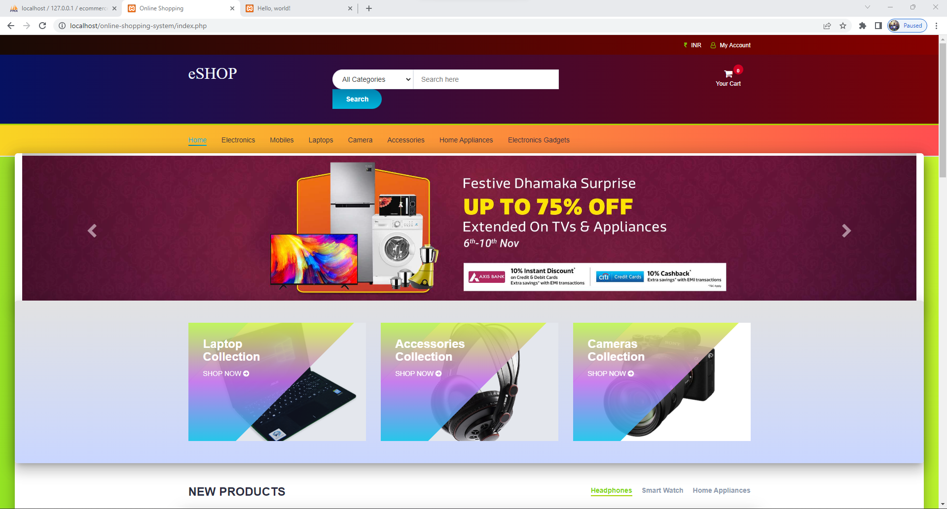

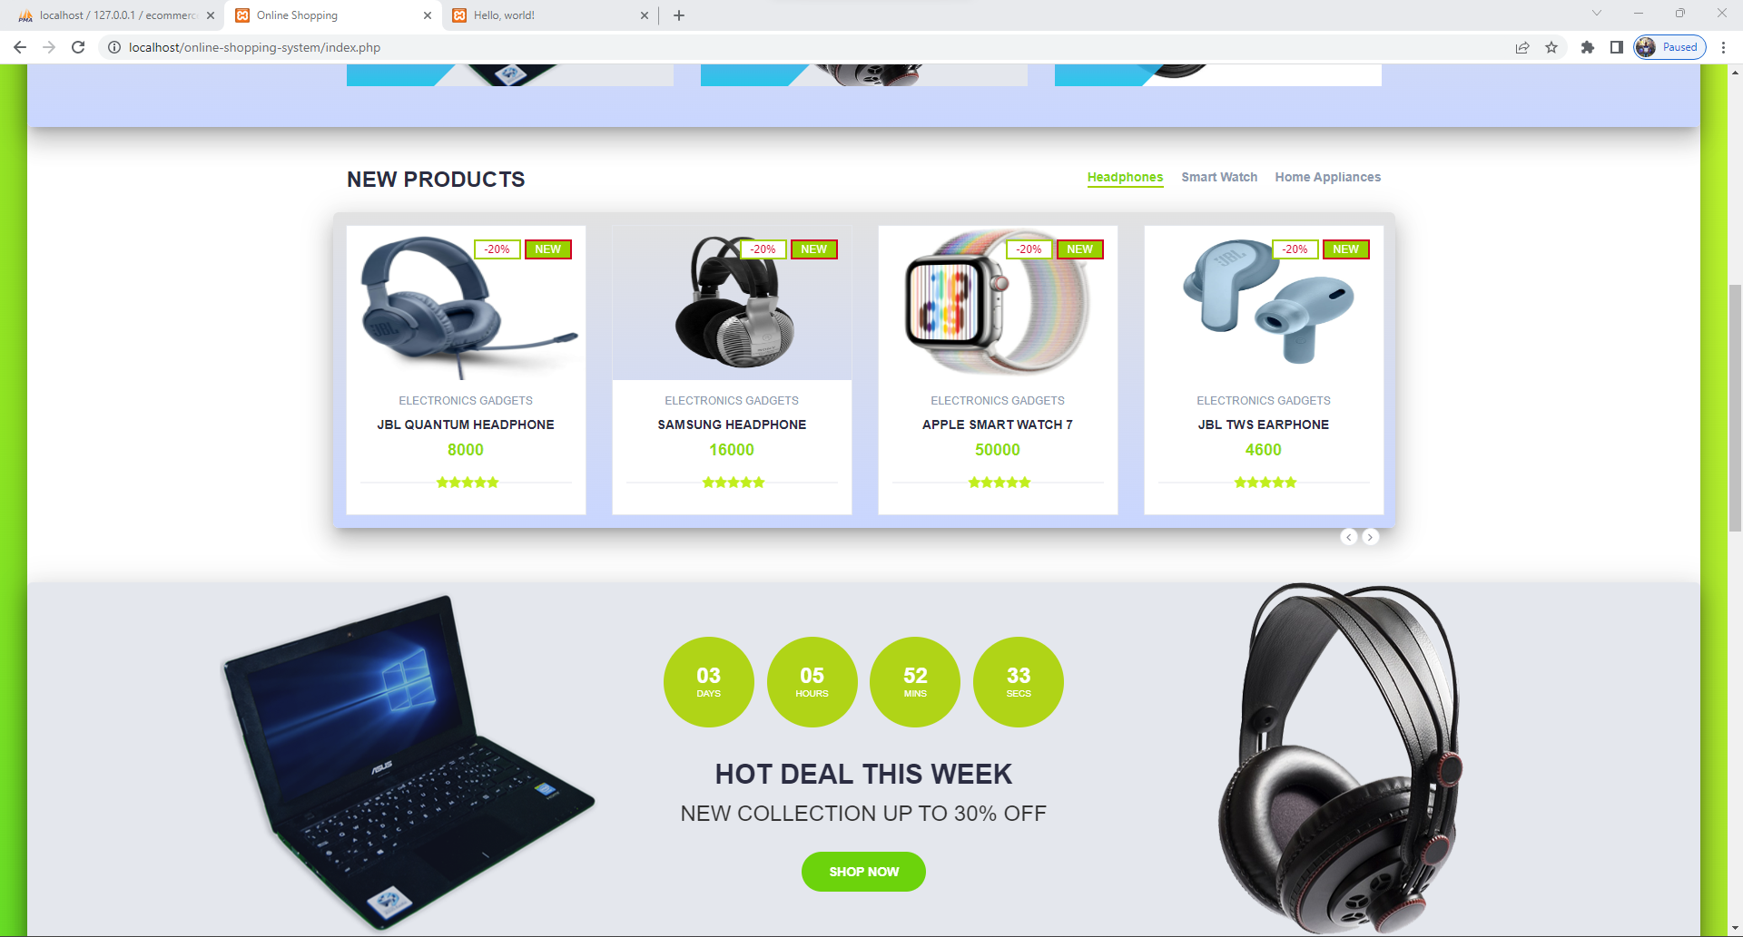

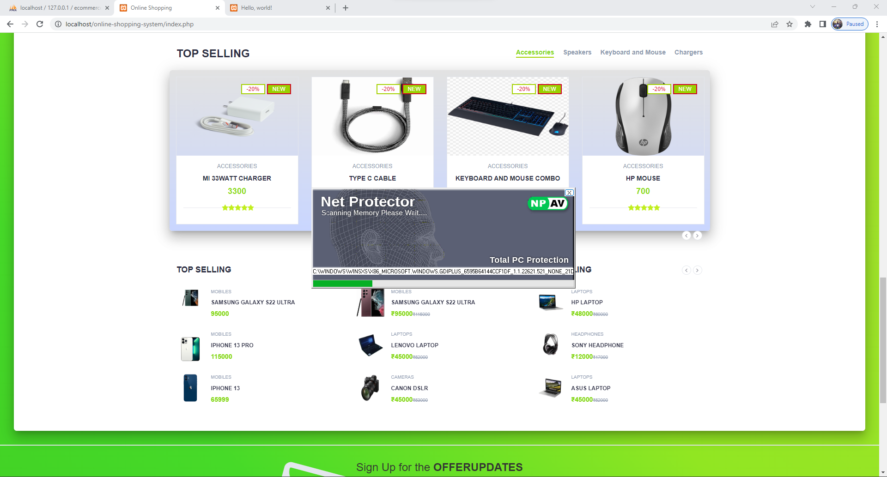

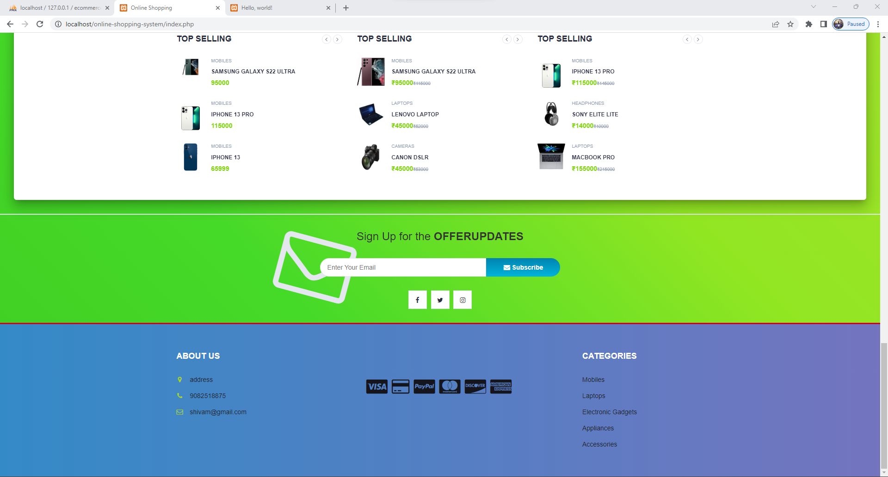

Product page-

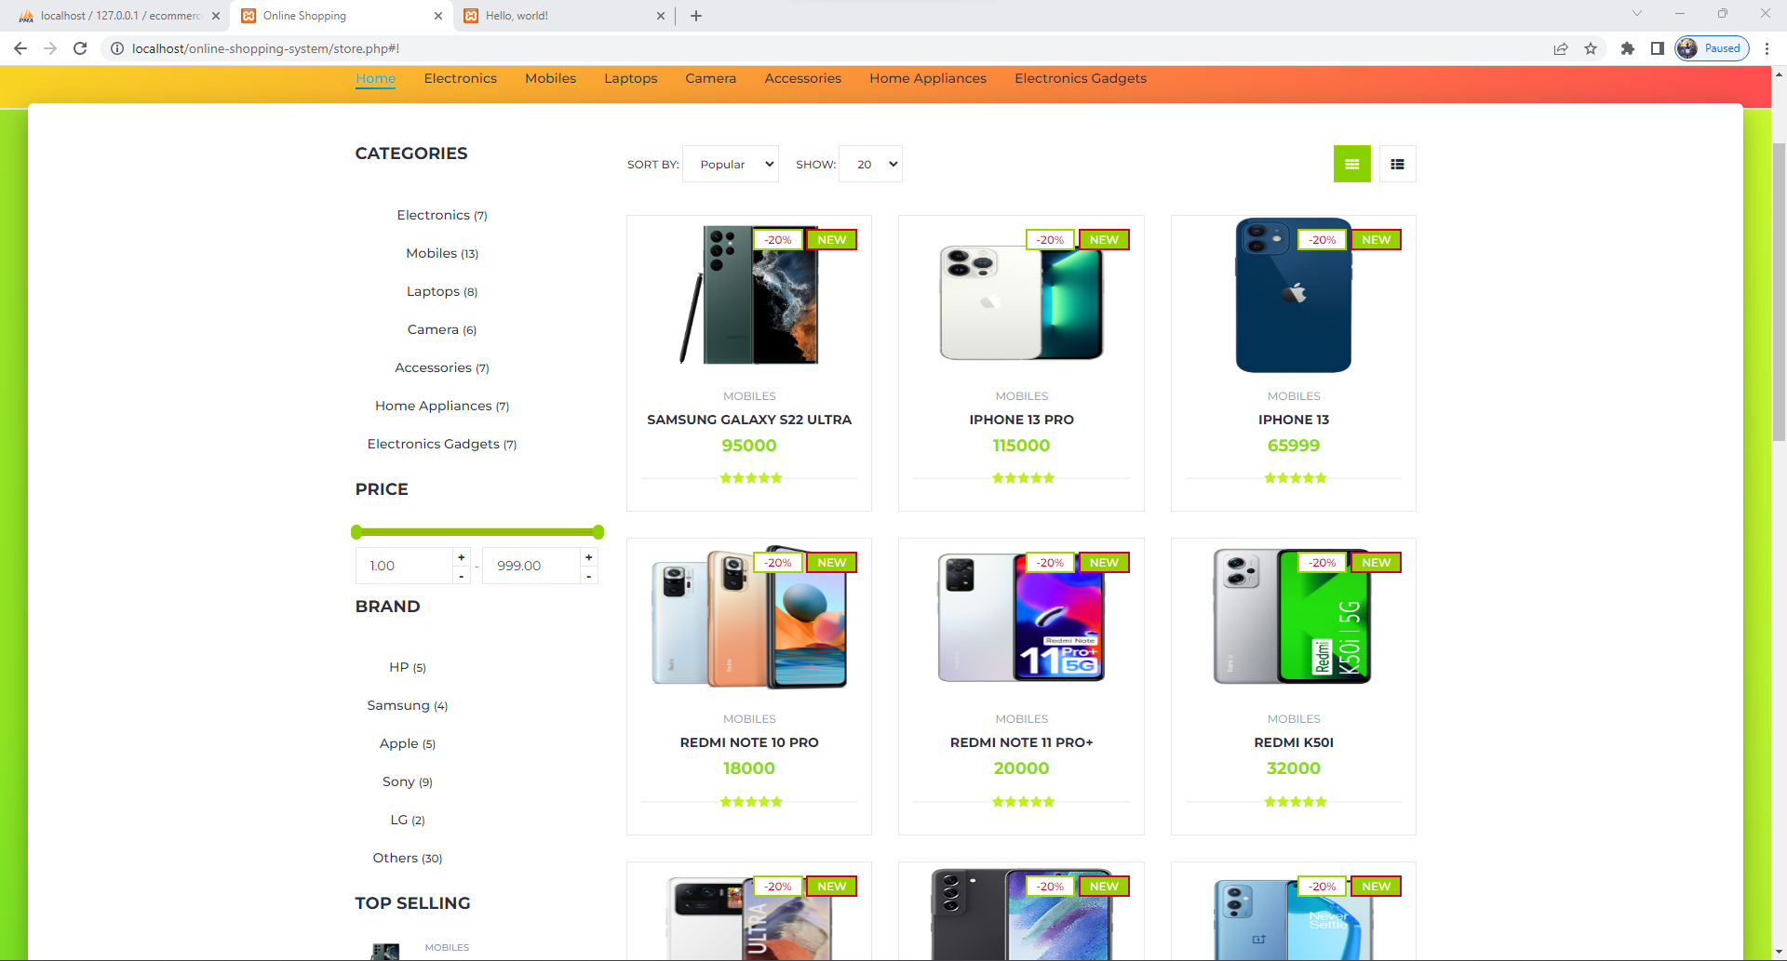

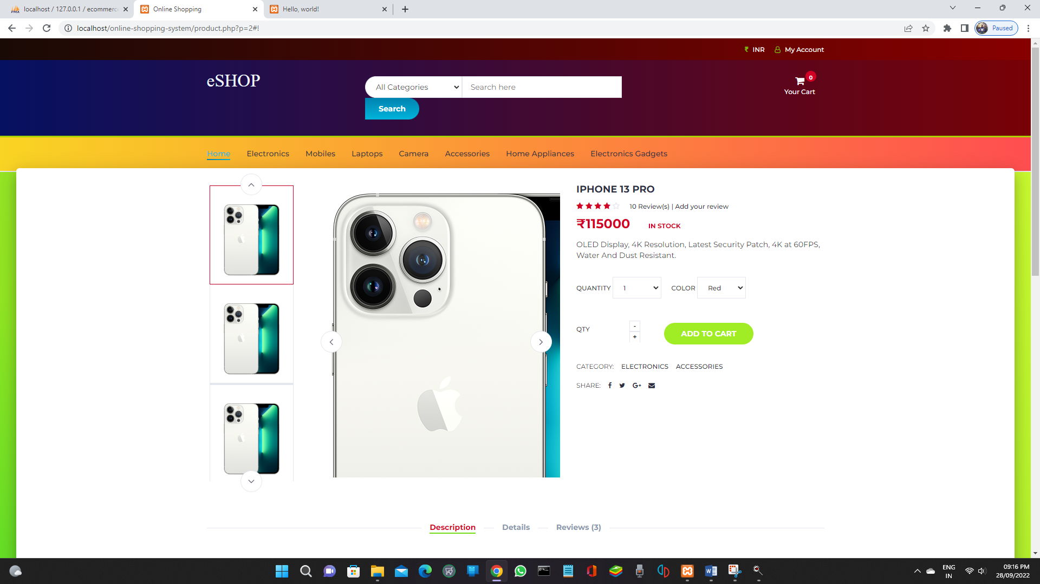

Brand All Products Available-

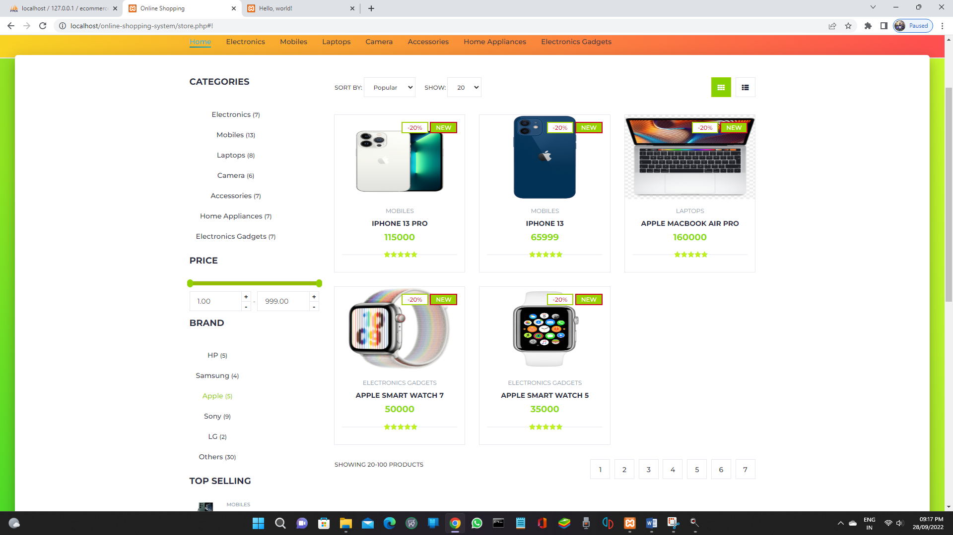

Login Page-

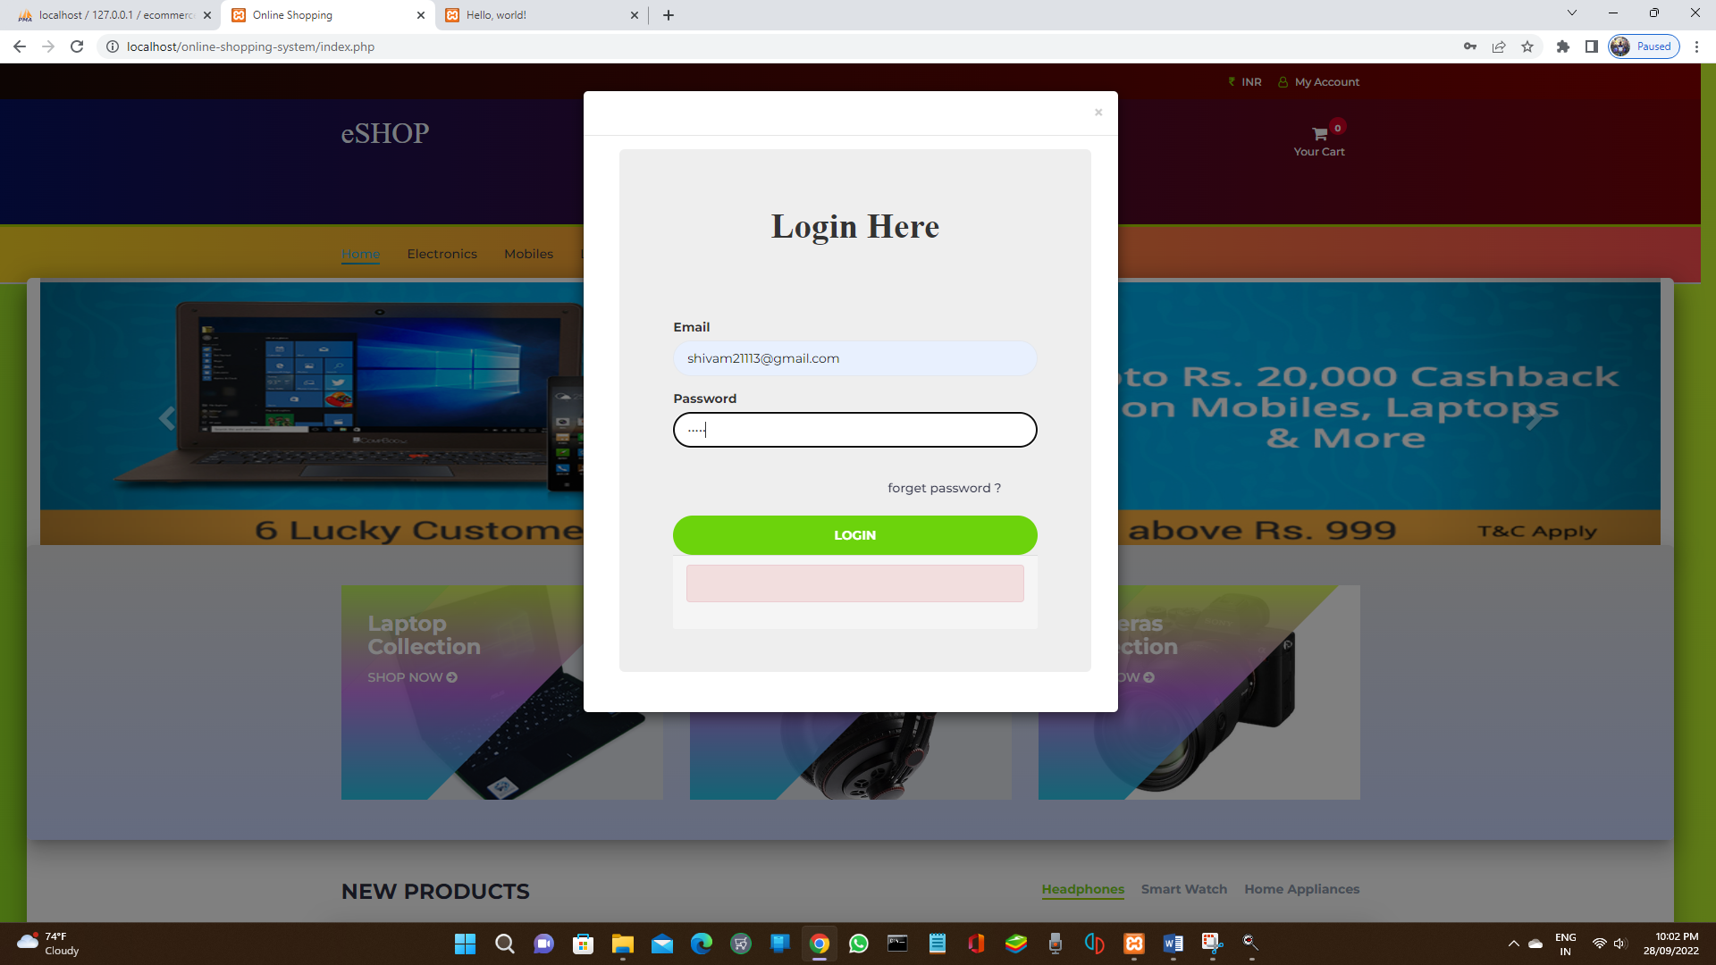

Register Page-

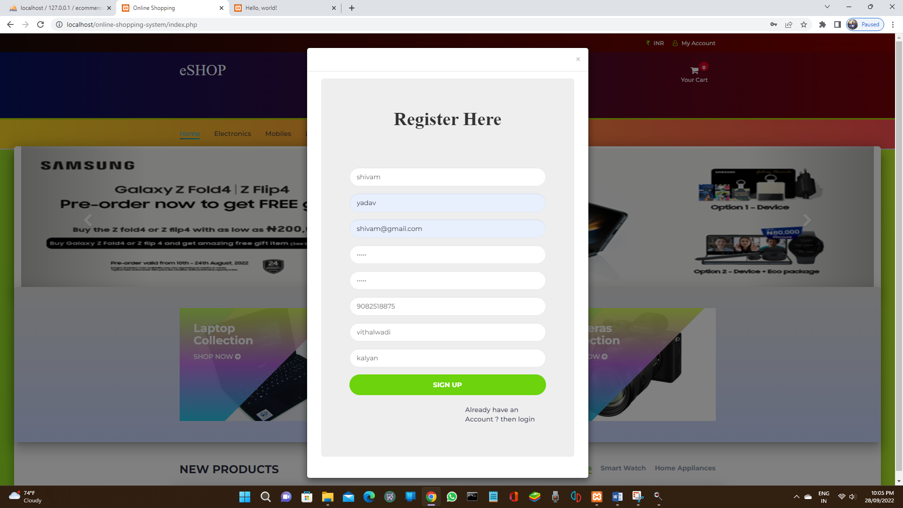

Add to cart for buy-

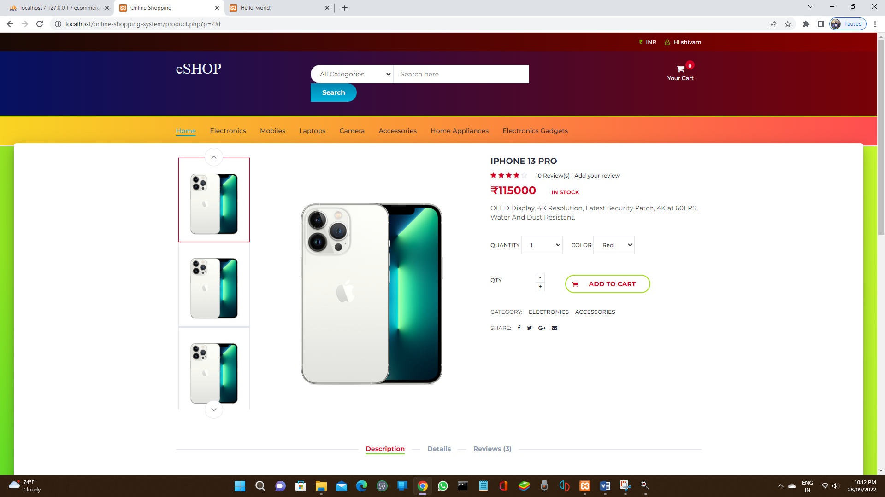

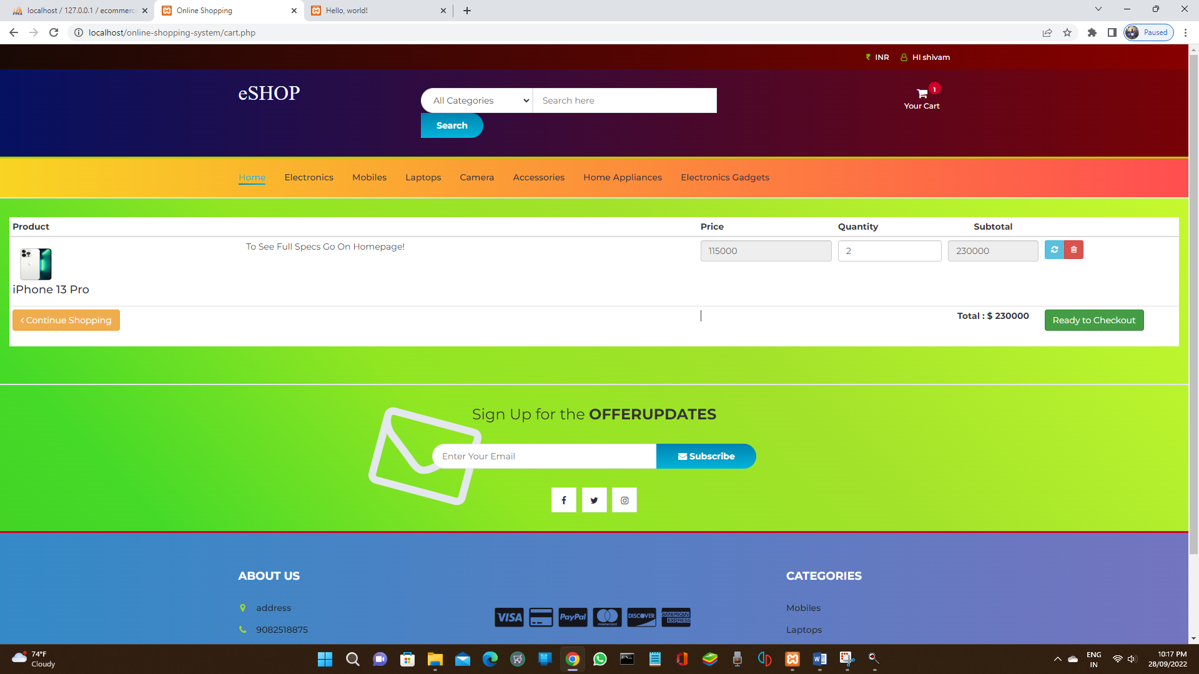

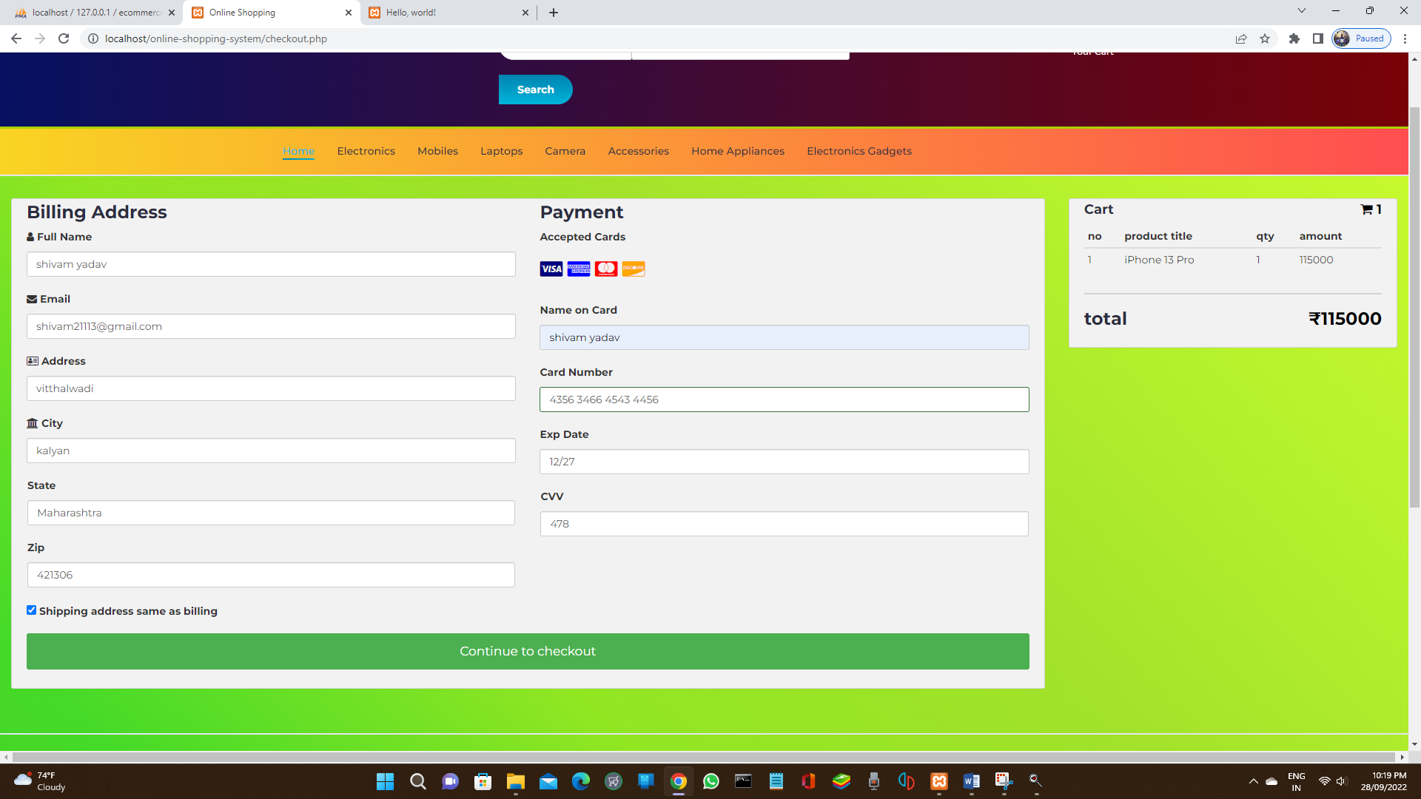

Orders-

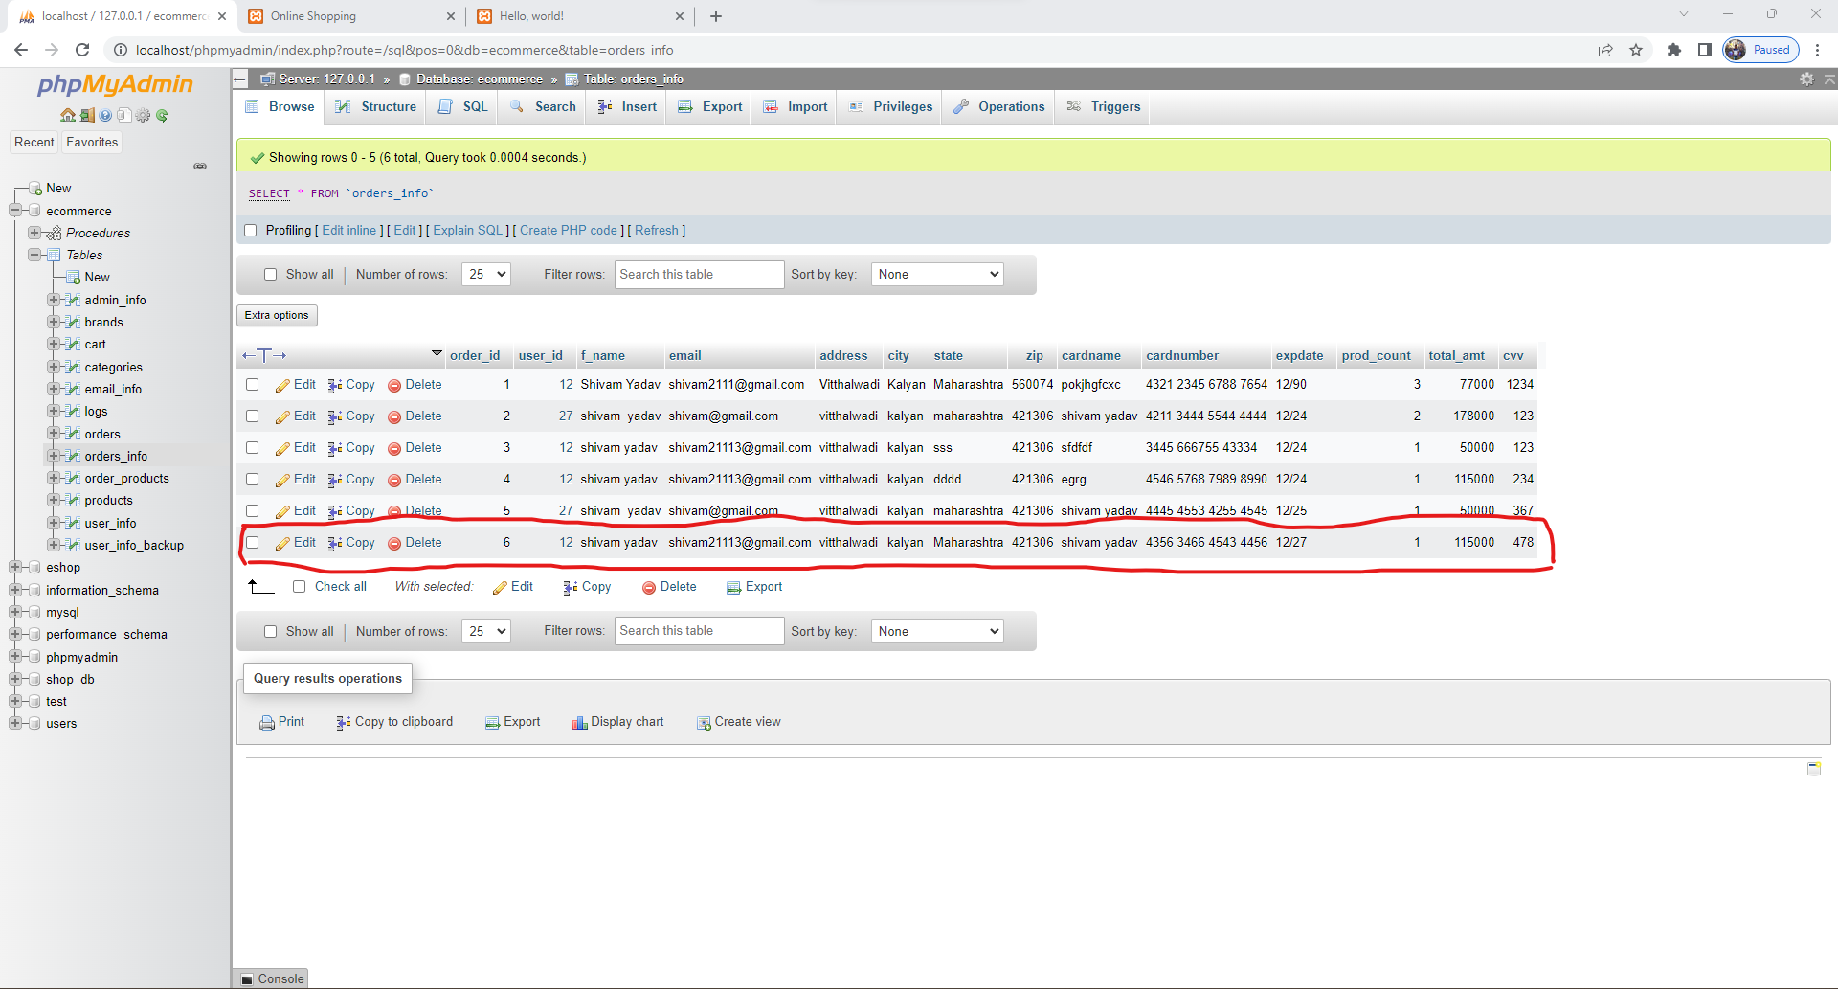

Admin Part:-

Dashboard-

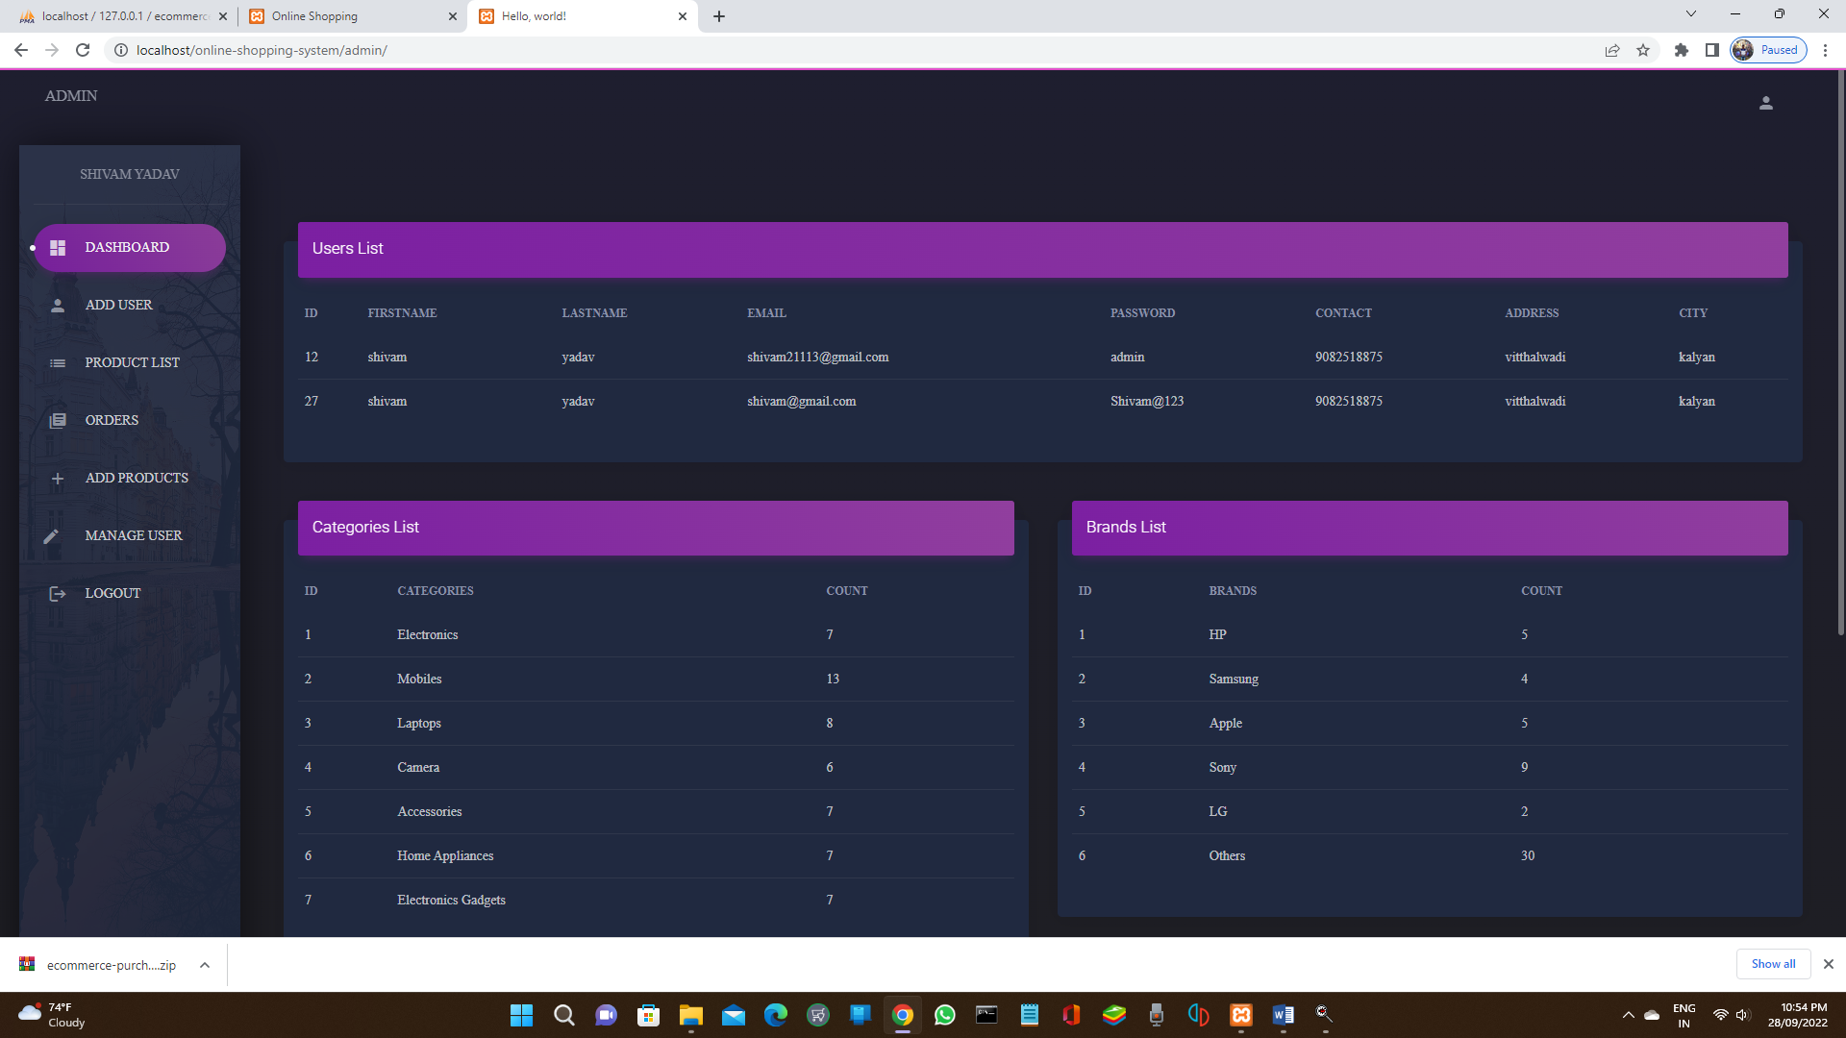

Adduser-

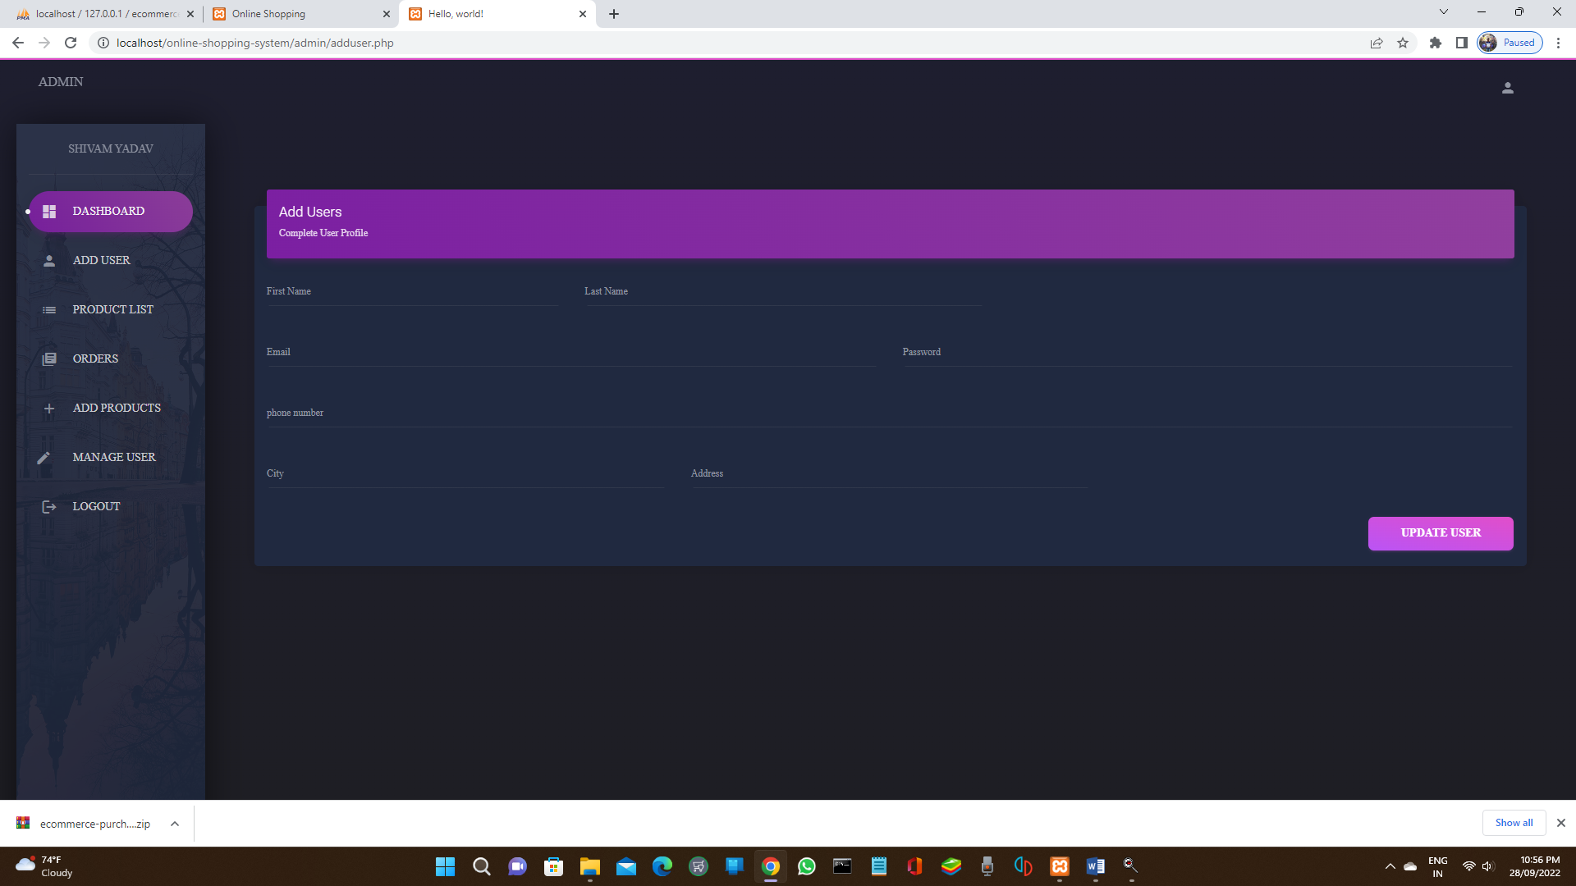

Manage Product (add/remove)-

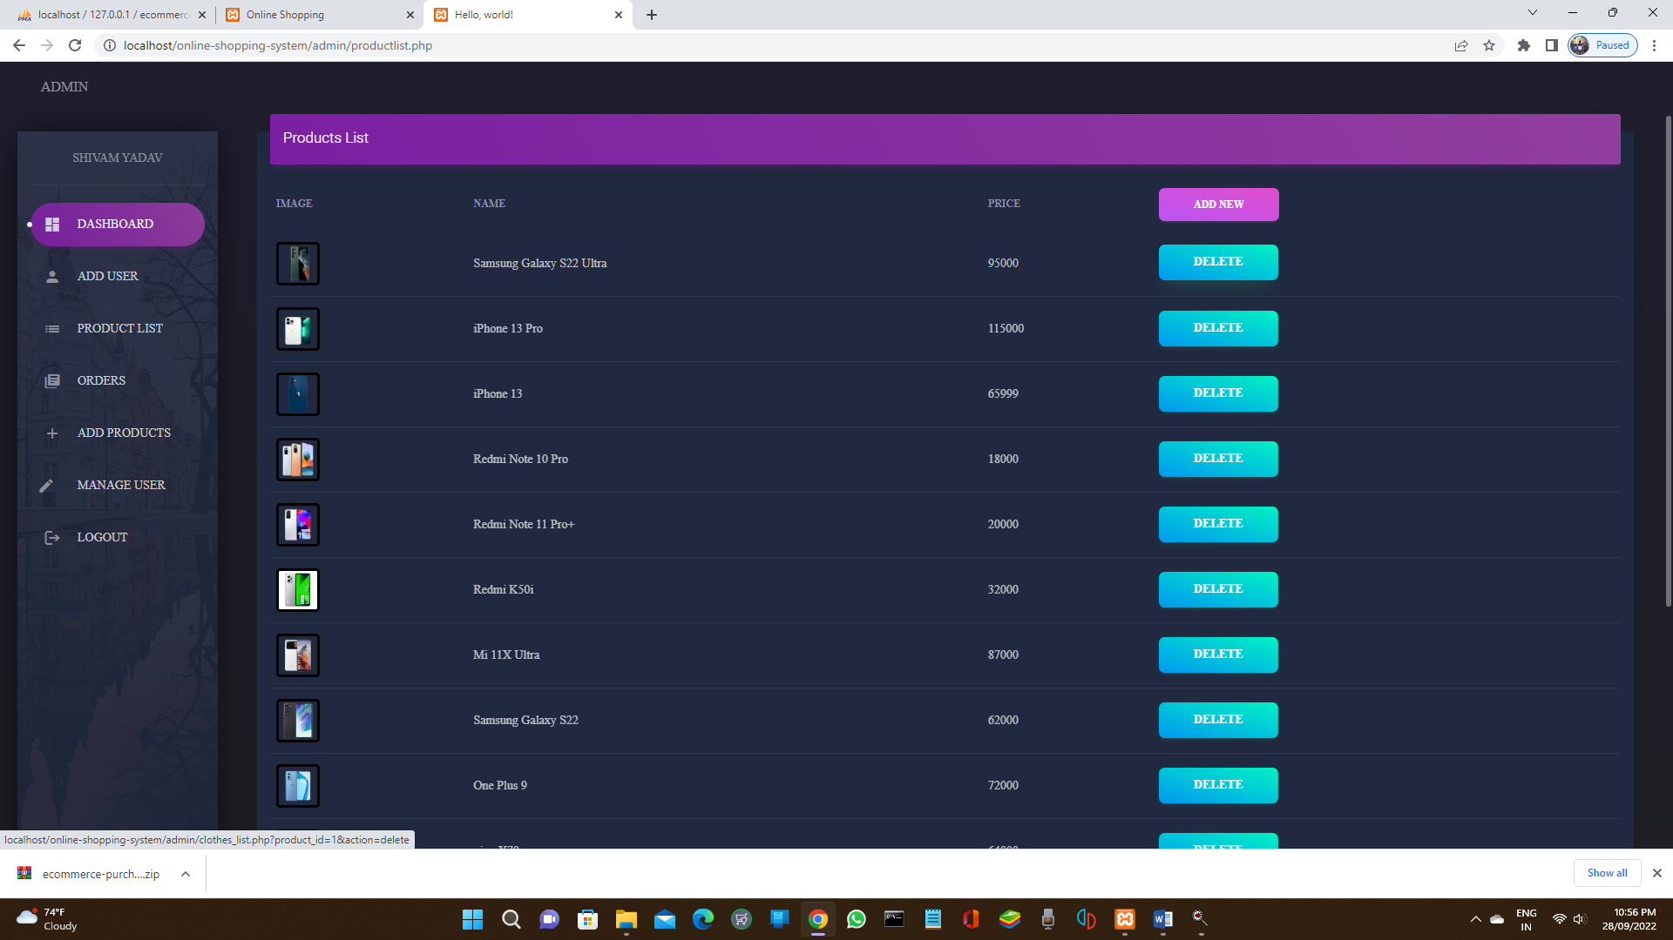

Manage Orders-

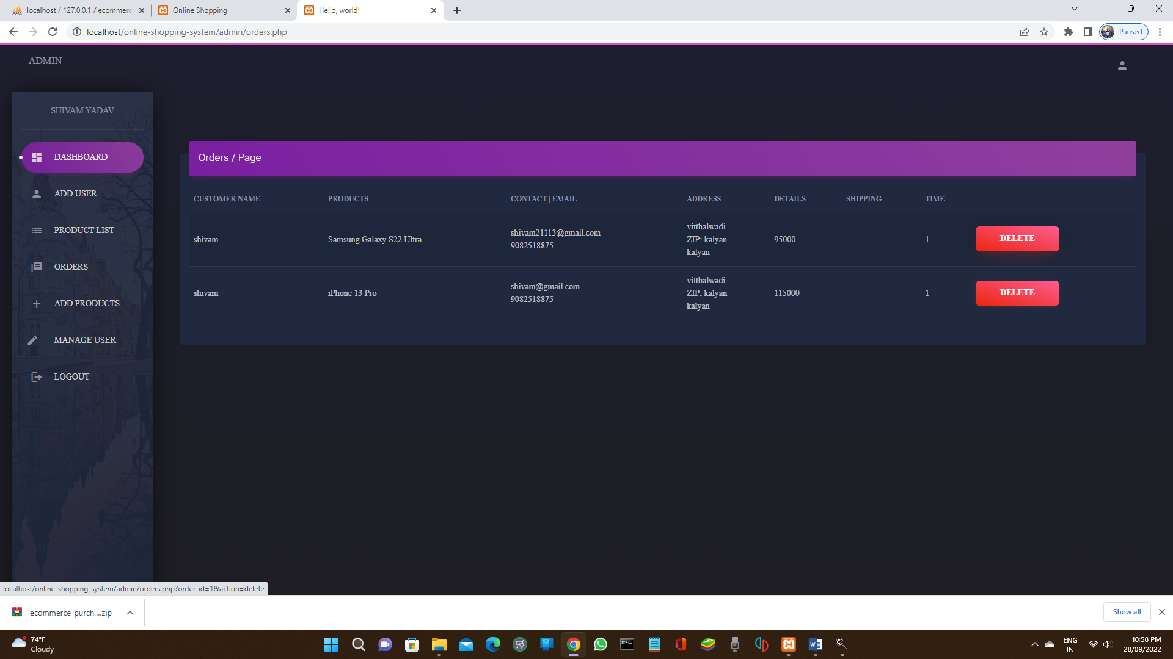

Add or update products-

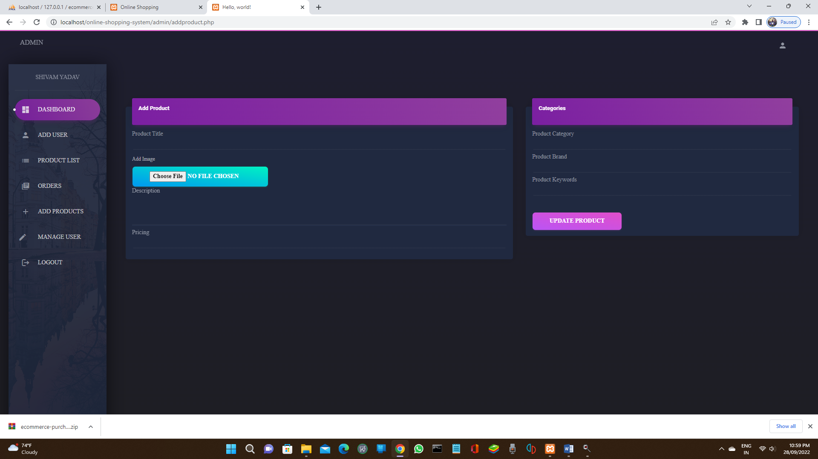

Manage User-

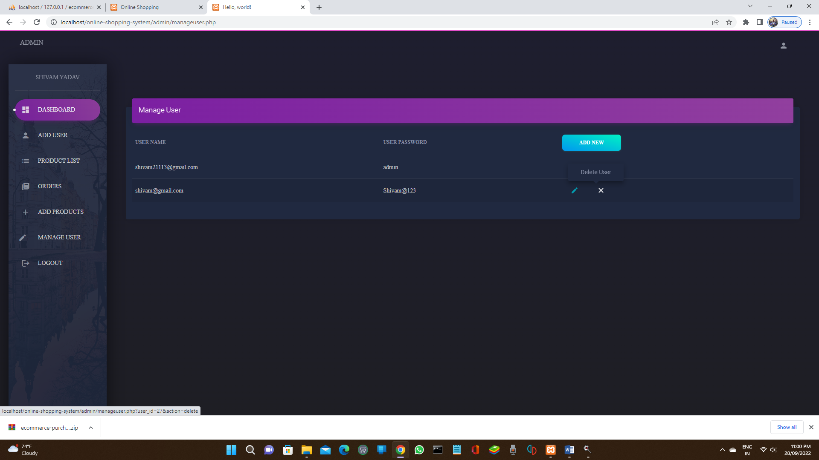

# Validations

## Test Cases

What is Test Case? “A Test Case has a component that describes an input, action or event expected response, to determine if a feature of an application is working correctly.” Software testing can be stated as the process of validating and verifying that a computer program/application/product: • Meets the requirements that guided its design and development. • Works as expected • Can be implemented with the same characters. • And satisfies the needs of Stakeholders.

Why we Write Test Case? A Test Case in Software Engineering is a set of conditions or variables under which a tester will determine whether an application , software system or one of its feature is working as it was originally established for it to do. The basic objective to write test case is to vali=date te testing coverage for the application. Test Cases bring some sort of standardization and minimize the ad-hoc approach in testing.

## Test Data

List of variables and possible values used in the test case. You can list specific values or describe value ranges. The test case should be performed once for each combination Of values. These values written in set notation one per line. E.g.; Login ID {Valid login, invalid login, login empty}

1) Login ID {Valid login, invalid login, login empty}

2) Name {Name cannot be blank, Name should be a string}

3) Email {Invalid email id, Email id is a compulsory attribute}

4) Age {Age is a required attribute, Specify age with respect to range}

5) Validation Summary-Show pop ups at the top of the page

**Steps to carry out the test.**

**See step formatting rules below:**

1. Visit Login page

2. Enter User Name

3. Enter Password Click Login

**Actual Results:**

….Empty username and empty password Here you have to paste your empty user name and password field.. along with message box in alert type message box………. After than invalid username and password image along with msgbox…. (Total there should be 4 images)….

**Comments:**

If username and password are correctly entered only then you will be taken to next page.

## Test Results

Entering wrong password-

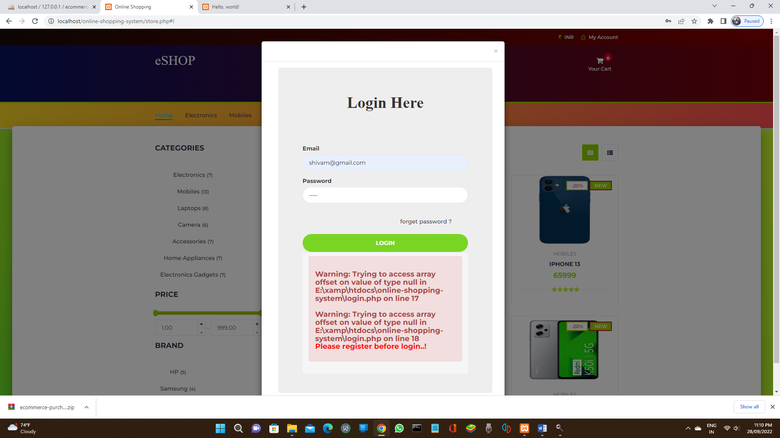

Email validation-

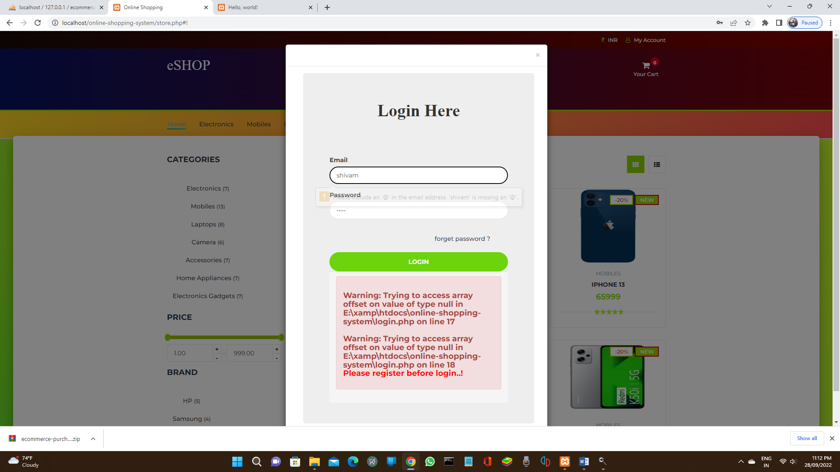

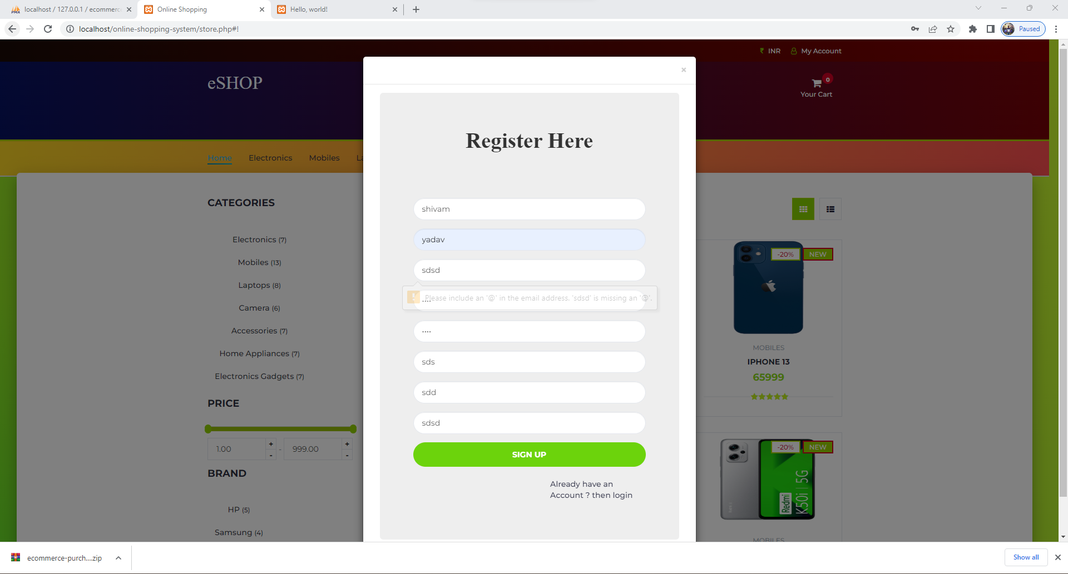

Payment completed with transaction id-

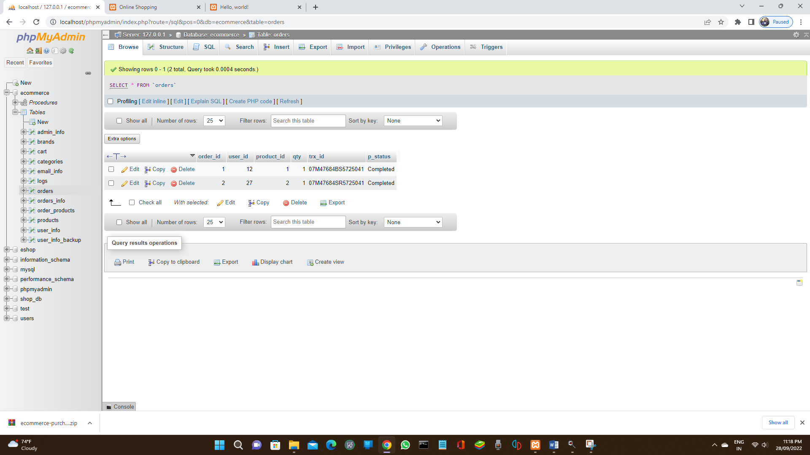

# Report Layout

